**MINISTRY OF EDUCATION AND TRAINING**

**HO CHI MINH CITY UNIVERSITY OF TECHNOLOGY AND EDUCATION**

**FACULTY OF INFORMATION TECHNOLOGY**

**----**🙟🕮🙝**----**



**CAPSTONE PROJECT**

**BUILDING AN E-COMMERCE WEBSITE FOR AN ELECTRONICS STORE**

**MEMBERS:**

1. **Phạm Hoàng Phước MSSV: 18110040**
2. **Đặng Hoàng Sơn MSSV: 18110043**
3. **Ngô Minh Thành MSSV: 18110045**

**INSTRUCTORS: Ms. Lê Thị Minh Châu**

**HO CHI MINH CITY** – **2022**

|  |  |
| --- | --- |
|  | THE SOCIALIST REPUBLIC OF VIETNAM  **Independence – Freedom – Happiness**  -------- |

**PROJECT ASSIGNMENT**

**Student Name:** Pham Hoang Phuoc **ID:** 18110040

**Student Name:** Dang Hoang Son **ID:** 18110043

**Student Name:** Ngo Minh Thanh **ID:** 18110045

**Specialization:** Capstone Project

**Thesis name:** Building an e-commerce website for an electronics store

**Implementation of Content**

**Theory:**

* Research and learn React.JS, Next.JS
* Research and learn MongoDB

**Practice:**

- **Build an E-web Application:**

* For users: Basic functions of e-commerce website

- **Build a Management Website:**

* For admin: Manage the information on the website

**Processing time:** (Starting from …/…/…… to …/…/……)

Student's signature:

Student's signature:

Student's signature:

|  |  |
| --- | --- |
| **CHAIR OF THE PROGRAM**  (Sign with full name) | **ADVISOR**  (Sign with full name) |

|  |  |
| --- | --- |
|  | THE SOCIALIST REPUBLIC OF VIETNAM  **Independence – Freedom– Happiness**  -------- |

**ADVISOR’S EVALUATION SHEET**

**Student Name:** Pham Hoang Phuoc **ID:** 18110040

**Student Name:** Dang Hoang Son **ID:** 18110043

**Student Name:** Ngo Minh Thanh **ID:** 18110045

**Major:** Capstone Project

**Project title:** Building an e-commerce website for an electronics store

**Advisor:** Ms. Le Thi Minh Chau

**EVALUATION**

1. **Content of the project:**

.............................................................................................................................

.............................................................................................................................

1. **Strengths:**

.............................................................................................................................

.............................................................................................................................

.............................................................................................................................

1. **Weaknesses:**

.............................................................................................................................

.............................................................................................................................

1. **Approval for oral defense? (Approved or denied)**

.............................................................................................................................

1. **Overall evaluation: (Excellent, Good, Fair, Poor)**

.............................................................................................................................

**6. Mark:** ……………… (**in words:** .................................................................)

**ADVISOR**

(Sign with full name)

|  |  |
| --- | --- |
|  | THE SOCIALIST REPUBLIC OF VIETNAM  **Independence – Freedom– Happiness**  -------- |

**PRE-DEFENSE EVALUATION SHEET**

**Student Name:** Pham Hoang Phuoc **ID:** 18110040

**Student Name:** Dang Hoang Son **ID:** 18110043

**Student Name:** Ngo Minh Thanh **ID:** 18110045

**Major:** Software Engineering

**Project title:** Building an e-commerce website for an electronics store

**Name of Reviewer:**

**EVALUATION**

**1.** **Content and workload of the project**

.............................................................................................................................

.............................................................................................................................

**2.** **Strengths:**

.............................................................................................................................

.............................................................................................................................

.............................................................................................................................

**3.** **Weaknesses:**

.............................................................................................................................

.............................................................................................................................

**4.** **Approval for oral defense? (Approved or denied)**

.............................................................................................................................

**5.** **Overall evaluation: (Excellent, Good, Fair, and Poor)**

.............................................................................................................................

**6. Mark:** ……………… (**in words:** ..................................................................)

**REVIEWER**

(Sign with full name)

**ACKNOWLEDGEMENTS**

We would like to express our sincere thanks to the teachers of the Department of Software Engineering and Communication, Faculty of Information Technology, Ho Chi Minh City University of Technology and Education for helping us carry out this thesis. Especially, we would like to express our sincere thanks to Ms. Le Thi Minh Chau for enthusiastically helping, instructing, and imparting to us her experiences, techniques, and methods in developing this topic.

Due to limited time, we have not been able to fully develop our ideas on the topic. During the reporting process, it is inevitable that there will be shortcomings. We hope to receive the contributions and opinions of teachers and friends.

**TABLE OF CONTENTS**

**CHAPTER 1: PROBLEM SURVEY** 11

**1.1** **Reasons for choosing the topic** 11

**1.2** **Problem analysis** 12

1.2.1 Shoppe 12

1.2.2 Lazada 13

1.2.3 Sendo 14

1.2.4 Tiki 15

1.2.5 Lesson learned: 16

**1.3 Requirement analysis** 17

1.3.1. System requirement 17

1.3.2 Functional requirements: 19

1.3.3 Non-functional requirements: 21

**CHAPTER 2: THEORY FOUNDATION** 23

**2.1 Next.js Overview** 23

**2.2 React** 23

**2.3 Next.JS (version 12.2.x)** 24

2.3.1 What is Next.JS? 24

2.3.2 API Routes 25

2.3.3 Data Fetching 26

2.3.4 Automatic code splitting 27

2.3.5 Hot Module Replacement (HMR) 28

**2.4 MongoDB** 28

2.4.1 What is MongoDB? 28

2.4.2 Why should we use MongoDB? 29

**2.5 Tailwind CSS (version 2)** 30

2.5.1 What is Tailwind CSS? 30

2.5.2 Why should we use Tailwind CSS? 30

**2.6 Ant Design (version 4)** 31

2.6.1 What is Ant Design? 31

2.6.2 Why should we use Ant Design? 31

**2.7 Redux toolkit** 32

2.7.1 What is Redux? 32

2.7.2 React with Redux 33

2.7.3 Redux toolkit 33

**2.8 React query (version 3)** 34

2.8.1 What is React query? 34

2.8.2 Two important hooks in React query 34

2.8.3 Why should we use React query? 34

2.8.4 Compare React query and useSWR? 35

**2.9 GHN API** 35

**2.10 Chat Facebook Plugin** 35

2.10.1 What is Chat Facebook Plugin? 35

2.10.2 Why should we use Chat Facebook Plugin? 35

**2.11 Product Recommendation** 36

**2.12 ChatBot** 37

**CHAPTER 3: MODELIZED REQUIREMENT** 38

**3.1 Identify actors and use case in use case diagram:** 38

**3.2 Describe in detail each use case and actors:** 39

3.2.1 Describe actors: 39

3.2.2 Describe use cases: 40

**CHAPTER 4: SOFTWARE DESIGN** 42

**4.1 Use case Diagram** 42

4.1.1 Use case Overview 42

4.1.2 Account 43

4.1.3 Wish List 43

4.1.4 Cart 44

4.1.5 Order 45

4.1.6 Review 45

4.1.7 Dashboard 46

4.1.8 Management 46

**4.2 Specification** 47

4.2.1 Sign In 47

4.2.2 Sign Up 47

4.2.3 Forgot Password 48

4.2.4 Reset Password 49

4.2.5 Add Address 50

4.2.6 Search Product 51

4.2.7 Recommended Product 51

4.2.8 Filter Product 52

4.2.9 Add Product to Wish List 52

4.2.10 View Cart 53

4.2.11 Add to Cart 53

4.2.12 Apply Gift Code 54

4.2.13 Payment by PayPal 54

4.2.14 Payment by Stripe Card 55

4.2.15 Payment by ZaloPay 55

4.2.16 Payment by Momo 56

4.2.17 View Order History 56

4.2.18 View Order Tracking 57

4.2.19 Reply Review 57

4.2.20 Cancel Order 58

4.2.21 Chatbot 58

4.2.22 Add Comment 59

4.2.23 Reply Comment 60

4.2.24 Update Order Status 60

4.2.25 Delete User 61

4.2.26 Compare Products 61

4.2.27 Create Product 62

4.2.28 Chat Facebook Plugin 63

4.2.29 Chat Facebook Management 63

**4.3 Sequence Diagram** 64

4.3.1 Sign In 64

4.3.2 Sign Up 64

4.3.3 Reset Password 65

4.3.4 Forgot Password 66

4.3.5 Add Address 67

4.3.6 Search Product 68

4.3.7 Recommended Product 68

4.3.8 Filter Product 69

4.3.9 Add Product to Wish List 69

4.3.10 Add to Cart 70

4.3.11 Apply Gift Code 71

4.3.12 Payment by PayPal 71

4.3.13 Payment by Stripe Card 72

4.3.14 Payment by ZaloPay 72

4.3.15 Payment by Momo 73

4.3.16 View Order History 73

4.3.17 View Order Tracking 74

4.3.18 Cancel Order 75

4.3.19 Add Comment 76

4.3.20 Reply Comment 77

4.3.21 Delete User 78

4.3.22 Update Order Status 79

4.3.23 Create Product 80

4.3.24 Reply Review 81

**4.4 Class Diagram** 82

**4.5 Database Design** 83

4.5.1 Product 84

4.5.2 Review 85

4.5.3 User 86

4.5.4 Wish List 87

4.5.5 Coupon 87

4.5.6 Cart 87

4.5.7 Order 88

**CHAPTER 5: UI DESIGN** 89

**5.1 Overview UI** 89

**5.2 Detailed description of screens** 90

5.2.1 Home Page Screen 90

5.2.2 Login Modal 91

5.2.3 Register Modal 93

5.2.4 Forgot Password Modal 94

5.2.5 Edit Profile Screen 95

5.2.6 Address Screen 97

5.2.7 Like/Dislike Product and Wish List Screen 99

5.2.8 Cart Screen 100

5.2.9 Checkout Screen 102

5.2.10 Review Product Screen 103

5.2.11 Recommended Items Screen 105

5.2.12 Order Management for Customer Screen 106

5.2.13 Review Purchased Product Screen 109

5.2.14 View, Search product Screen 110

5.2.15 Dashboard Screen 111

5.2.16 User Management Screen 114

5.2.17 Order Management for Admin Screen 117

5.2.18 Product Management Screen 119

5.2.19 Create Product Screen 120

5.2.20 Review Management Screen 124

5.2.21 Coupon Management Screen 125

5.2.22 Chat Facebook Plugin 128

5.2.23 ChatBot 128

5.2.24 Send an email to confirm the checkout 129

5.2.25 Compare Products 130

**CHAPTER 6: SOFTWARE TESTING** 131

**CHAPTER 7: SUMMARY** 140

**7.1 The summary result that we got:** 140

**7.2 Advantages:** 141

**7.3 Disadvantages:** 141

**7.4 Advanced functions of the website:** 142

**7.5 Things to update in the future:** 143

**REFERENCES** 144

**ROLE TABLE** 145

# **CHAPTER 1: PROBLEM SURVEY**

* 1. **Reasons for choosing the topic**

With the explosion of the current global network system, the Internet and its enormous benefits have attracted and conquered people. Taking advantage of the powerful features of the Internet and new technologies in information and communication, people have built special systems for others to apply and put into practice. And that will change the lives of people in our society in the direction of being more convenient and more civilized.

Along with the Internet's rapid spread across the globe, the commercial website will become the main and most effective tool for doing business on a global scale. Instead of managing, buying, and selling by hand, it is critical to use computers to manage, buy, and sell in businesses, companies, and as individuals. Companies and businesses can advertise their products and services on websites while also allowing users to buy and sell goods online. This will help increase revenue and customers while making it easier to find business partners. And paying online is very quick and simple via credit cards. The management, purchase, and sale of goods online are indispensable in every business and company and especially bring convenience to users.

Therefore, it is necessary to have new technologies to manage and administer the website to meet the above needs. That's why we chose the topic "Building an e-commerce website for an electronics store," because it can fulfill the above functions.

* 1. **Problem analysis**

### **1.2.1 Shoppe**

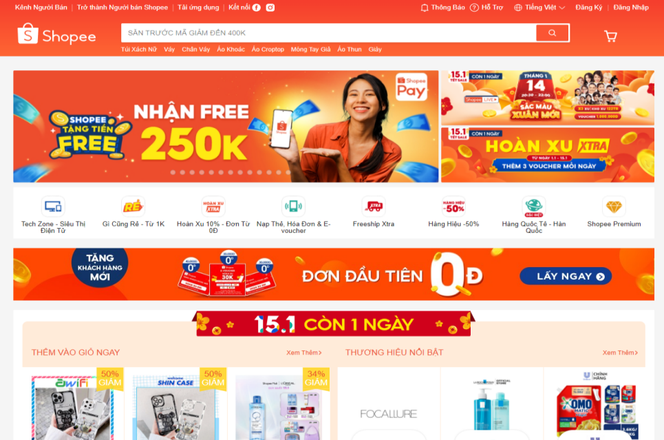

**Advantages:**

* They have a built-in chat service that allows people to message sellers directly to get questions answered.
* The entire transaction process goes smoothly, from product browsing and ordering to purchase payment.
* The variety of products
* Shopee is committed to refunding if customers receive the wrong product.
* Shopee offers numerous payment options to customers.
* Fairly fast shipping with package tracking information
* There are often discount events to help attract users.

**Disadvantages:**

* There is no way to help buyers check the quality of goods.
* Unreasonable order cancellation
* Shopee approves orders sometimes quickly and sometimes slowly.
* Shopee is not responsible for product warranties.
* The problem is that the account on the web sometimes does not work as expected.

### **1.2.2 Lazada**

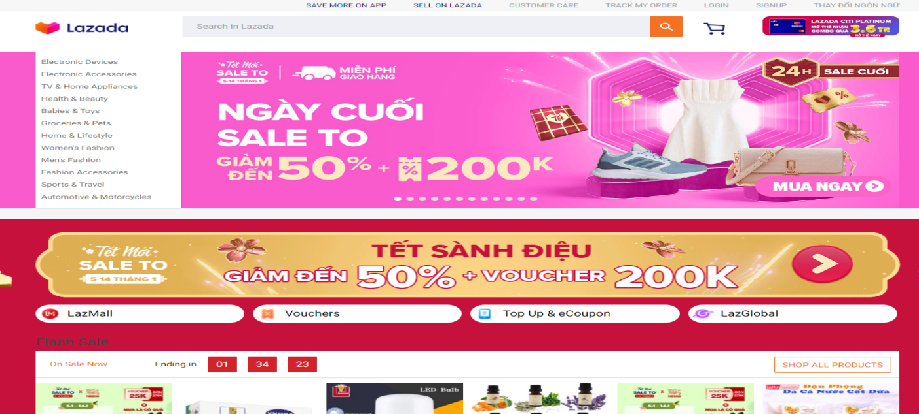

**Advantages:**

* The whole transaction process is smooth, from browsing products and placing an order to paying for the purchase.
* Lazada’s product pages have more detailed and easy-to-read product descriptions with more images.
* The Lazada app is easier to navigate, too. When you open a product page, you can quickly go to sections like Ratings and Recommendations without scrolling down the page, as the links can be tapped on the top of the screen.

**Disadvantages:**

* The accuracy of its product search results: For example, when you sort the items from lowest to the highest price, the first page displays some items that do not exactly match the search term.
* Error on the part of the seller or buyer
* Lazada has abandoned installment shopping.
* Lazada does not have a point system for buyers when making purchases.
* Lazada does not allow product inspection upon receipt.

### **1.2.3 Sendo**

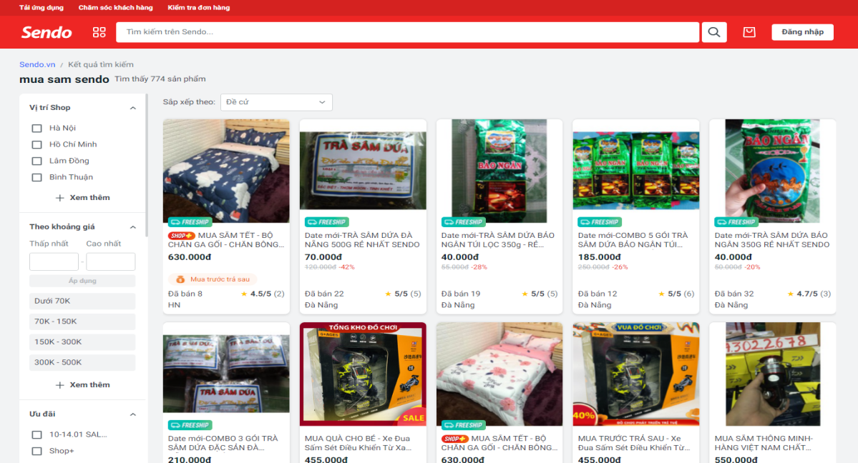

**Advantages:**

* User-friendly
* Chat operation: allows the user to easily ask the seller about product information such as color or how to use it.
* Encourage customers to pay a delivery fee.
* Customer information security is quite good.
* Create conditions for customers to easily return products according to the allowed regulations.
* It is easy for the customer to buy a product because you just need to input the phone number and the seller will call you for authenticity.

**Disadvantages:**

The seller management mechanism is not good, so there are still fake goods and poor-quality goods.

The buyer management mechanism is not good, so virtual goods often appear.

Sendo offers a variety of payment options for customers.

### **1.2.4 Tiki**

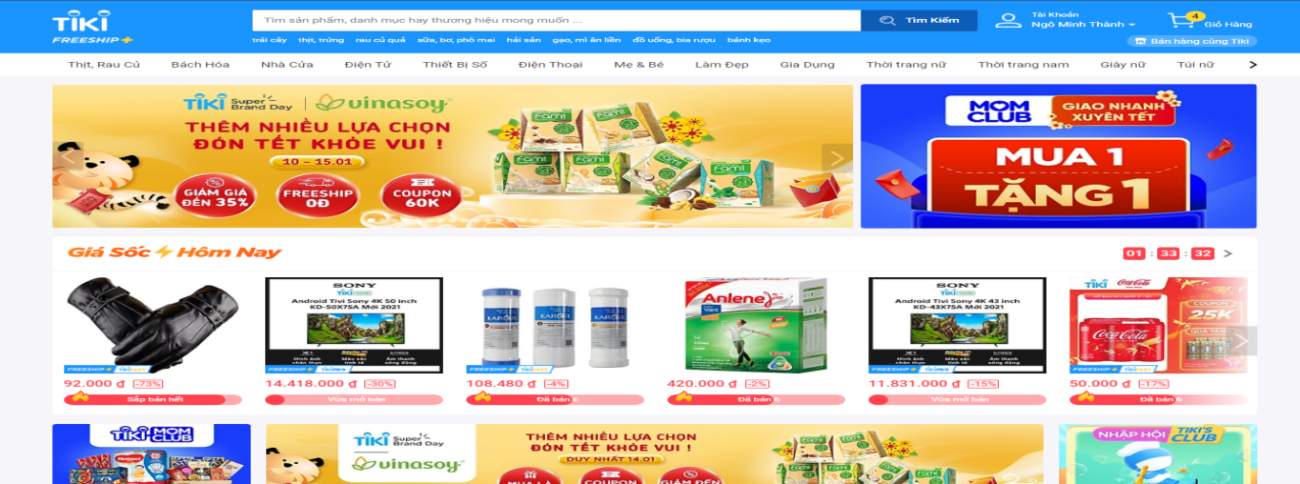

**Advantages:**

* User-friendly
* Excellent customer service, such as online chat and customer consultation.
* The entire transaction process goes smoothly, from product browsing and ordering to purchase payment.
* Convenient, simple, and quick transaction
* Addition of more addresses for ease of selecting an address when ordering
* Tiki provides many payment options for customers.
* Fairly fast shipping with package tracking information
* There are promotions to attract users to shop and help save money for customers.

**Disadvantages:**

* There is no way to help buyers check the quality of goods, so the quantity of poor-quality goods is high.
* If the user has linked to the e-wallet in an unreasonable manner, the payment will be made automatically.
* There is no installment purchase service.

**1.2.5 Lesson learned:**

* Build a good interface that is not only user-friendly but also has enough basic functions for an e-commerce website.
* There should be a reasonable management policy for the following:

+ **Products:**

* Product input and product verification
* Add product to the warehouse

+ **Orders:** In which, according to me, the part to pay attention to is Order Status. The system must divide according to reasonable logic so that the merchant can track the order’s current status. and change order information when the customer wants to change

+ **Customers:** This is valuable information, so it should be kept confidential.

+ **Report / Analysis:** The statistics allow us to monitor the web's operational status and make the most informed decisions about how to develop or maintain the web.

+ **Payment method:** This is one of the most important functions of the website because it provides a source of income, so make sure it works correctly.

+ **Shipping method:** ensure that three parties are linked: the deliverer, the buyer, and the receiver. Because when the product is delivered to the customer and the quality is still guaranteed, it can help us create trust with customers, leading to our website becoming more and more developed and being used by more users.

+ **Store locations:** updating the store address regularly is very important. It helps the contractor estimate the delivery time. It will be less time-consuming. Goods must reach consumers as soon as possible.

+ **Web builder:** The link between the backend and the frontend. Web Builder is a tool to help merchants change the way their website content is displayed. The tool will take the data that the merchant has added to the backend and arrange it in various ways to make it look beautiful on the front end.

**1.3 Requirement analysis**

### **1.3.1. System requirement**

**The system stores information about:**

* Customer information
* Product information
* Product review comments
* Transaction history

**Searching:**

* Search products, orders, users, reviews, and coupons.
* Filter products by condition: rating, best seller, price range, and product category.

**Payment:**

* Via credit card
* Via QR code from Momo, ZaloPay
* Via cash
* Apply the gift code

**Orders:**

* A list of all purchased items
* Order status

**Feedback:**

* Product reviews
* Respond to a comment
* **Requirement of the system:**

**Environment:** The system works on the website using Next.js (The React Framework for Production) and accesses MongoDB in the cloud.

**Authorization and Authentication:**

* Customer: Provide feedback, rate products after purchasing them, pay for them, and save them to your favorites list.
* Administrators can add and check products, revenue statistics, order information, and user information.

**Convenient:**

* Friendly with the user.
* Easy to use.
* The buttons on the system are not complex and are easy to use.
* The layout must interact well with one another so that the user is satisfied when using it.

**Effective:**

* Database storage needs to be safe and easy to use.
* The system operates as steadily as possible, accessing and executing data as quickly as possible.

**Suitable:**

* Systems installed on various computers can interact with one another.
* The system can satisfy the customer's requirements and does not harm the system.
* **Relate to information technology staff:**

**Reusable:**

* The system's designs and functions can be reused for the next update or rebuilt for a specific function.
* The code can be reused in another application.

### **1.3.2 Functional requirements:**

**Division (user): Customer ID: CM**

|  |  |  |
| --- | --- | --- |
| **OD** | **Function** | **Description** |
| 1 | Search Product | Customers can find exactly the products they want |
| 2 | Add Comment | Customers can write comments on the product |
| 3 | Reply Comment | Customers can reply to comments on the product |
| 4 | Add/Edit/Delete to cart | Customers can manage the products in the cart |
| 5 | Add/Delete to the wish list | Customers can manage the products on the wish list |
| 6 | View Order Tracking | Customers can view order tracking |
| 7 | Payment | Customers can choose different types of payments |
| 8 | View order history | Customers can view order history based on transacted invoices |
| 9 | Sign up | Customers can register on the website. |
| 10 | Sign In | Customers can log in to the website. |
| 11 | Forgot Password | In case the customer forgets the password, It can be recovered via email or phone number verification |
| 12 | Add/Update/Delete address | Customers can manage their address |
| 13 | Cancel Order | Customers can cancel the order if the status of the order is not packed yet |
| 14 | Edit Profile | Customers can edit their information |
| 15 | Change password | Customers can change their password |
| 18 | Apply gift code | Customers can apply the gift code to get a discount on the payment |
| 19 | View discount product | Customers can view the list of discount products |
| 20 | View recommended product | Customers can view the list of recommended products |
| 21 | Filter product | Customers can filter products |
| 22 | Chat Facebook Plugin | Customers can get help from the admin |
| 23 | Chatbot | The customer can ask questions about the product |

**Division (user): Administrator ID: AD**

|  |  |  |
| --- | --- | --- |
| **OD** | **Function** | **Description** |
| 1 | Search Product | The administrator can find exactly the products they want |
| 2 | Create Product | The administrator can create the products |
| 3 | Edit Product | The administrator can update the products |
| 4 | Delete Product | The administrator can delete the products |
| 5 | Update Order Status | The administrator can update the order status |
| 6 | View sales statistics | The administrator can view sales statistics depending on revenue, warehouse, access times |
| 7 | User management | The administrator can manage the users |
| 8 | Coupon management | The administrator can manage the users |
| 9 | Reply review | The administrator can reply to review |
| 10 | Hide/unhide review | The administrator can hide or unhide the review |
| 11 | Search review | The administrator can find the review of the product |
| 12 | View the order of the customer | The administrator can view the order of the customer |
| 13 | Chat Facebook Management | The administrator can interact with users |

### **1.3.3 Non-functional requirements:**

* **User related:**

|  |  |  |  |  |
| --- | --- | --- | --- | --- |
| **ID** | **Contents** | **Criteria** | **Description** | **Note** |
| 1 | The software can be updated and modified to adapt to the trends of customers as well as the requirements of managing the owners. | Resilience |  |  |
| 2 | Graphic User-Interface:   * User-friendly. * Easy manipulation. * Feature buttons are laid out simply, conveniently, and clearly. * Functional windows can interact with each other, providing users with efficiency. | Usability |  |  |
| 3 | * The database is kept secure and easy to be accessed. * The system operates with stable, reliable, and instant response. | Efficiency |  |  |
| 4 | * Computers in the network can share the resources through installed software. * The software can meet the requirements of users without making slow effects. | Compatibility |  |  |

* **Staff-related:**

|  |  |  |  |  |
| --- | --- | --- | --- | --- |
| **ID** | **Contents** | **Criteria** | **Description** | **Note** |
| 1 | * The module, source code, and other proportions of the system can be reused for later projects. * The source code can be recycled and applied for other programs without changing the cores. | Reusability |  |  |

* **Quality:**

|  |  |  |  |  |
| --- | --- | --- | --- | --- |
| **ID** | **Contents** | **Criteria** | **Description** | **Note** |
| 1 | The search product function is convenient, natural, and visible. | Convenience | Support keyword-like searching. |  |
| 2 | Allow adding products, editing product | Compatibility |  |  |
| 3 | Processing time is acceptable | Effectiveness | Access a website in no more than 3 seconds |  |

# 

# **CHAPTER 2: THEORY FOUNDATION**

## **2.1 Next.js Overview**

Next.js creates fast, search-engine-optimized React apps with zero configuration.

* JS is a framework that allows us to build a React app but render the content in advance on the server.
* The first thing a user or search bot sees is the fully rendered HTML, and after receiving the initial page, client-side rendering takes over and it works just like a traditional React app.
* It helps us achieve both fully rendered content for bots and highly interactive content for users.

Next.js has a lot of features out of the box, and it also provides API routes that we can use to build the full-stack application. It gets better and better with every new release. Therefore, we decided to choose Next.js for this project.

## **2.2 React**

React is a free and open-source front-end JavaScript library for building user interfaces based on UI components.

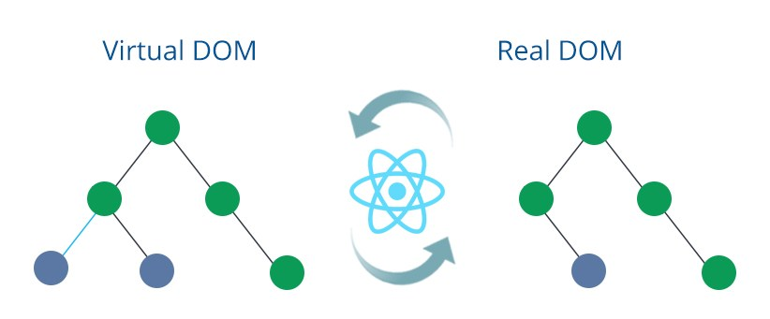

React.js uses a virtual DOM to improve processing speed. A virtual DOM is a JavaScript object; each object contains all the information needed to create a DOM; when data changes, it will calculate the change between the real object and tree, which will help optimize and re-render the real DOM tree.

## **2.3 Next.JS (version 12.2.x)**

### **2.3.1 What is Next.JS?**

Next.js is a React framework for developing single-page Javascript applications. The benefits of this framework are numerous, both for our client applications as well as for our development team.

Inside the next project, we have a page directory; each JavaScript file defined here exports a React component that represents a route in the application.

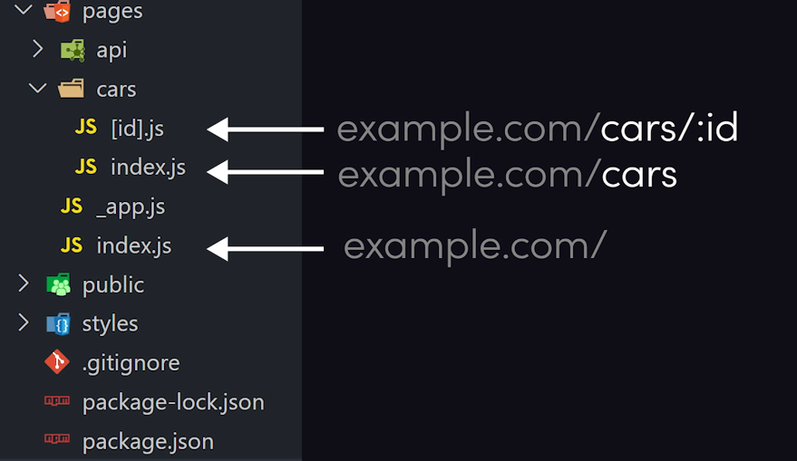

In other words, the file structure here mirrors the actual URLs that the user will navigate to, and next it provides its router to make navigation seamless. Unlike traditional React, we need to use third-party "react-router-doom."

* **page folder:** use to create a new page, and then we can navigate to it.
* **public folder:** React is used to store static files like images, SVG, etc.
* **CSS or SCSS files are stored in the styles folder...** (We'll use this to style our app or component files.)
* **Use the API folder (inside the page folder) to create an API route.**

### **2.3.2 API Routes**

API routes provide a solution for building APIs with Next.js.

For example, the following API route, "pages/api/user.js," returns a JSON response with a status code of 200:

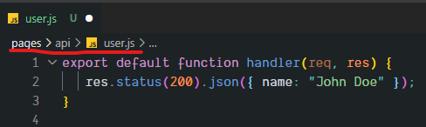

We use next-connect, that library was designed to work with API routing in Next.js

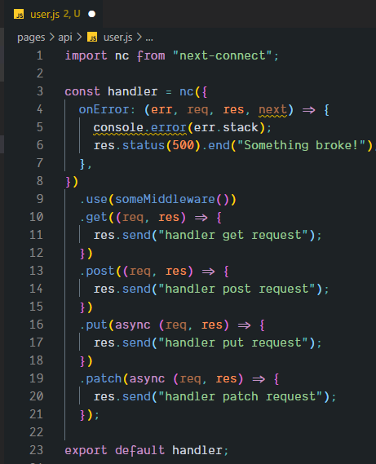

That library helps us recognize the verb in the request (GET, PUT, POST, etc.) more easily, and we can add some middleware (use()) to pre-handle something or have a central place (onError) to handle errors when they occur in our API.

### **2.3.3 Data Fetching**

We can choose which pre-rendering form to use for each page in Next.js because, by default, all pages are pre-rendered at build time (but not using useEffect, which only runs on the client side); currently, we have four strategies that render page

**CSR client-side rendering**

- Our page and data only render or fetch in the browser.

**SSG static site generation**

* Our HTML page is generated at build time and then reused for each request, which is easily hosted.
* We can fetch some external data to generate that page with that data.

**SSR server-side rendering**

* Like SSG, but instead of generating a page at build time, it generates a new HTML page on every request. This strategy will be slower than SSG, but our page will always be the newest.
* Our page and its contents will be rendered or fetched on the server in advance and then sent to the browser.

**ISR incremental static regeneration**

* Something between SSR and SSG
* We can create or update static pages without needing to rebuild the entire site by simply adding a "revalidate" option to them.

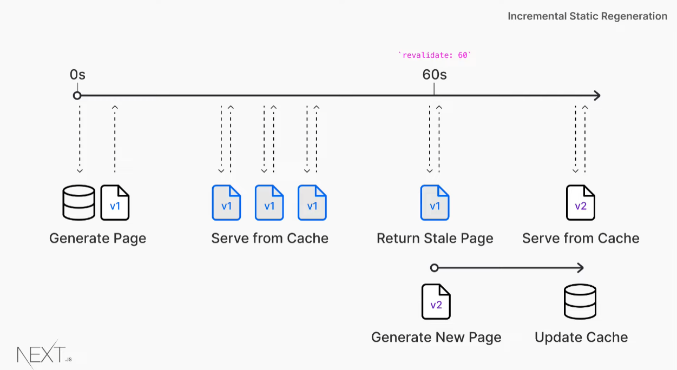

For example, if we set it to 60 seconds when a request comes in and it's within that 60-second period, it will just reuse that same existing HTML that's been statically generated at build time. After that, the next request that comes in will still give us a stale page, but the next request will recognize that we have stale data, so it will regenerate that page in the background, and from now on, the subsequent request after that will go and give us a new page with the new data that's been fetched.

**On-Demand Incremental Static Regeneration**

• Similar to incremental static regeneration (ISR)

• Can force the site to rebuild when we update our site or database without the user visiting it

### **2.3.4 Automatic code splitting**

Next.js is clever enough to only load the JavaScript and CSS that are needed for any given page. This makes for much faster page loading times, as a user’s browser doesn't have to download JavaScript and CSS that it doesn't need for the specific page the user is viewing. This increases performance as there is less for the user’s browser to download, and the user benefits from seeing the page content quicker.

### **2.3.5 Hot Module Replacement (HMR)**

HMR allows developers to see any changes they have made during development live in the application as soon as they have been made. The positive impact for our clients is that it takes us less time to develop because there are development efficiencies to be gained.

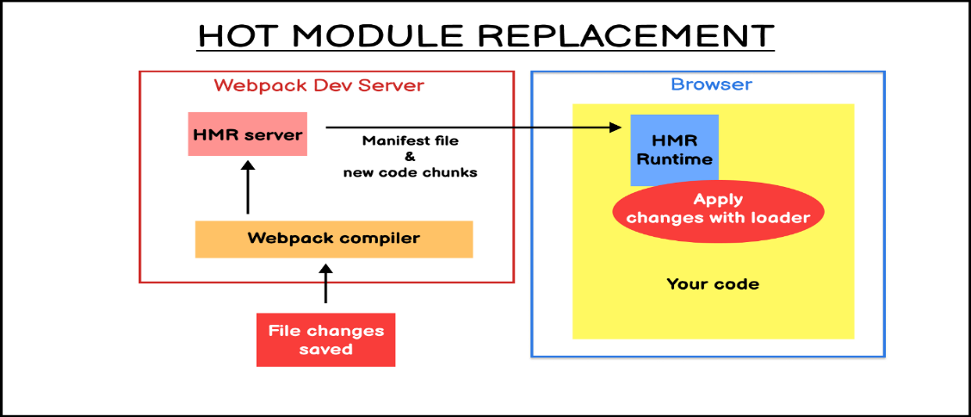

## **2.4 MongoDB**

### **2.4.1 What is MongoDB?**

MongoDB is one of the most popular open-source NoSQL databases written in C++. It is also a document-oriented database that stores data in JSON-like documents with a dynamic schema. It means that we can store our records without having to worry about data structure issues such as the number of fields or the types of fields used to store values. MongoDB documents are similar to JSON objects.

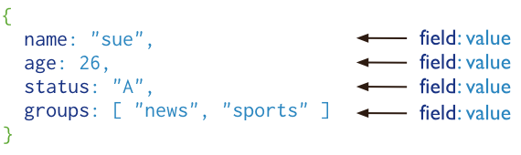

### **2.4.2 Why should we use MongoDB?**

Since MongoDB is a NoSQL database. In normal circumstances, MongoDB is always preferred by the developers or project managers when our main concern is dealing with a large volume of data with high performance. If we want to insert thousands of records in a second, then MongoDB is the best choice for that. Also, horizontal scaling (adding new columns) is not an easy process in any RDBMS system. But in the case of MongoDB, it is very easy since it is a schema-less database. Also, this type of work can be directly handled by the application automatically. There is no need for any type of administrative work to perform any type of horizontal scaling in MongoDB.

**MongoDB is good for the below types of situations:**

* Product-based applications based on e-commerce
* Blog and Content Management Systems
* High-speed logging, caching, etc. in the real-time
* Need to maintain location-wise geospatial data
* For maintaining data related to the social and networking types
* If the application is a loosely coupled mechanism, the design may change at any point in time.

## **2.5 Tailwind CSS (version 2)**

### **2.5.1 What is Tailwind CSS?**

Tailwind CSS is a "utility-first" CSS framework that provides a deep catalog of CSS classes and tools that lets us easily get started styling our website or application.

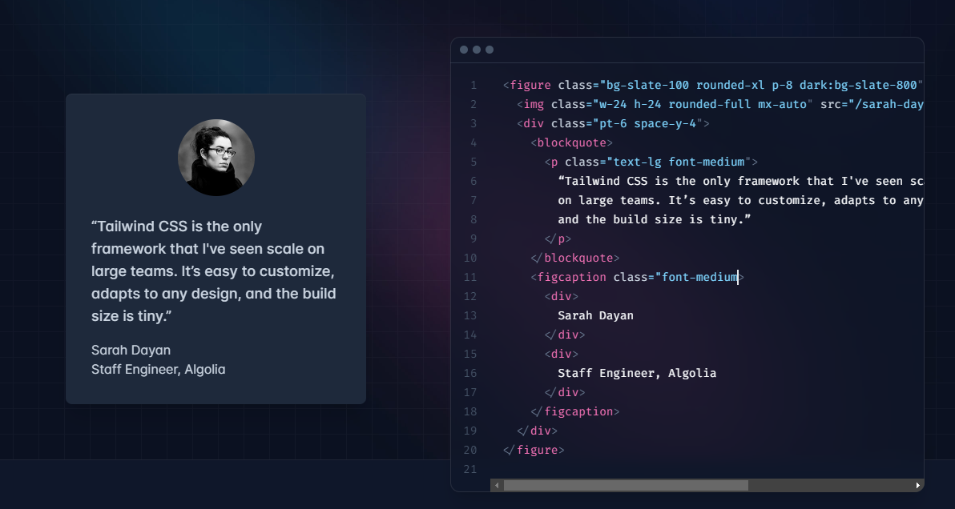

The underlying goal is that as we are building our project, we don't need to come up with a name for every class we make just use the utility class of tailwind and the tailwind class name is very descriptive.

### **2.5.2 Why should we use Tailwind CSS?**

* Provide a wide range of CSS classes, each with a specific purpose.
* Easy to use if we are familiar with CSS, it has an extension to help suggest class names.
* Highly Customizable

Instead of a class called "btn, which is created with a bunch of CSS attributes directly, in Tailwind, we would either apply a bunch of classes like "bg-blue-500 py-2 px-4 rounded" to the button element or build a "btn class by applying those utility classes to that selector.

## **2.6 Ant Design (version 4)**

### **2.6.1 What is Ant Design?**

Ant Design is a React UI library that has a plethora of easy-to-use components that are useful for building elegant user interfaces.

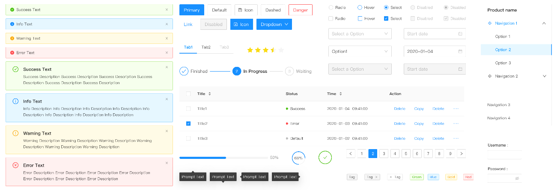

### **2.6.2 Why should we use Ant Design?**

* Ant Design has rich components which are easily customizable.
* Written in TypeScript with predictable static types.
* Has very good documentation
* It's popular and gets a good community support

## **2.7 Redux toolkit**

### **2.7.1 What is Redux?**

Redux is simply a store to store the state of the variables in our application. Redux creates a process and procedures to interact with the store so that components will not just update or read the store randomly.

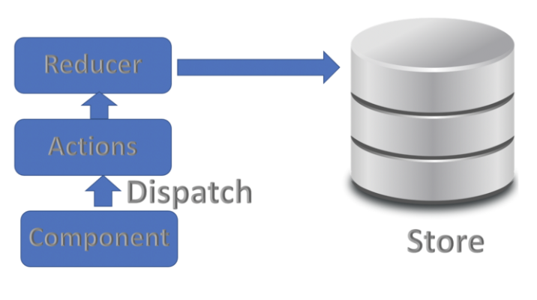

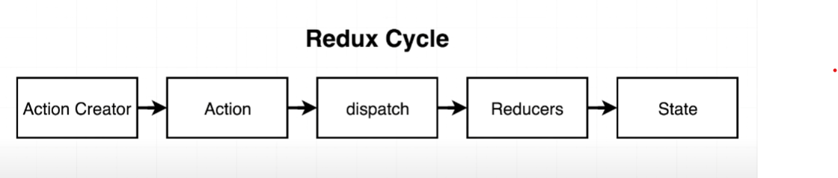

In Redux we don't update the state directly but we use the dispatcher function to dispatch some action which will tell the reducer to do its job to update the state.

### **2.7.2 React with Redux**

Because Redux's mechanism is that we will have a central store that stores all of our application's states, whenever a component needs to use that piece state, they will be able to do so easily. That's why this concept works very well with React.

### **2.7.3 Redux toolkit**

The Redux Toolkit package is intended to be the standard way to write Redux logic. It is also written by the Redux team, the same concept as Redux but it has some benefits over Redux

* Much less boilerplate code is required than Redux.
* Can change state instead of always returning new state in Redux
* There is thunk in the core package, so we don't have to install another third-party library to do async operations

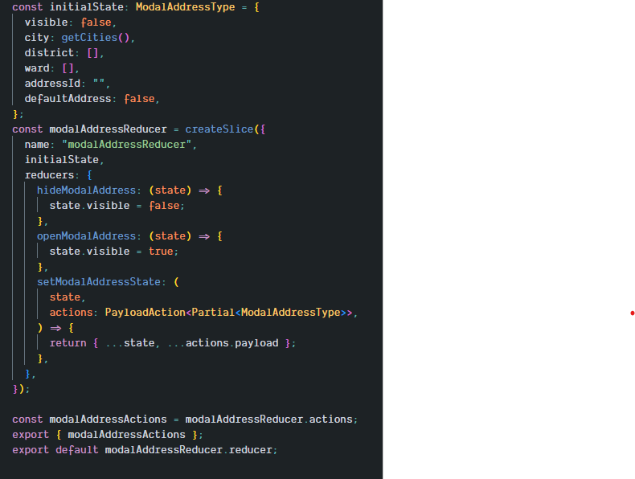

With the Redux toolkit, we just need to use the function createSlice and implement all the state change logic in the reducer, and then it will automatically generate all the functions (hideModalAddress, openModalAddress, and setModalAddressState) that we can use to dispatch that function to update our application state without having to set up multiple types of action strings and a reducer to handle this type of action.

## **2.8 React query (version 3)**

### **2.8.1 What is React query?**

React Query is hands down one of the best libraries for managing server states. It allows us to defeat and overcome the tricky challenges and hurdles of server state and control your app.

### **2.8.2 Two important hooks in React query**

There are two hooks in React queries that we use the most, which are useQuery and useMutation hook

* **useQuery:** commonly used to get data from the server (GET)

**data:** data returned from the query.

**isLoading:** to see if the query is fetching or not; based on this variable, we can update the UI while it fetches, like for a spinning effect.

**isError:** to see if an error occurred during the fetch.

**error:** If an error occurs, display the error name.

* **useMutation:** commonly used to update or post data to the server (POST, PUT PATCH, or DELETE).



**isLoading:** to see if we called the mutate function and it's executing or done; based on this variable, we can update the UI, like for a spinning effect.

**mutate:** The mutation function you can call with variables to trigger the mutation.

### **2.8.3 Why should we use React query?**

* It is easy to use
* We don't have to deal with useEffects or create multiple states to control our query.
* The application is almost always updated with the most recent server state.

### **2.8.4 Compare React query and useSWR?**

useSWR works like React query; the main difference is that useSWR's bundle size is lighter than React query because it has fewer features, whereas React query comes with dedicated dev tools with which we can monitor or view the data we have fetched.

## **2.9 GHN API**

The GHN API is one of the most popular shipping methods in Vietnam.

* It is easy to set up.
* High accuracy
* It has very good documentation.
* It's popular and gets good community support.

## **2.10 Chat Facebook Plugin**

### **2.10.1 What is Chat Facebook Plugin?**

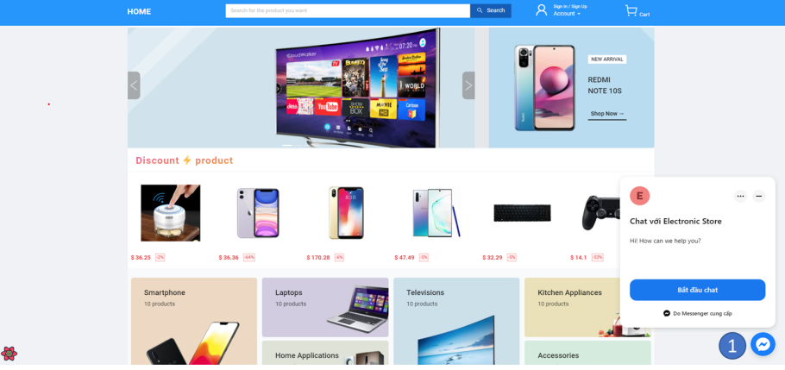

Chat Plugin is a tool that we can embed on our website to allow visitors to chat with you. We can use the chat to answer questions about pricing or products, book appointments, or provide customer support.

### **2.10.2 Why should we use Chat Facebook Plugin?**

* A lot of people use Facebook messenger to chat
* Communicating with customers is easier
* It's popular and gets a good community support

## **2.11 Product Recommendation**

In this project, we use a collaborative filtering algorithm to recommend products based on categories and other users' tastes. It is a technique that can filter out items that a user might like based on reactions by similar users.

For example, when a user visits a product on television, we will first obtain a list of products in the same category, and then, based on the preferences of other users who also like this product, we will suggest additional products that you may be interested in.

The input should be an array matrix that defines the product in the database that the user liked. It should be in the form of a matrix with 0s (not liked) and 1s (liked the product).

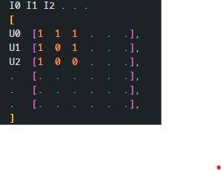 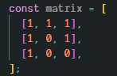

* I0, I1, I2 are products
* U0, U1, U2 are users

If you want to get the list of product recommendations of user 2 with information that you like product 1, the order of products in the list of suggestions will be product 2 and then product 1 [2,1].

## **2.12 ChatBot**

In this project, we create a chatbot using the ChatGPT package on npm that uses the official OpenAI completion API with a leaked model that ChatGPT uses under the hood.

We just need to create an OpenAI account to get their key and use it to request on their server for a response message, but we must use a phone number that hasn't verified any of the accounts to get the free tier for 18 dollars.

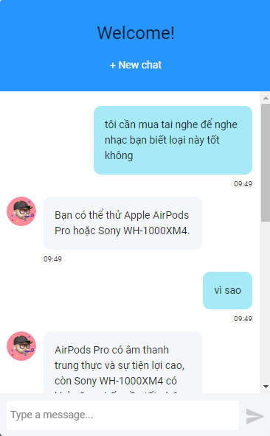 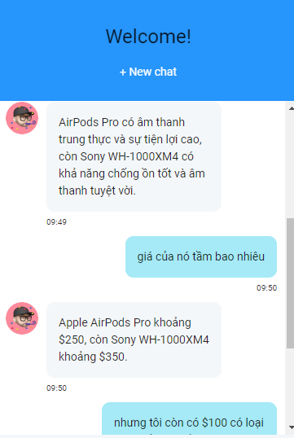 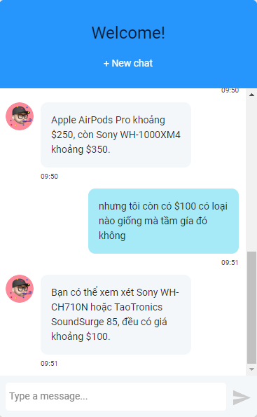

# **CHAPTER 3: MODELIZED REQUIREMENT**

## **3.1 Identify actors and use case in use case diagram:**

|  |  |
| --- | --- |
| **Actors** | **Use cases** |
| Customer | * Sign In / Sign Up * Forgot Password * Change Password * Edit Profile * View Order Status * View Order History * View Recommended Items * View Order Tracking * Search Product * Filter product * Add/Edit/Delete Product to Cart * Add/Delete Product to Wish List * Add/Update/Delete Address * Cancel Order * Apply Gift Code * Write Review * Add/Reply comment * Checkout * ChatBot, ChatBox * Chat Facebook Plugin * Compare Products |
| Administrator | * Login * Forgot Password * User Management * Order Management * Product Management * Review Management * Coupon Management * View sales statistics * Chat Facebook Management |

Table 3‑1. List of Actors and Use cases

## **3.2 Describe in detail each use case and actors:**

### **3.2.1 Describe actors:**

|  |  |
| --- | --- |
| **Actors** | **Use cases /** **Responsibility** |
| Customer | * Login in the website. * Allow customers change/forgot password * Edit customer information * Can view order status * Can view transaction history * Can view all previous review * Can view recommended items * Product searching * Can filter product * Can manage your product in the cart * Can manage your product on the wish list * Can apply gift code * Add/Update/Delete Address * Cancel Order * Apply Gift Code * Write Review * Add/Reply comment * Checkout * ChatBot, ChatBox * Chat Facebook Plugin * Compare Products |
| Administrator | * Login to the website * Allow manager forgot password * Can manage the products * Can manage the gift code * Can update the order status * Can manage the user * Can manage the review * View sales statistics * Chat Facebook Management |

Table 3‑2. Describe actors

### **3.2.2 Describe use cases:**

|  |  |  |
| --- | --- | --- |
| **Order** | **Use cases** | **Description** |
| 1 | Search Product | Customers can find exactly the products they want |
| 2 | Add Comment | Customers can write comments for the product |
| 3 | Reply Comment | Customers can reply to comments for the product |
| 4 | Add/Edit/Delete to cart | Customers can manage the products in the cart |
| 5 | Add/Delete to wish list | Customers can manage the products on the wish list |
| 6 | View Order Tracking | Customers can view order tracking |
| 7 | Payment | Customers can choose different types of payments |
| 8 | View order history | Customers can view order history based on transacted invoices |
| 9 | Sign up | Customers can register to the website. |
| 10 | Sign In | Customers can log in to the website. |
| 11 | Forgot Password | In case the customer forgets the password, it can be recovered via email or phone number verification |
| 12 | Add/Update/Delete address | Customers can manage their address |
| 13 | Cancel Order | Customers can cancel the order if the status of the order is not packed yet |
| 14 | Edit Profile | Customers can edit their information |
| 15 | Change password | Customers can change their password |
| 18 | Apply gift code | Customers can apply the gift code to get a discount |
| 19 | View discount product | Customers can view the list of discount products |
| 20 | View recommended product | Customers can view a list of recommended products |
| 21 | Filter product | Customers can filter products |
| 22 | Chat Facebook Plugin | Customers can get help from the admin |
| 23 | Search Product | The administrator can find exactly the products |
| 24 | Create Product | The administrator can create the products |
| 25 | Edit Product | The administrator can update the products |
| 26 | Delete Product | The administrator can delete the products |
| 27 | Update Order Status | The administrator can update the order status |
| 28 | View sales statistics | The administrator can view sales statistics depending on revenue, warehouse, access times |
| 29 | User management | The administrator can manage the users |
| 30 | Coupon management | The administrator can manage the users |
| 31 | Reply review | The administrator can reply review |
| 32 | Hide/unhide comment | The administrator can hide or unhide comment |
| 33 | View customer order | The administrator can view the order of the customer |
| 34 | Chat Facebook Management | The administrator can interact with users |
| 35 | Chatbot | The customer can ask questions about the product |
| 36 | Compare Products | The customer can compare products |

Table 3‑3. Describe use cases

# **CHAPTER 4: SOFTWARE DESIGN**

## **4.1 Use case Diagram**

### **4.1.1 Use case Overview**

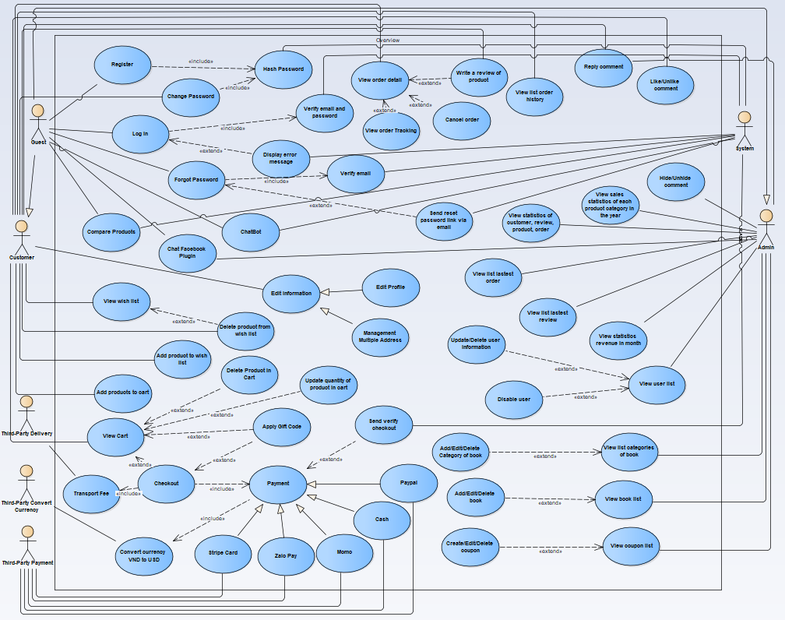

**Figure: Use case overview diagram**

### **4.1.2 Account**

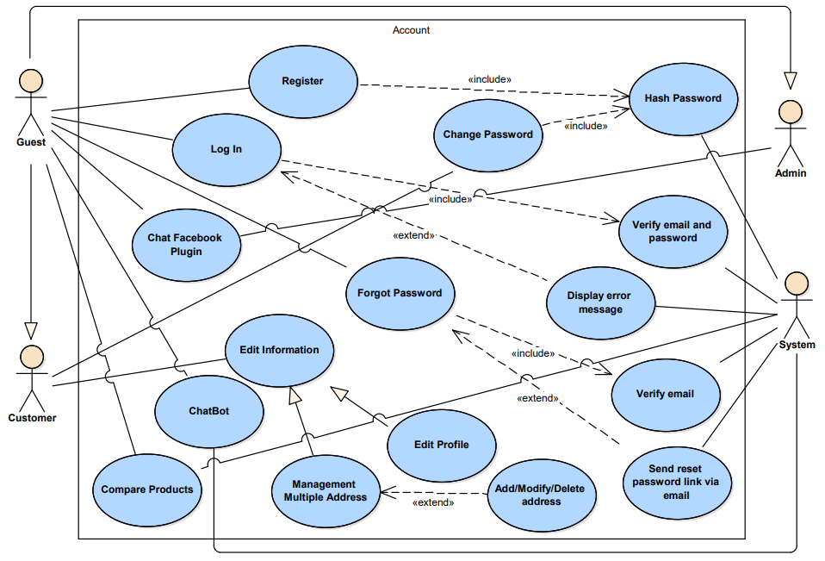

**Figure: Account use case diagram**

### **4.1.3 Wish List**

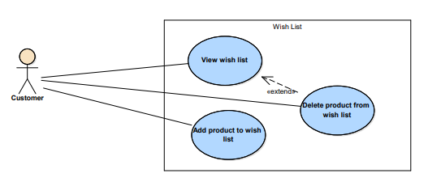

**Figure: Wish list use case diagram**

### **4.1.4 Cart**

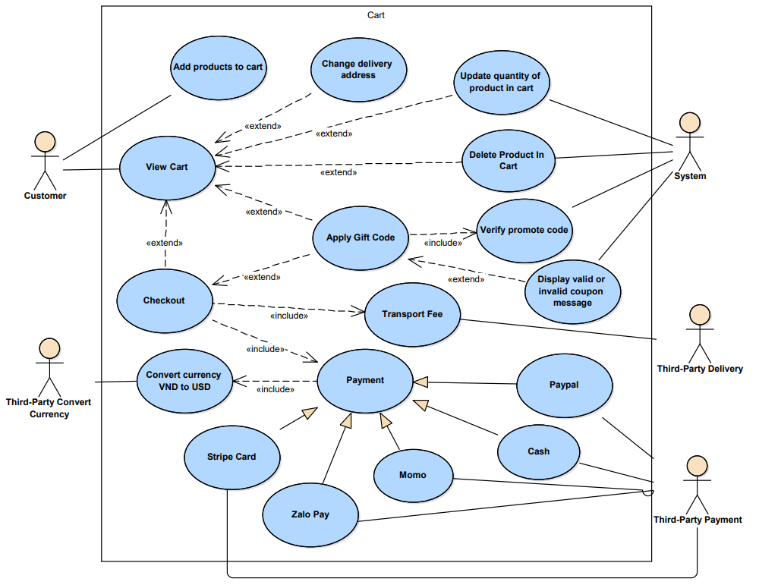

**Figure: Cart use case diagram**

### **4.1.5 Order**

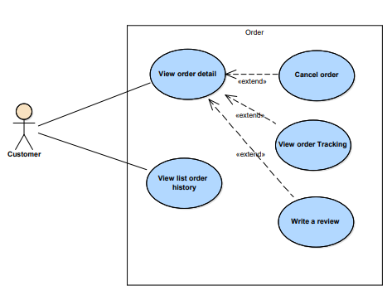

**Figure: Order use case diagram**

### **4.1.6 Review**

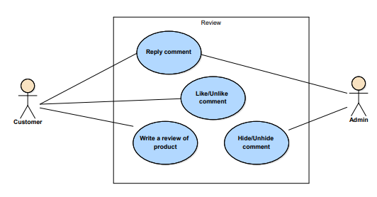

**Figure: Review use case diagram**

### **4.1.7 Dashboard**

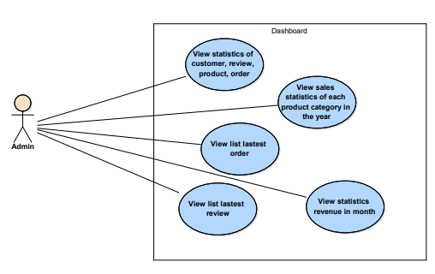

**Figure: Dashboard use case diagram**

### **4.1.8 Management**

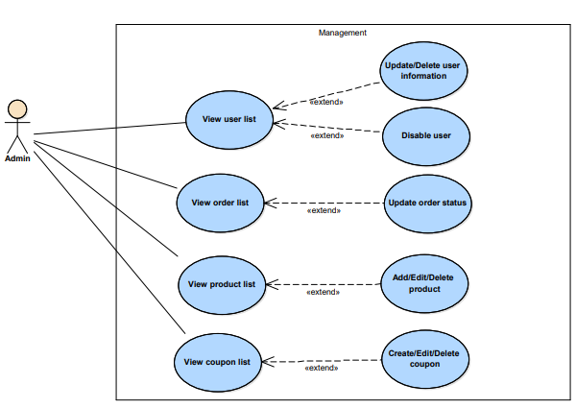

**Figure: Management use case diagram**

## **4.2 Specification**

### **4.2.1 Sign In**

|  |  |
| --- | --- |
| **Use Case Sign in** | |
| **Description** | Allow Customers to log into the system |
| **Activation agent** | Customer |
| **Pre-conditions** | Customers know the login account and password |
| **Step to be taken** | (1) The customer opens the website  (2) Hover on Account  (3) Click on “Sign In”  (4) Enter the username and password  (5) Press the “Login” button or press Enter  If login fails, the message "Wrong username or password". The customer re-entered the information and logged in again  (6) If enter a valid username and password it will show message login successfully |

### **4.2.2 Sign Up**

|  |  |
| --- | --- |
| **Use Case Sign up** | |
| **Description** | Allow Customers to create an account to login the system |
| **Activation agent** | Customer |
| **Pre-conditions** | none |
| **Step to be taken** | (1) The customer opens the website  (2) Hover on Account  (3) Clicks on “Sign up”  (4) Enter the username, password and confirm  (5) Clicks on “Register”  (6) If an email exists, the customer must input another email or password that does not match the customer should enter it again  (7) If valid email and the password match it will show message register successfully |

### **4.2.3 Forgot Password**

|  |  |
| --- | --- |
| **Use Case for Customer If they Forgot Password** | |
| **Description** | Allow Customers to reset their password |
| **Activation agent** | Customer |
| **Pre-conditions** | none |
| **Step to be taken** | (1) The customer opens the website  (2) Hover on Account  (3) Click on “Sign In” or “Sign Up”  (2) Clicks on “Forgot password”  (3) Enter the email  (4) Click "Click send to email"  (5) If the wrong email or email does not exist it will show message invalid email  (6) If valid email it will send a link to reset the password to this email |

### **4.2.4 Reset Password**

|  |  |
| --- | --- |
| **Use Case for Customer Reset Password** | |
| **Description** | Allow Customers to reset their password |
| **Activation agent** | Customer |
| **Pre-conditions** | none |
| **Step to be taken** | (1) The customer opens the website  (2) Hover on Account on the header  (3) Click on “Sign In” or “Sign Up”  (2) Clicks on “Forgot password”  (3) Enter the email  (4) Click "Click send to email"  (5) If the wrong email or email does not exist it will show message invalid email  (6) If valid email it will send a link to reset the password to this email  (7) Login email you had sent  (8) Click the link and input password to reset the password  After getting the password is changed and showing the successful message and the user who is currently logged into an account somewhere else need to re-login to verify, the process is finished |

### **4.2.5 Add Address**

|  |  |
| --- | --- |
| **Use Case for Customer to Add address** | |
| **Description** | Allow Customers to add the address |
| **Activation agent** | Customer |
| **Pre-conditions** | Customer login successfully |
| **Step to be taken** | (1) The customer opens the website  (2) The customer inputs correctly username and password for authentication  (3) Hover on Account  (4) Click on “My Account”  (5) Click on Address  (6) Click on “Add address”  (7) Input all fields for add address  (8) If you want it to be your default address, click the “set default address” checkbox  (9) Clicks on “Save”  (10) The system will get data from the form and verify. If some fields do have not data, return a message to require input. Else Saving that data to the database.  After checking valid input will show a successful message, the process is finished |

### **4.2.6 Search Product**

|  |  |
| --- | --- |
| **Use Case for Customer to Search Product** | |
| **Description** | Allow Customers for searching product |
| **Activation agent** | Customer |
| **Pre-conditions** | none |
| **Step to be taken** | (1) The customer opens the website  (2) Input the name of the product on the header  (3) Clicks on “Search” or relative name  (4) The system will get data from the input field and find data of product based on customer input. And the system will save your search history on local storage  (5) The system will show the search results to the customer |

### **4.2.7 Recommended Product**

|  |  |
| --- | --- |
| **Use Case for Customer to View recommended items** | |
| **Description** | Allow Customers for viewing their recommended items |
| **Activation agent** | Customer |
| **Pre-conditions** | none |
| **Step to be taken** | (1) The customer opens the website  (2) Select product  (3) The system will get a list of related products which generated by using Collaborative Filtering algorithm. |

### **4.2.8 Filter Product**

|  |  |
| --- | --- |
| **Use Case for Customer to Filter Product** | |
| **Description** | Allow Customers to filter product |
| **Activation agent** | Customer |
| **Pre-conditions** | none |
| **Step to be taken** | (1) The customer opens the website  (2) Click on “Shop now”  (3) Choose filter by product category, rating, or price product  (4) The system will get a list products filter and display for customer |

### **4.2.9 Add Product to Wish List**

|  |  |
| --- | --- |
| **Use Case for Customer to Add product to wish list** | |
| **Description** | Allow Customers to add a product to wish list |
| **Activation agent** | Customer |
| **Pre-conditions** | Customer login successfully |
| **Step to be taken** | (1) The customer opens the website  (2) The customer inputs correctly username and password for authentication  (2) Click on a product  (3) Click icon heart to add a product to the wish list  (4) The system will get a list of products customers liked and display for the customer |

### 

### **4.2.10 View Cart**

|  |  |
| --- | --- |
| **Use Case for Customer to Add to Cart** | |
| **Description** | Allow Customers to view their cart |
| **Activation agent** | Customer |
| **Pre-conditions** | Customer login successfully |
| **Step to be taken** | 1. The customer opens the website   (2) The customer inputs correctly username and password for authentication  (3) Clicks “Cart” on the header  (4) The system will display your cart |

### **4.2.11 Add to Cart**

|  |  |
| --- | --- |
| **Use Case for Customer to Add to Cart** | |
| **Description** | Allow Customers for adding products to the cart |
| **Activation agent** | Customer |
| **Pre-conditions** | Customer login successfully |
| **Step to be taken** | (1) The customer opens the website  (2) The customer inputs correctly username and password for authentication  (3) Clicks on a product  (4) Clicks on the “Add to cart” button  (5) The product will be saved on their cart in the database and displayed message add to cart successfully  (6) The system will update the number of products in the cart on the header |

### **4.2.12 Apply Gift Code**

|  |  |
| --- | --- |
| **Use Case for Customer to Apply Gift Code** | |
| **Description** | Allow Customers to apply gift code |
| **Activation agent** | Customer |
| **Pre-conditions** | Customer login successfully |
| **Step to be taken** | (1) The customer opens the website  (2) The customer login account  (3) Clicks on “Cart”  (4) Input promotion code  (5) Click on “Apply”  (6) The system will check for valid codes. If valid will display a valid coupon message otherwise will display an invalid coupon message |

### **4.2.13 Payment by PayPal**

|  |  |
| --- | --- |
| **Use Case for Customer to Payment by PayPal** | |
| **Description** | Allow Customers for payment by PayPal |
| **Activation agent** | Customer |
| **Pre-conditions** | Customer login successfully |
| **Step to be taken** | (1) The customer login account  (2) Clicks on “Cart”  (3) Select products that customers want to buy  (4) Clicks on “Checkout”  (5) Selected payment by PayPal  (6) Login PayPal account to pay  (7) If payment success the system creates an order and will show message order as successful |

### **4.2.14 Payment by Stripe Card**

|  |  |
| --- | --- |
| **Use Case for Customer to Payment by Stripe card** | |
| **Description** | Allow Customers for payment by Stripe card |
| **Activation agent** | Customer |
| **Pre-conditions** | Customer login successfully |
| **Step to be taken** | (1) The customer login account  (2) Clicks on “Cart”  (3) Select products that customers want to buy  (4) Clicks on “Checkout”  (5) Selected payment by Stripe card  (6) Input valid Stripe card number  (7) If payment success the system creates an order and will show message order as successful |

### **4.2.15 Payment by ZaloPay**

|  |  |
| --- | --- |
| **Use Case for Customer to Payment by ZaloPay** | |
| **Description** | Allow Customers for payment by ZaloPay |
| **Activation agent** | Customer |
| **Pre-conditions** | Customer login successfully |
| **Step to be taken** | (1) The customer login account  (2) Clicks on “Cart”  (3) Select products that customers want to buy  (4) Clicks on “Checkout”  (5) Selected payment by ZaloPay  (6) Scan QR code  (7) If payment success the system creates an order and will show message order as successful |

### **4.2.16 Payment by Momo**

|  |  |
| --- | --- |
| **Use Case for Customer to Payment by Momo** | |
| **Description** | Allow Customers for payment by Momo |
| **Activation agent** | Customer |
| **Pre-conditions** | Customer login successfully |
| **Step to be taken** | (1) The customer opens the website  (2) The customer login account  (3) Clicks on “Cart”  (4) Select products that customers want to buy  (5) Clicks on “Checkout”  (6) Selected payment by Momo  (7) Clicks on “Order”  (8) Scan QR code  (9) If payment success the system creates an order and will show message order as successful |

### **4.2.17 View Order History**

|  |  |
| --- | --- |
| **Use Case for Customer to View Order History** | |
| **Description** | Allow Customers to view order history |
| **Activation agent** | Customer |
| **Pre-conditions** | Customer login successfully |
| **Step to be taken** | (1) The customer opens the website  (2) The customer inputs correctly username and password for authentication  (3) Clicks on “Order Management”  (4) The system will get the data order history of this customer and display it as a table |

### **4.2.18 View Order Tracking**

|  |  |
| --- | --- |
| **Use Case for Customer to View Order Tracking** | |
| **Description** | Allow Customers to view order tracking |
| **Activation agent** | Customer |
| **Pre-conditions** | Customer login successfully |
| **Step to be taken** | (1) The customer login account  (2) Clicks on “Order Management”  (3) The system will get data of order history of this customer and display it as a table  (4) Click on icon search to view order detail  (5) Click on Order Tracking  (6) The system will get the order status of that order from the database and display it to the customer |

### **4.2.19 Reply Review**

|  |  |
| --- | --- |
| **Use Case for Admin to Reply Review** | |
| **Description** | Allow Admin for reply review |
| **Activation agent** | Admin |
| **Pre-conditions** | Admin must be login successfully |
| **Step to be taken** | (1) The admin login account  (2) Clicks on ‘‘Review”  (3) Click on “Reply” on review want to reply  (4) Write reply comment  (5) Click on “Send”  (6) The system will add reply comments to the database |

### **4.2.20 Cancel Order**

|  |  |
| --- | --- |
| **Use Case for Customer to View Cancel Order** | |
| **Description** | Allow Customers to cancel the order |
| **Activation agent** | Customer |
| **Pre-conditions** | Customer login successfully |
| **Step to be taken** | (1) The customer login account  (2) Clicks on “Order Management”  (3) The system will get data of order history of this customer and display it as a table  (4) Click on icon search to view order detail  (5) Click on Cancel Order  (6) The system will ask the customer to confirm  (7) If the customer clicks “Sure” the system will update the order status to “canceled” |

### **4.2.21 Chatbot**

|  |  |
| --- | --- |
| **Use Case for Customer to interact with system** | |
| **Description** | Allow Customer interact with system |
| **Activation agent** | Customer |
| **Pre-conditions** | none |
| **Step to be taken** | (1) The customer opens the website  (2) Clicks icon ‘‘Message”  (3) Enter text  (4) Click on “Send”  (5) The system will reply message |

### **4.2.22 Add Comment**

|  |  |
| --- | --- |
| **Use Case for Customer to Add Comment** | |
| **Description** | Allow Customers for adding a comment |
| **Activation agent** | Customer |
| **Pre-conditions** | Customer bought product |
| **Step to be taken** | 1. The customer opens the website   (2) The customer inputs correctly username and password for authentication  (3) Hover on Account  (4) Clicks on “Review purchased products” or click on “Order Management” and click on icon search to view order detail  (5) Clicks on “Write a review”  (6) Choose start rating and input comment of product  (7) The system will get data review of customers and display message create review successfully |

### **4.2.23 Reply Comment**

|  |  |
| --- | --- |
| **Use Case for Customer to Reply Comment** | |
| **Description** | Allow Customer for reply comment |
| **Activation agent** | Customer |
| **Pre-conditions** | The customer must be login successfully |
| **Step to be taken** | (1) The admin opens the website  (2) The admin login account  (3) Clicks on product and scroll down to “Review from Customer” part  (4) Click on “Comment” on review want to reply  (5) Write comment want reply review  (6) Click “Send” or press Enter on the keyboard  (7) The system will display reply comments of customer |

### **4.2.24 Update Order Status**

|  |  |
| --- | --- |
| **Use Case for Admin to Update Order Status** | |
| **Description** | Allow Admin for update order status |
| **Activation agent** | Admin |
| **Pre-conditions** | Admin must be login successfully |
| **Step to be taken** | (1) The admin opens the website  (2) The admin login account  (3) Clicks on ‘‘Order”  (4) Click on “Update”  (5) Select order status want update  (6) The system will update the order status in the database and display it for the admin |

### **4.2.25 Delete User**

|  |  |
| --- | --- |
| **Use Case for Admin to Delete User** | |
| **Description** | Allow Admin for delete user |
| **Activation agent** | Admin |
| **Pre-conditions** | Admin must be login successfully |
| **Step to be taken** | (1) The admin login account  (2) Clicks on ‘‘User”  (3) Hover to operation  (4) Click on “Delete”  (5) The system will display a message to confirm again before deleting.  (6) Click “Ok”  (7) The system will disable user and update list users for admin |

### **4.2.26 Compare Products**

|  |  |
| --- | --- |
| **Use Case for Customer compare products** | |
| **Description** | Allow Customers compare products |
| **Activation agent** | Customer |
| **Pre-conditions** | none |
| **Step to be taken** | (1) The customer opens the website  (2) Click on “Product Details” or “Product Categories”  (3) Click on “Compare”  (4) Add other products to compare  (5) Clicks on “Compare Product” |

### **4.2.27 Create Product**

|  |  |
| --- | --- |
| **Use Case for Admin to Create Product** | |
| **Description** | Allow Admin to create the product |
| **Activation agent** | Admin |
| **Pre-conditions** | Admin must be login successfully |
| **Step to be taken** | 1. The admin opens the website 2. The admin input the correct username and password for authentication   (3) Clicks on ‘‘Product’’  (4) Clicks on “Create product”  (5) The system displays the form of creating the product.  (6) Admin enter product information including upload image and add a description (Text, Image, Video)  (7) Click on “Create product”  (8) The system will get information of product and check the valid field  If there is no violation, it will show the message create product successfully |

### **4.2.28 Chat Facebook Plugin**

|  |  |
| --- | --- |
| **Use Case for Customer to interact with admin** | |
| **Description** | Allow Customer interact with admin |
| **Activation agent** | Customer |
| **Pre-conditions** | Customer must login with Facebook or Guest |
| **Step to be taken** | (1) The customer opens the website  (2) Clicks icon ‘‘Messenger”  (3) The customer must login with Facebook or Guest  (4) Enter text  (5) Click on “Send”  (6) The system will send message to admin |

### **4.2.29 Chat Facebook Management**

|  |  |
| --- | --- |
| **Use Case for Admin to support customer** | |
| **Description** | Allow Customer interact with admin |
| **Activation agent** | Customer |
| **Pre-conditions** | Customer must login with Facebook or Guest |
| **Step to be taken** | (1) The admin opens the website  (2) The admin inputs correctly username and password for authentication  (3) Access to ‘‘Chat Facebook Management”  (4) Click on “User Messages”  (4) Enter text  (5) Click on “Send” to reply customer  (6) The system will send message to customer |

## **4.3 Sequence Diagram**

### **4.3.1 Sign In**

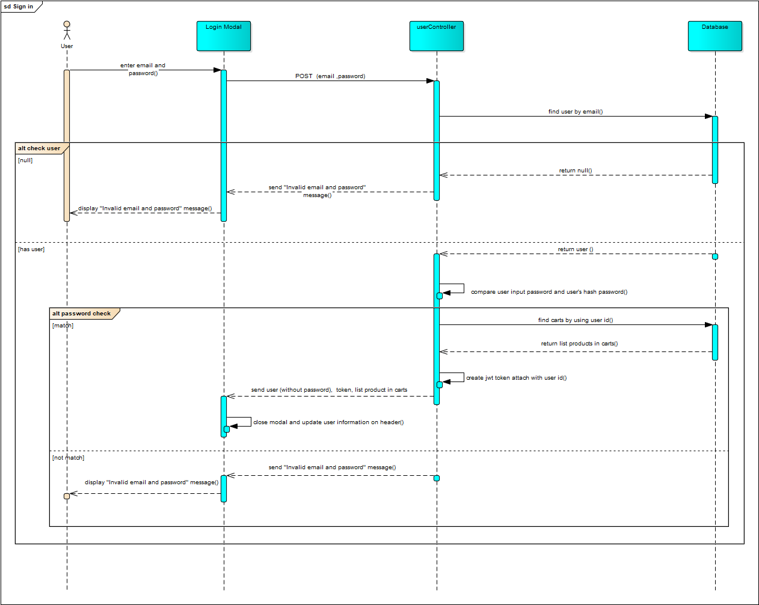

### **4.3.2 Sign Up**

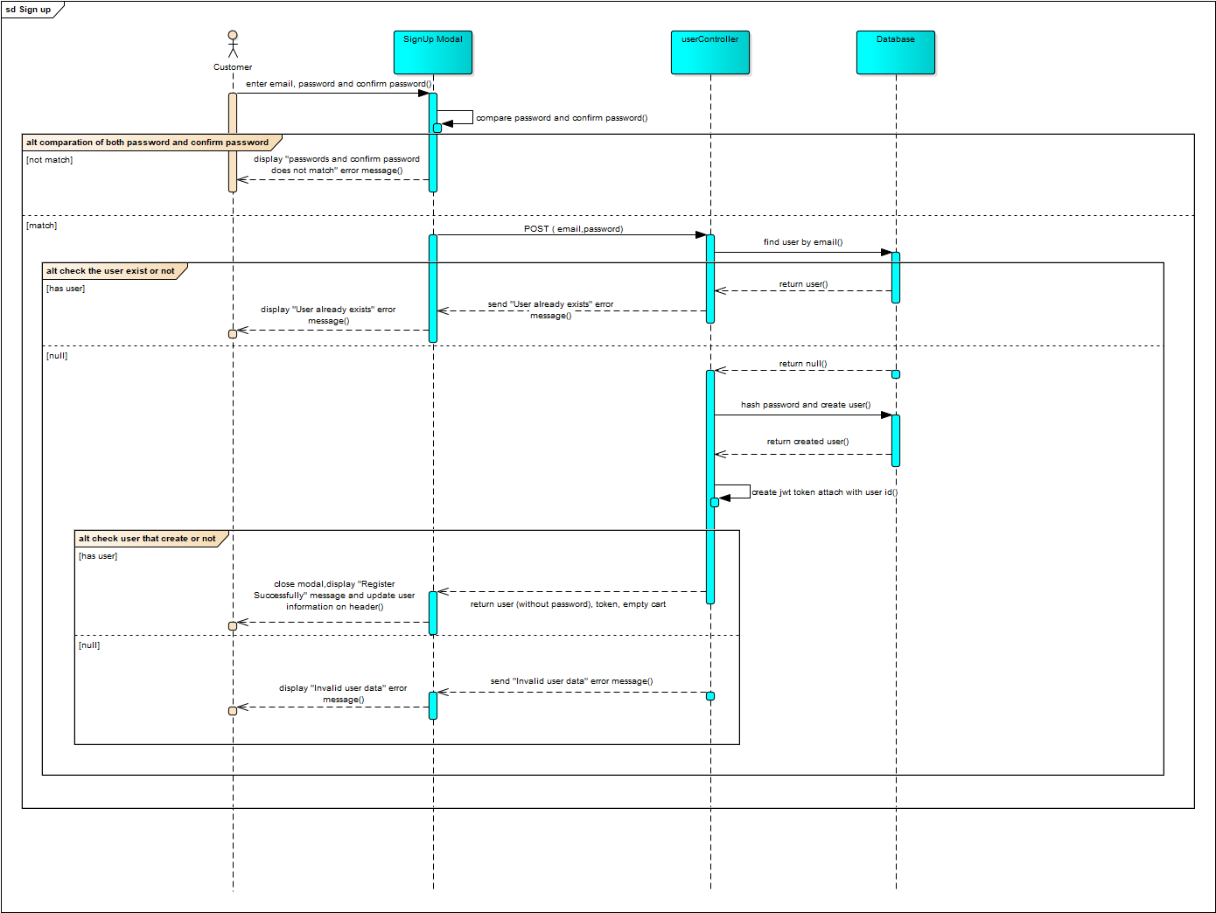

### **4.3.3 Reset Password**

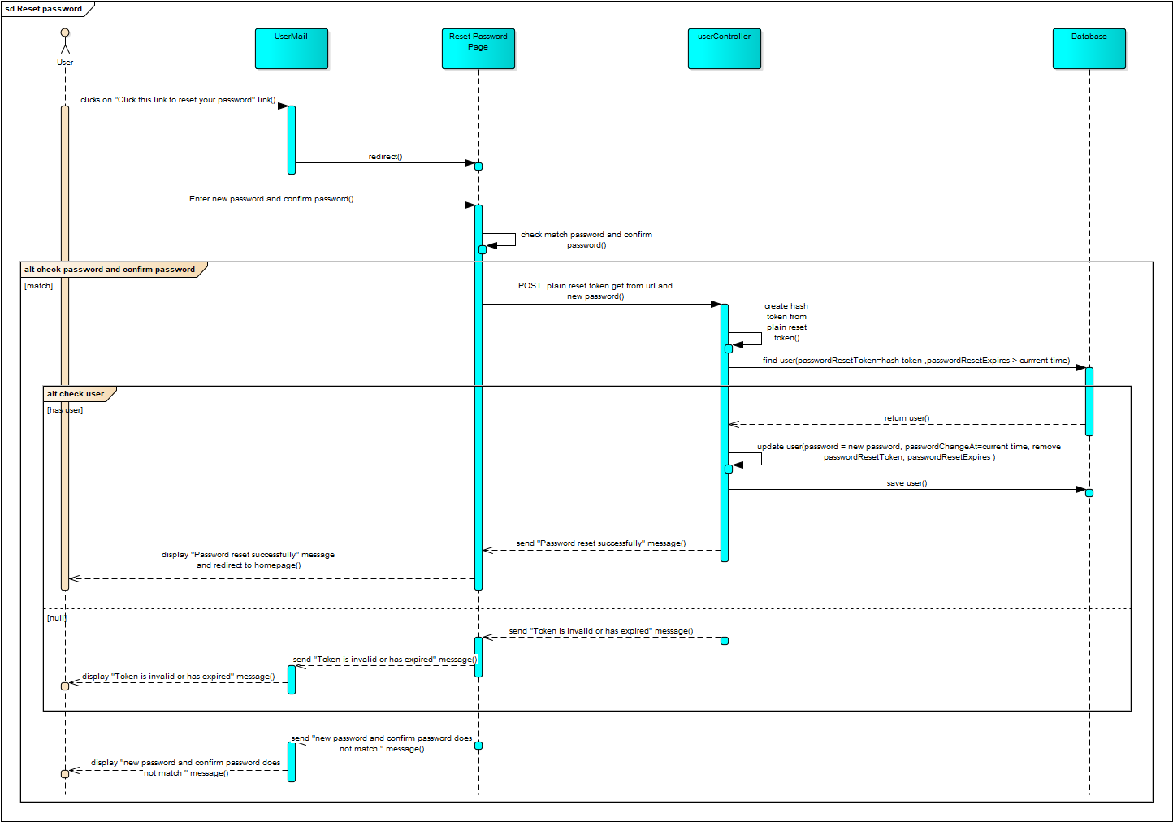

### **4.3.4 Forgot Password**

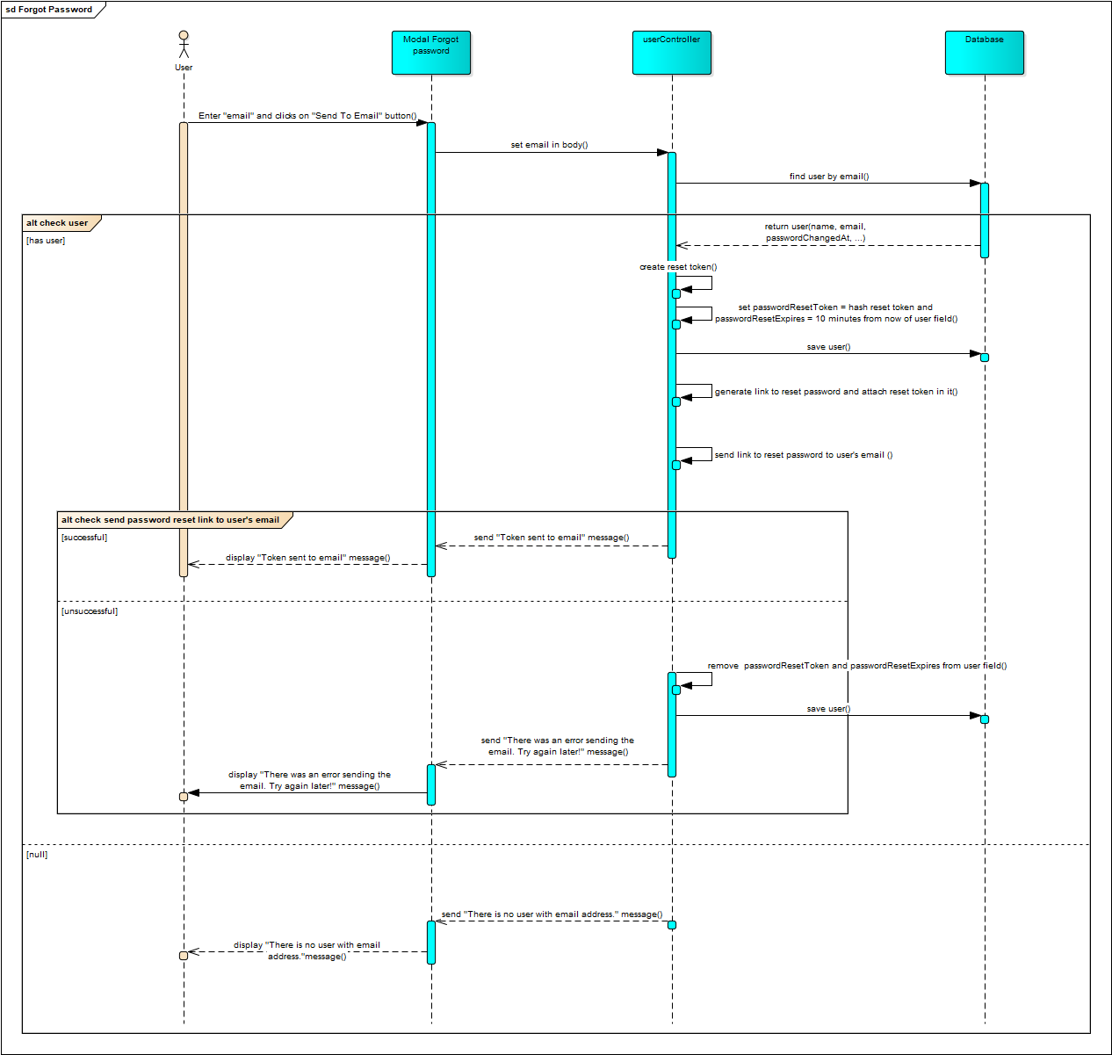

### **4.3.5 Add Address**

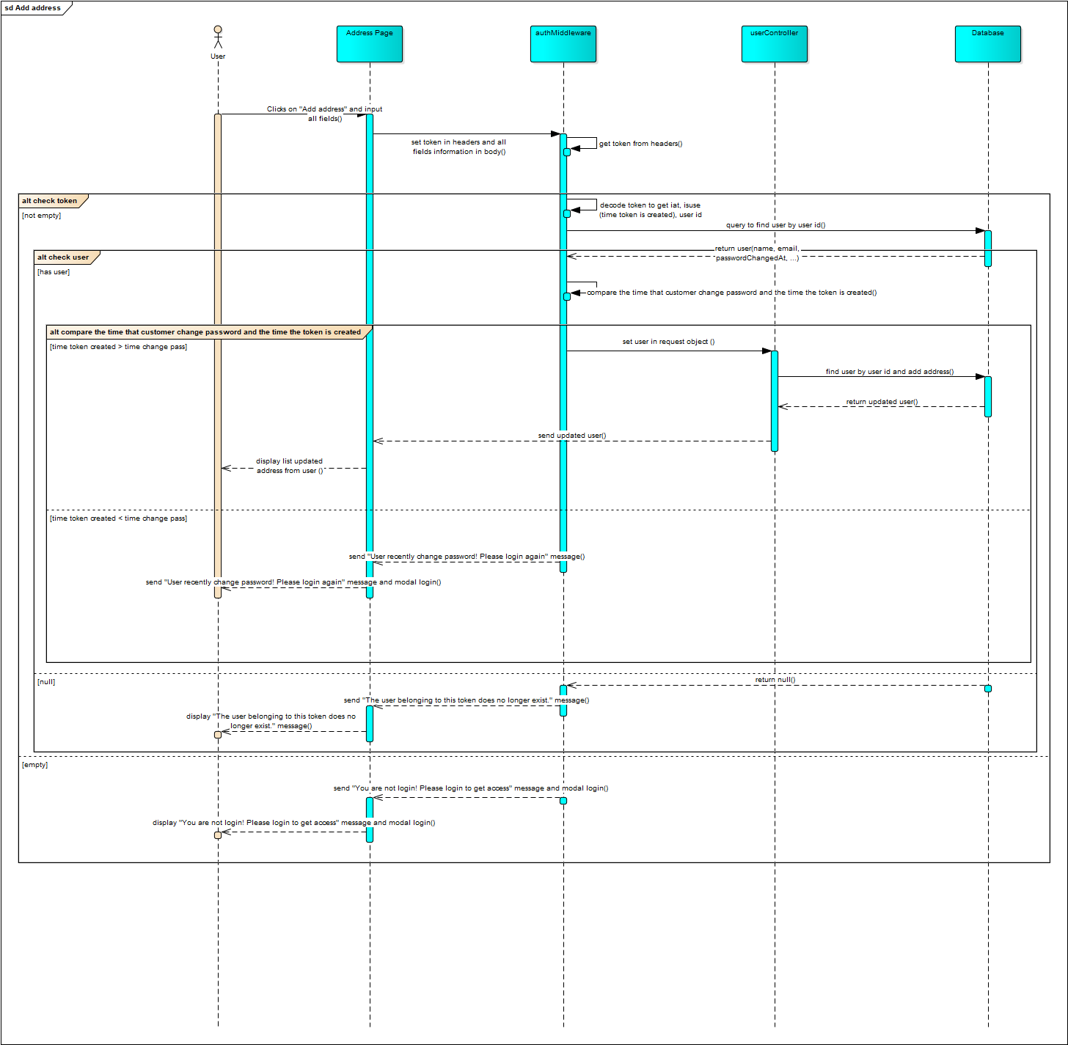

### **4.3.6 Search Product**

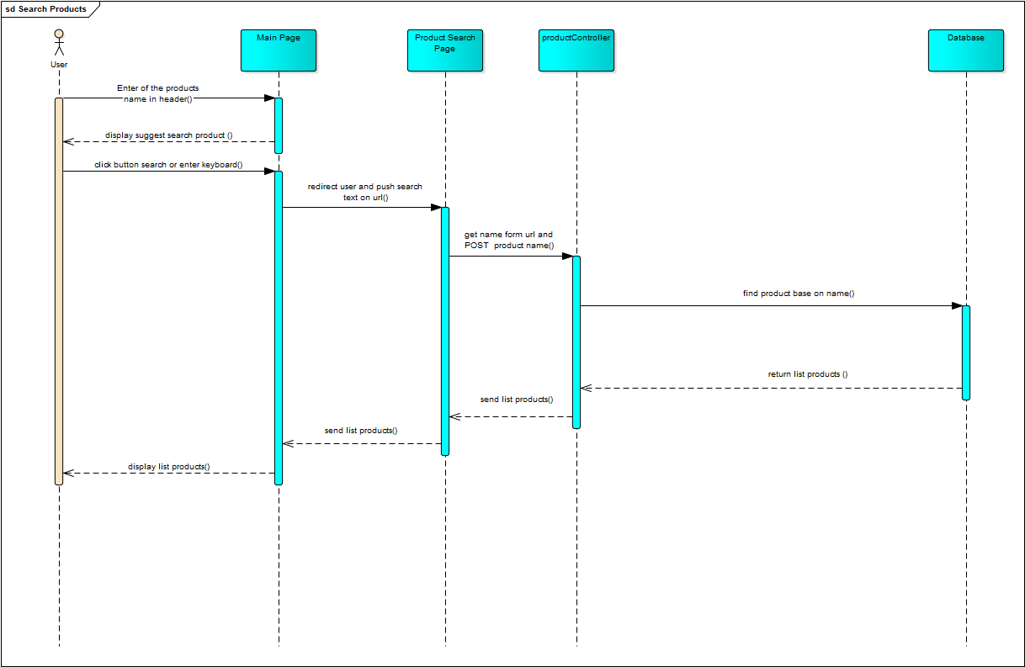

### **4.3.7 Recommended Product**

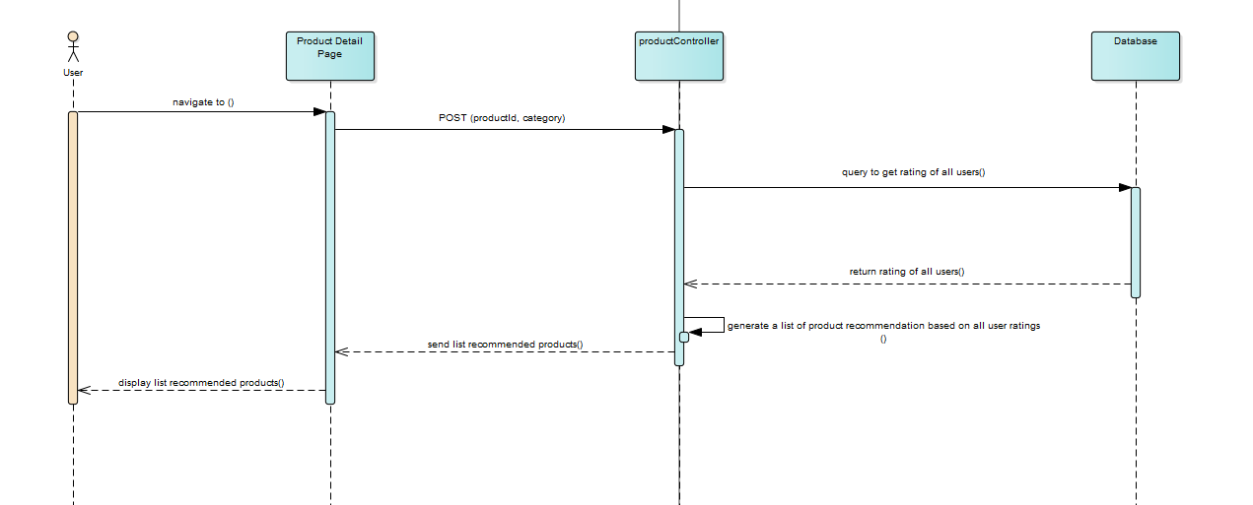

### **4.3.8 Filter Product**

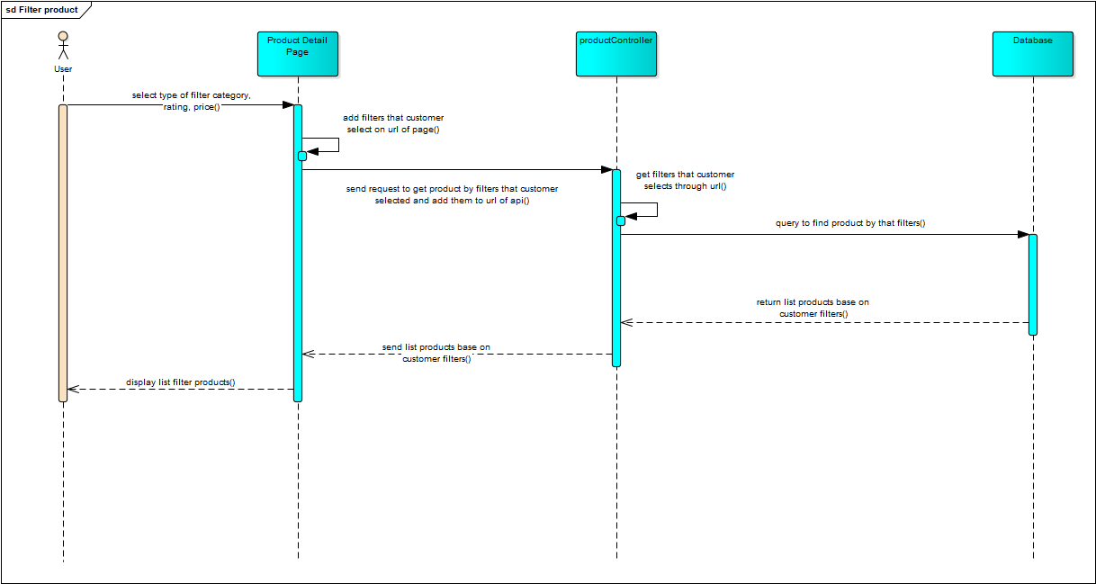

### **4.3.9 Add Product to Wish List**

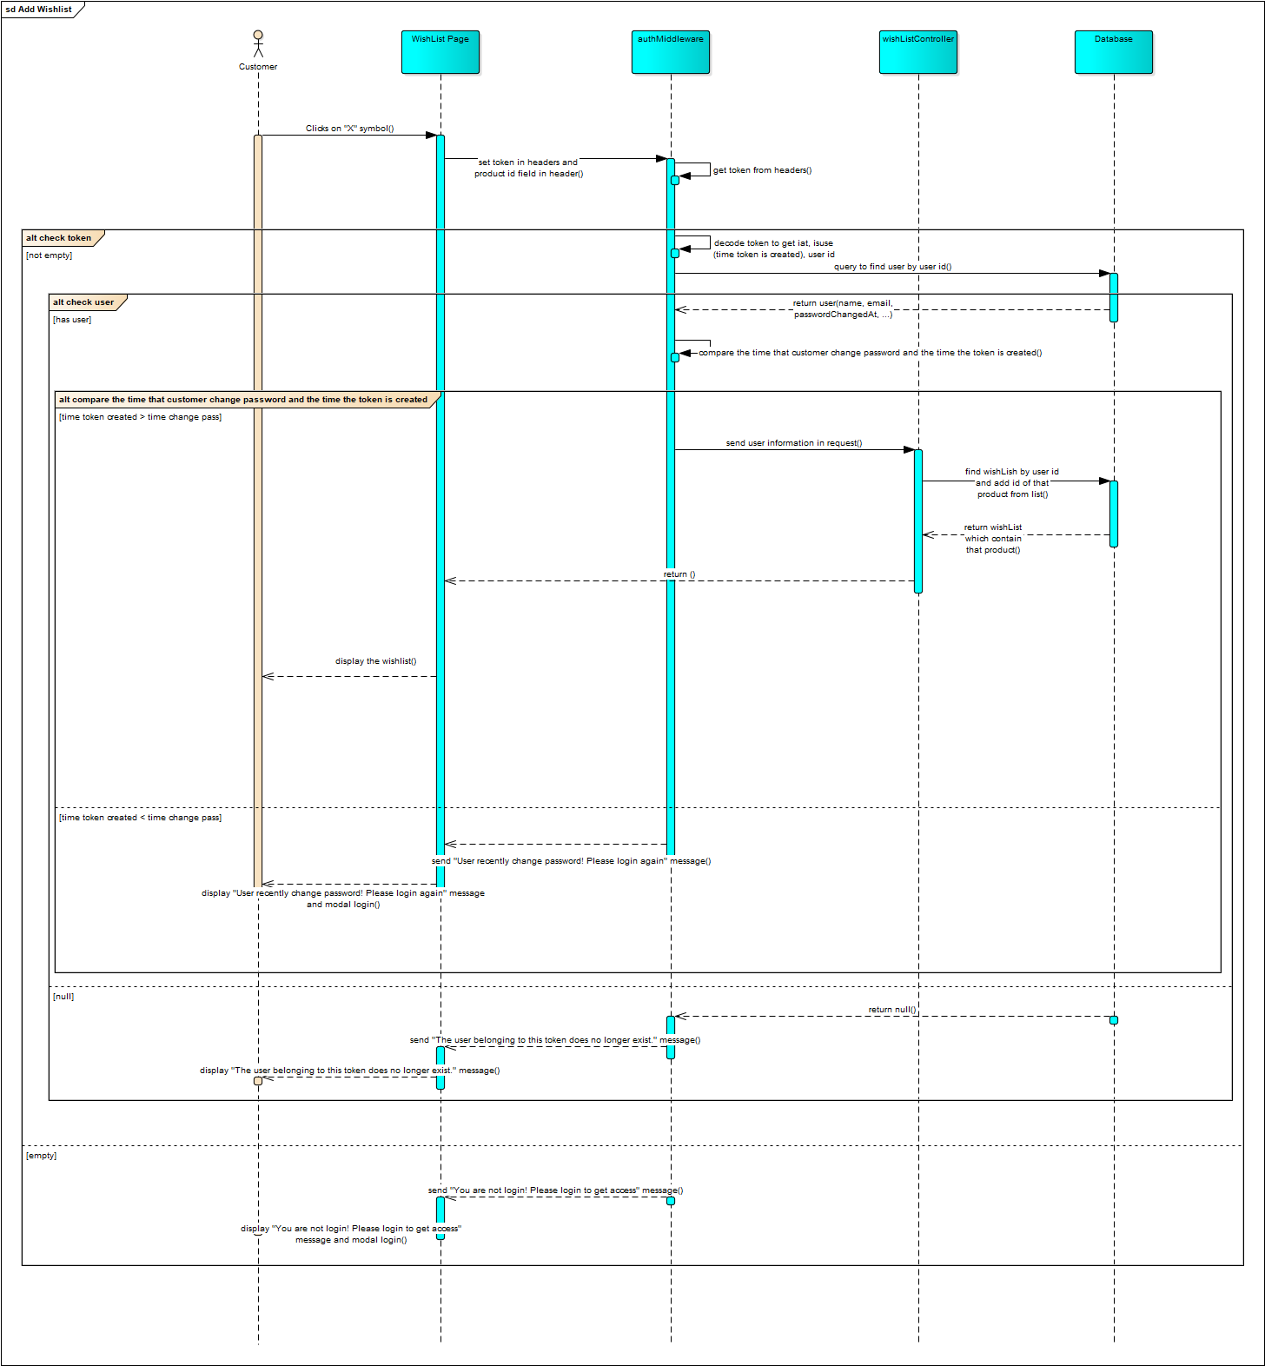

### **4.3.10 Add to Cart**

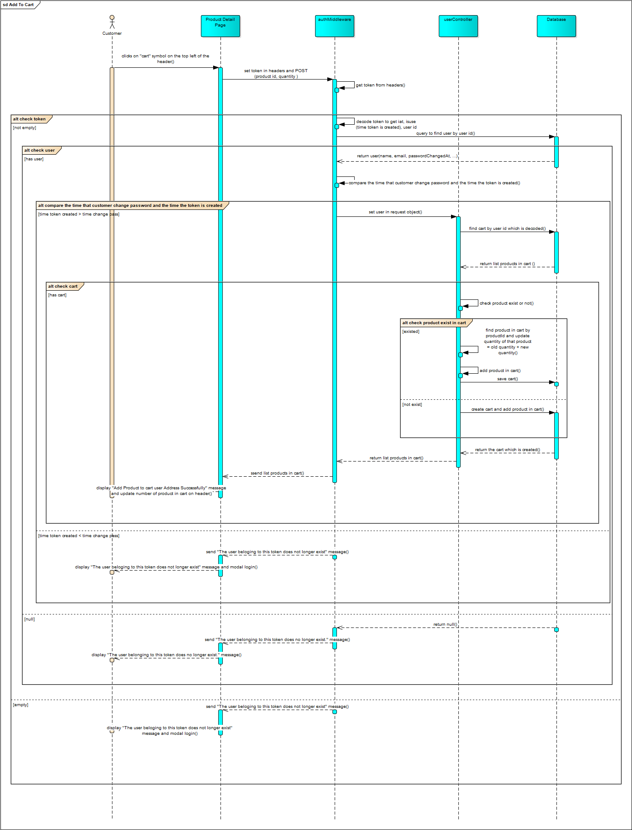

### **4.3.11 Apply Gift Code**

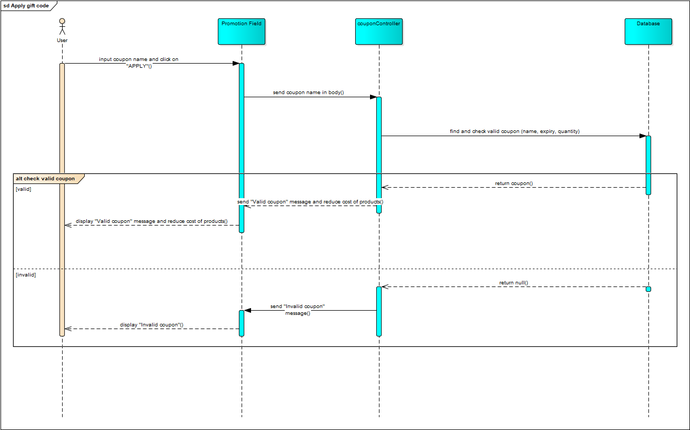

### **4.3.12 Payment by PayPal**

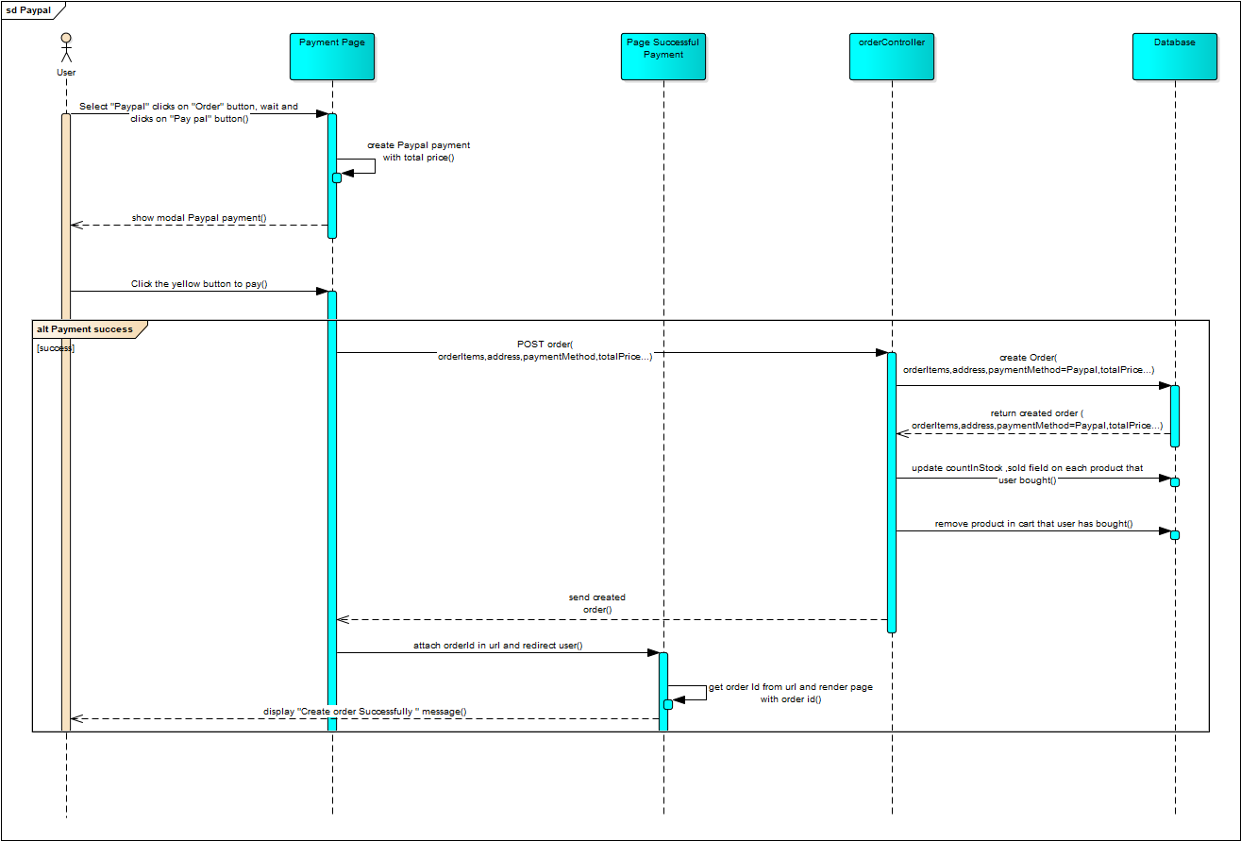

### **4.3.13 Payment by Stripe Card**

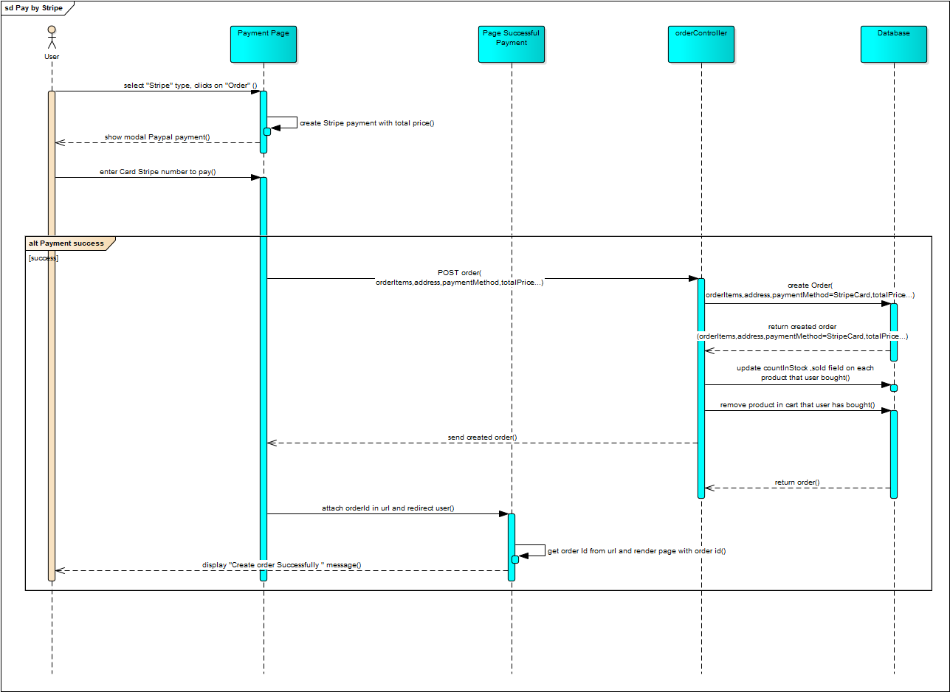

### **4.3.14 Payment by ZaloPay**

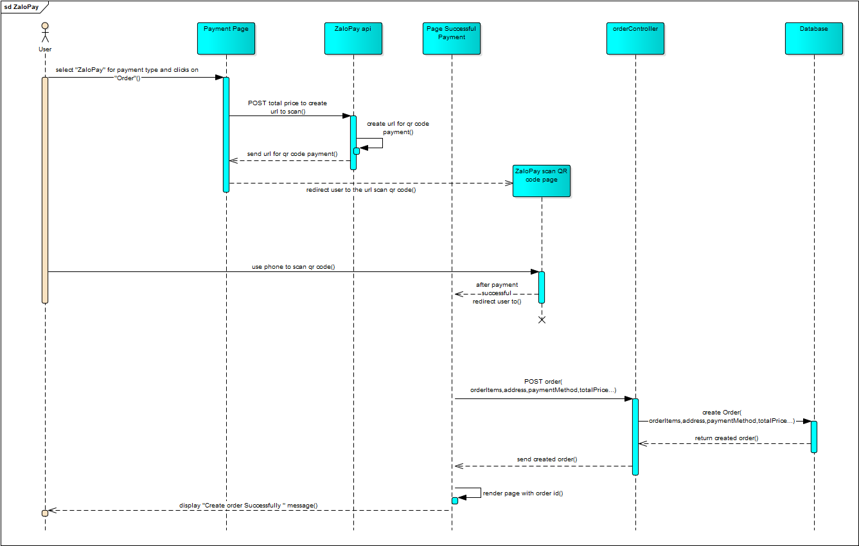

### **4.3.15 Payment by Momo**

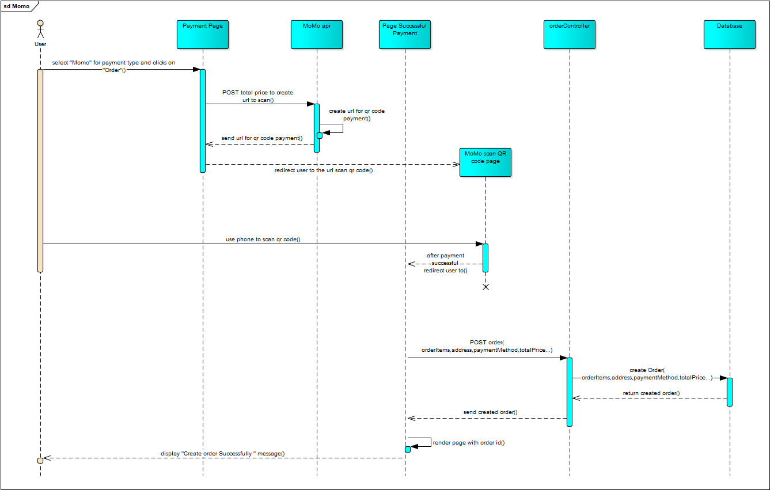

### **4.3.16 View Order History**

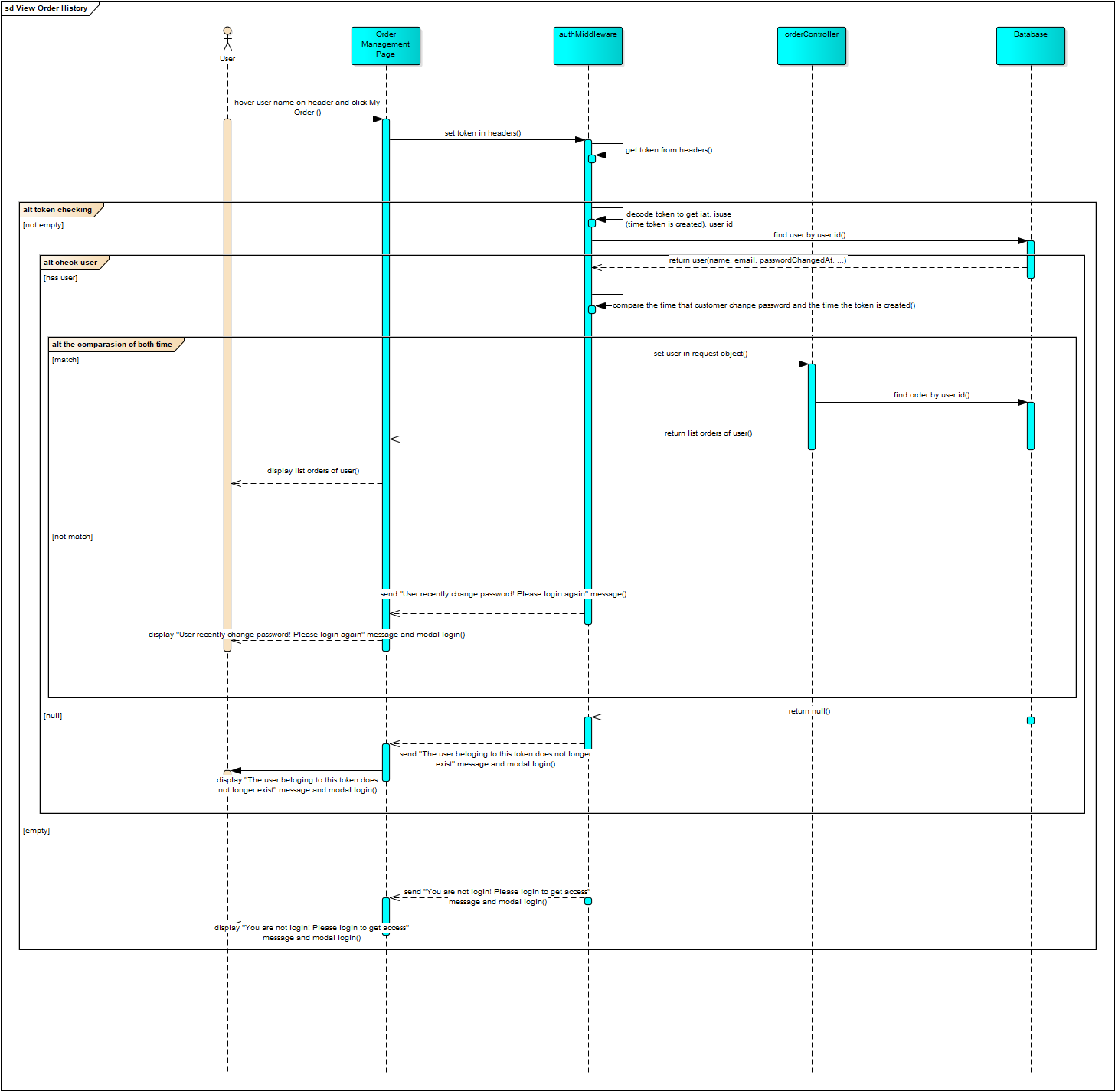

### **4.3.17 View Order Tracking**

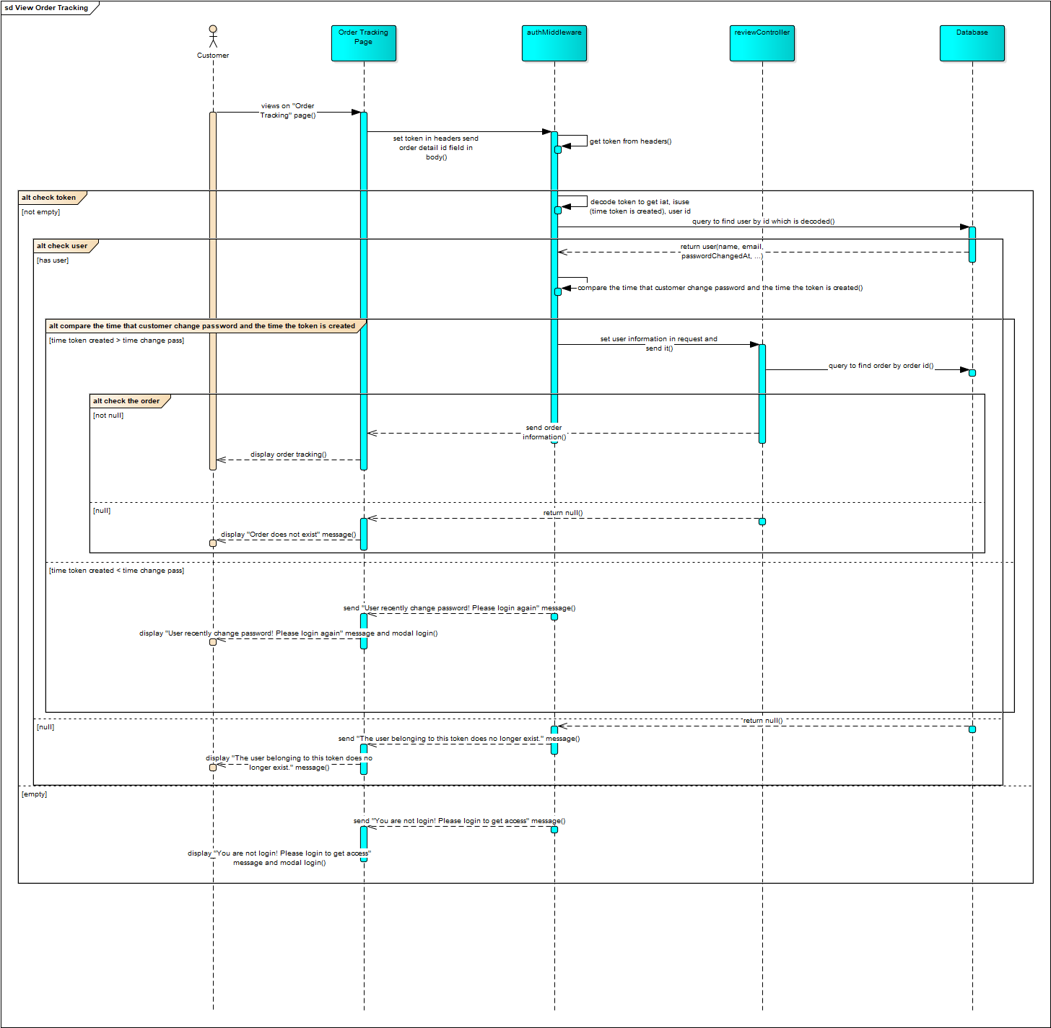

### **4.3.18 Cancel Order**

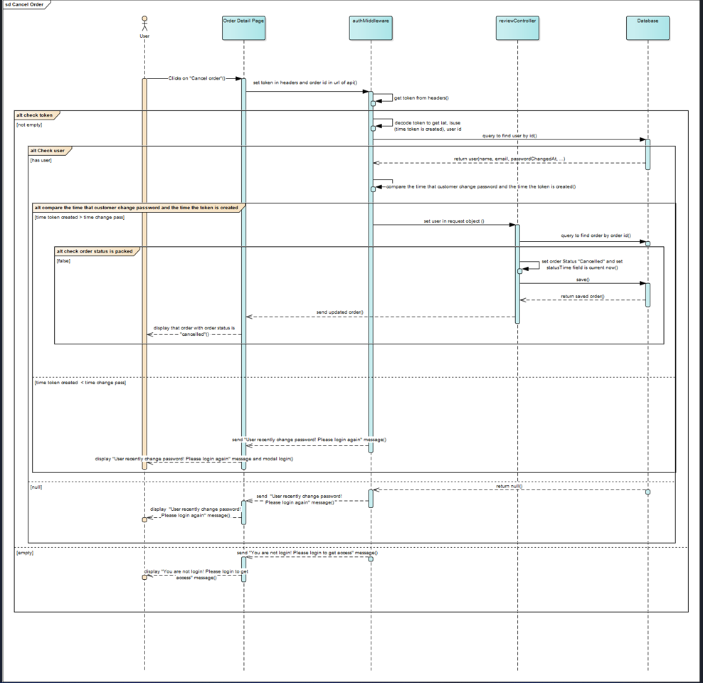

### **4.3.19 Add Comment**

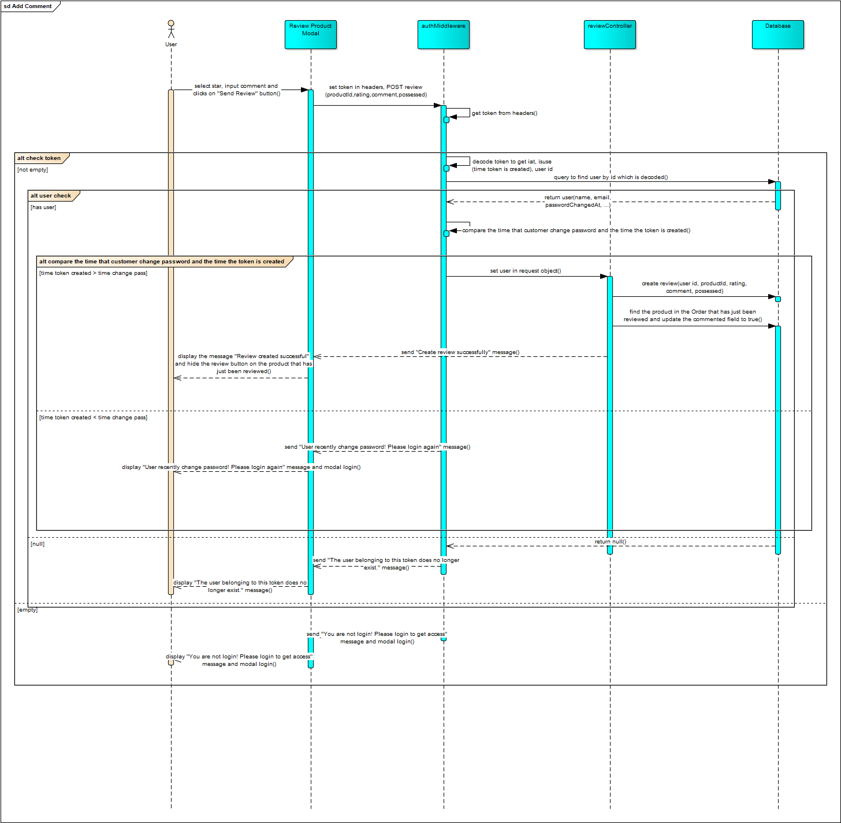

### **4.3.20 Reply Comment**

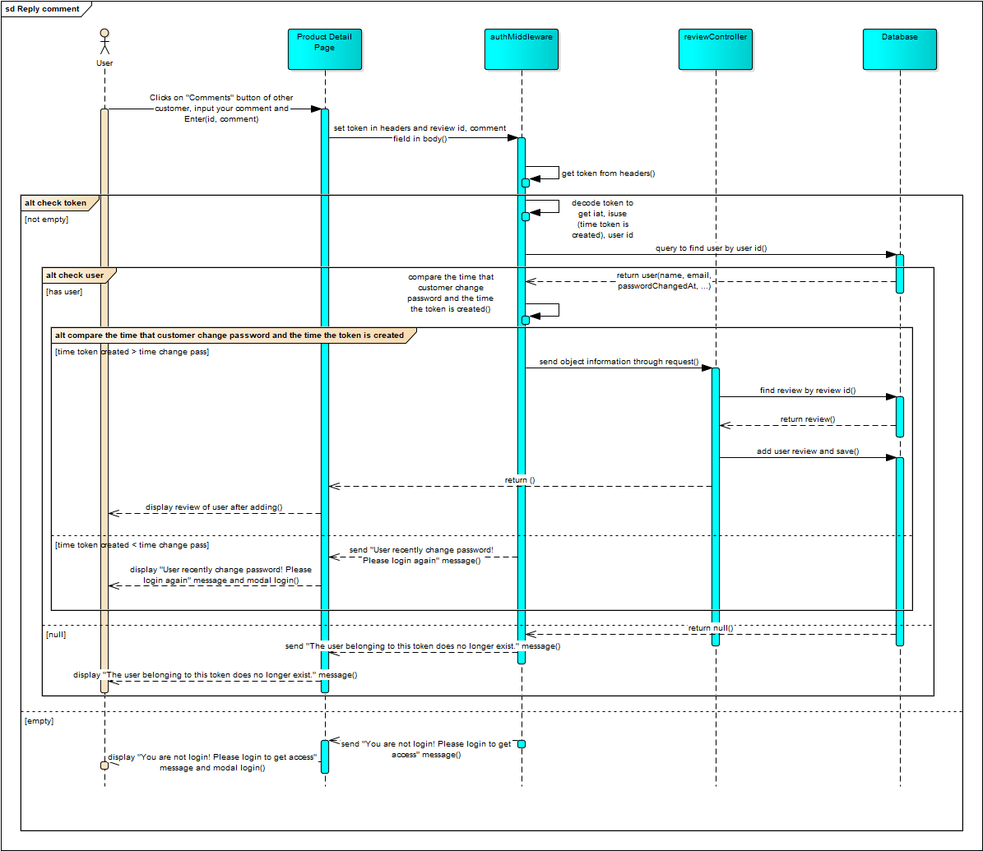

### **4.3.21 Delete User**

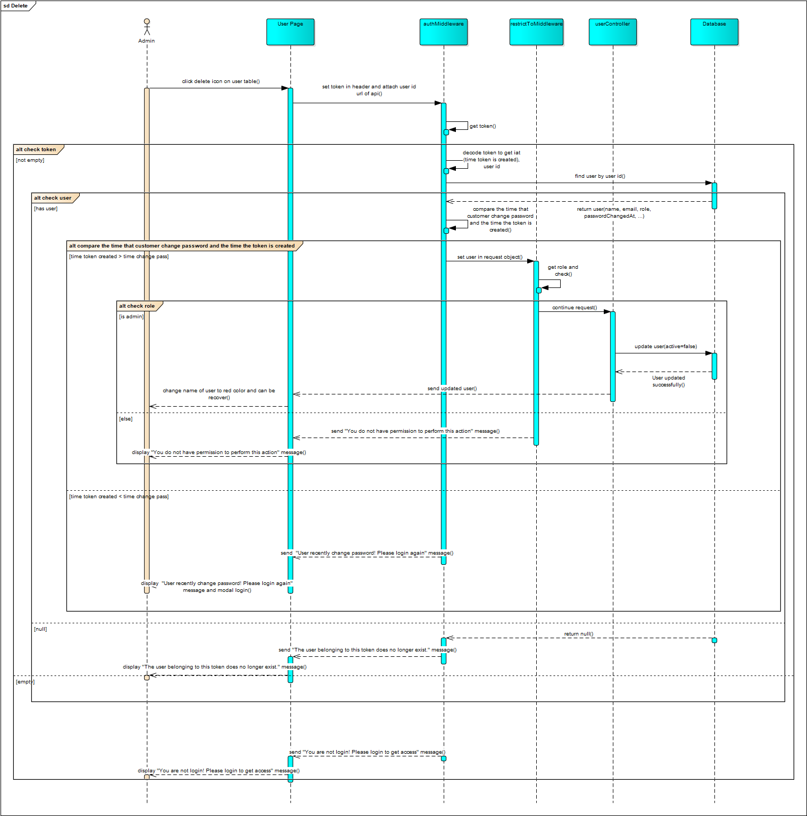

### **4.3.22 Update Order Status**

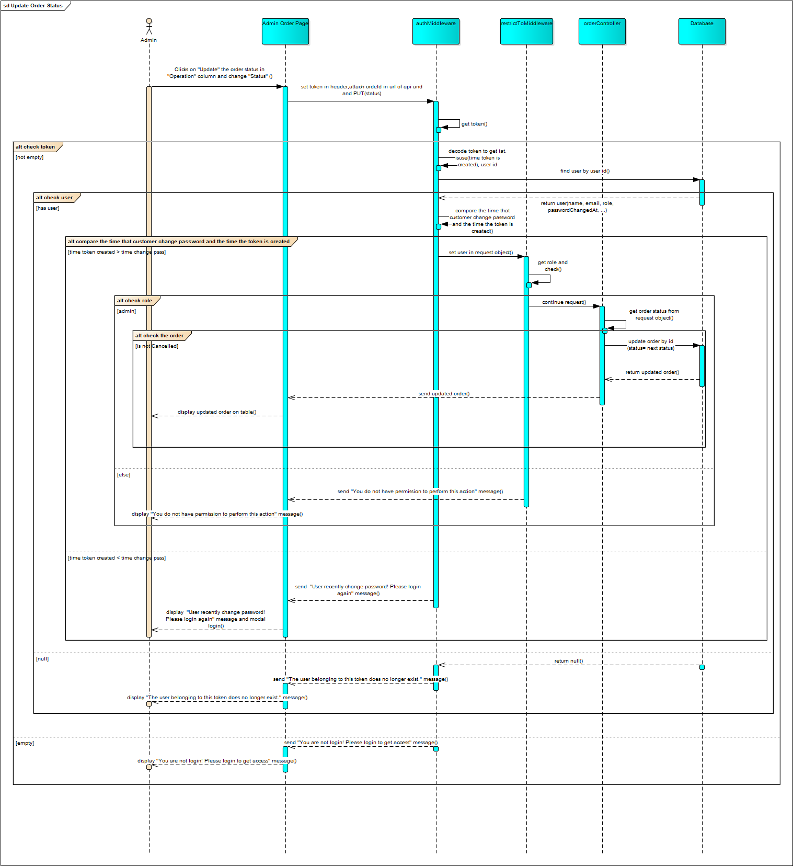

### **4.3.23 Create Product**

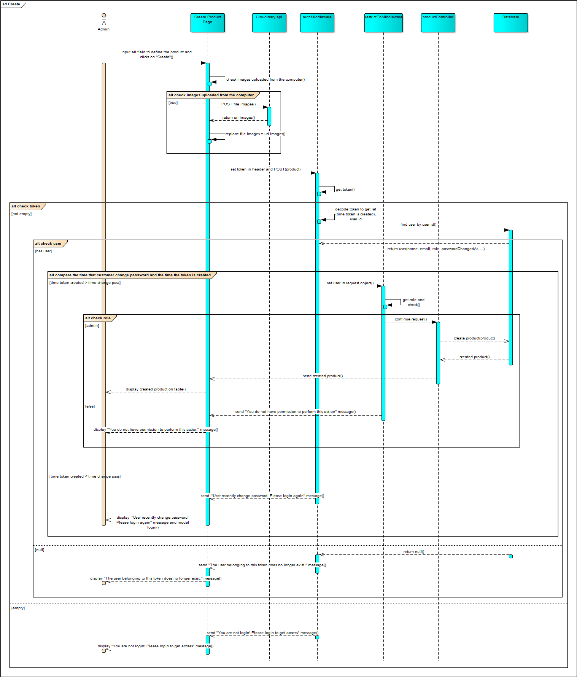

### **4.3.24 Reply Review**

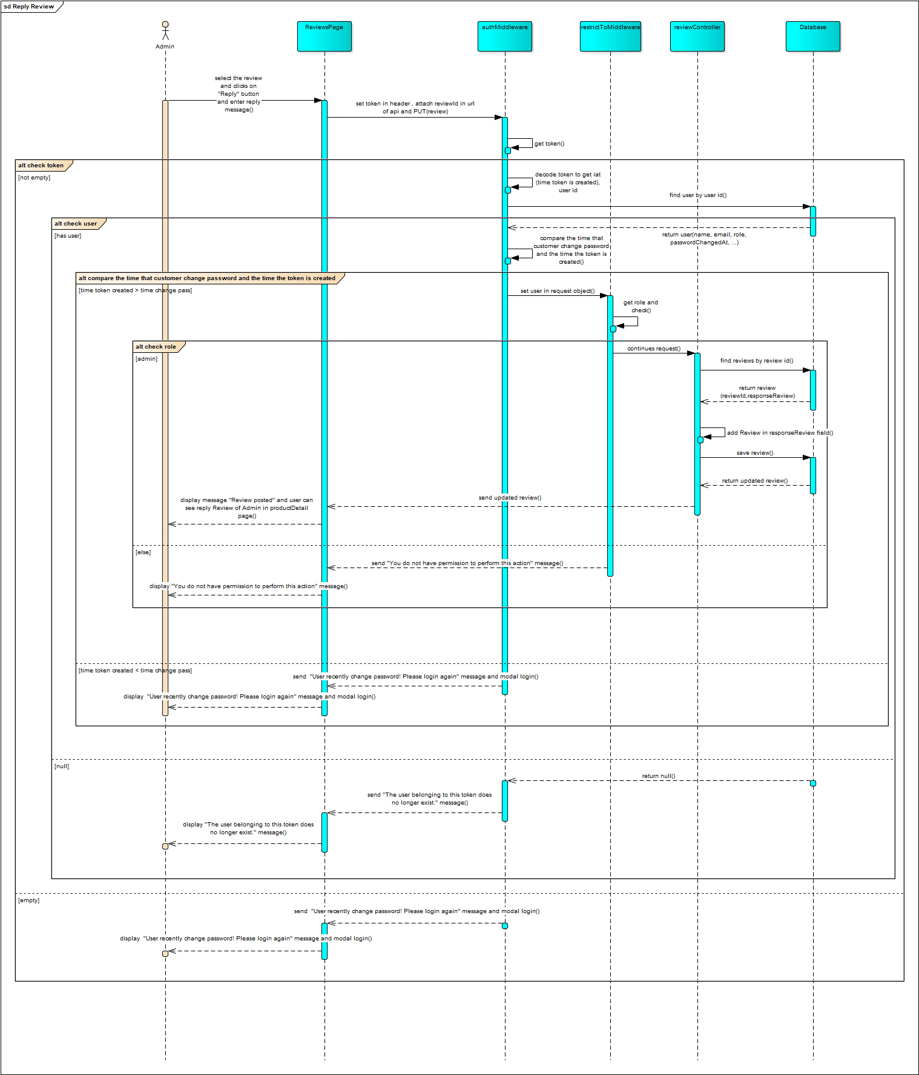

## **4.4 Class Diagram**

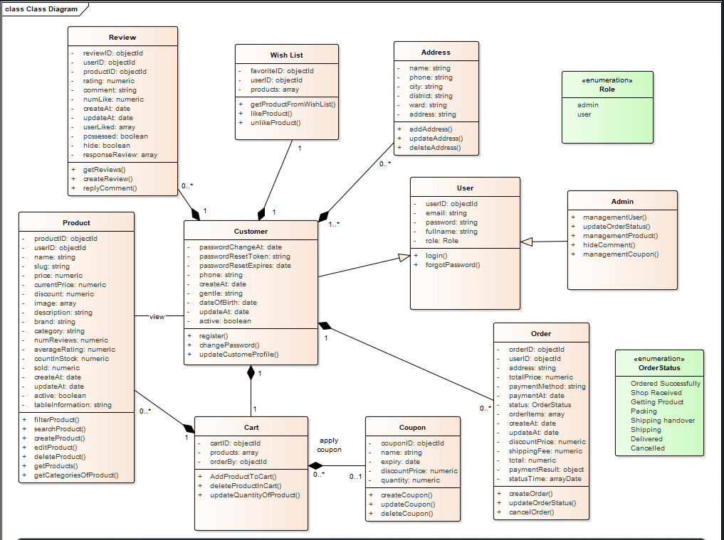

**Figure: Class overview diagram**

## **4.5 Database Design**

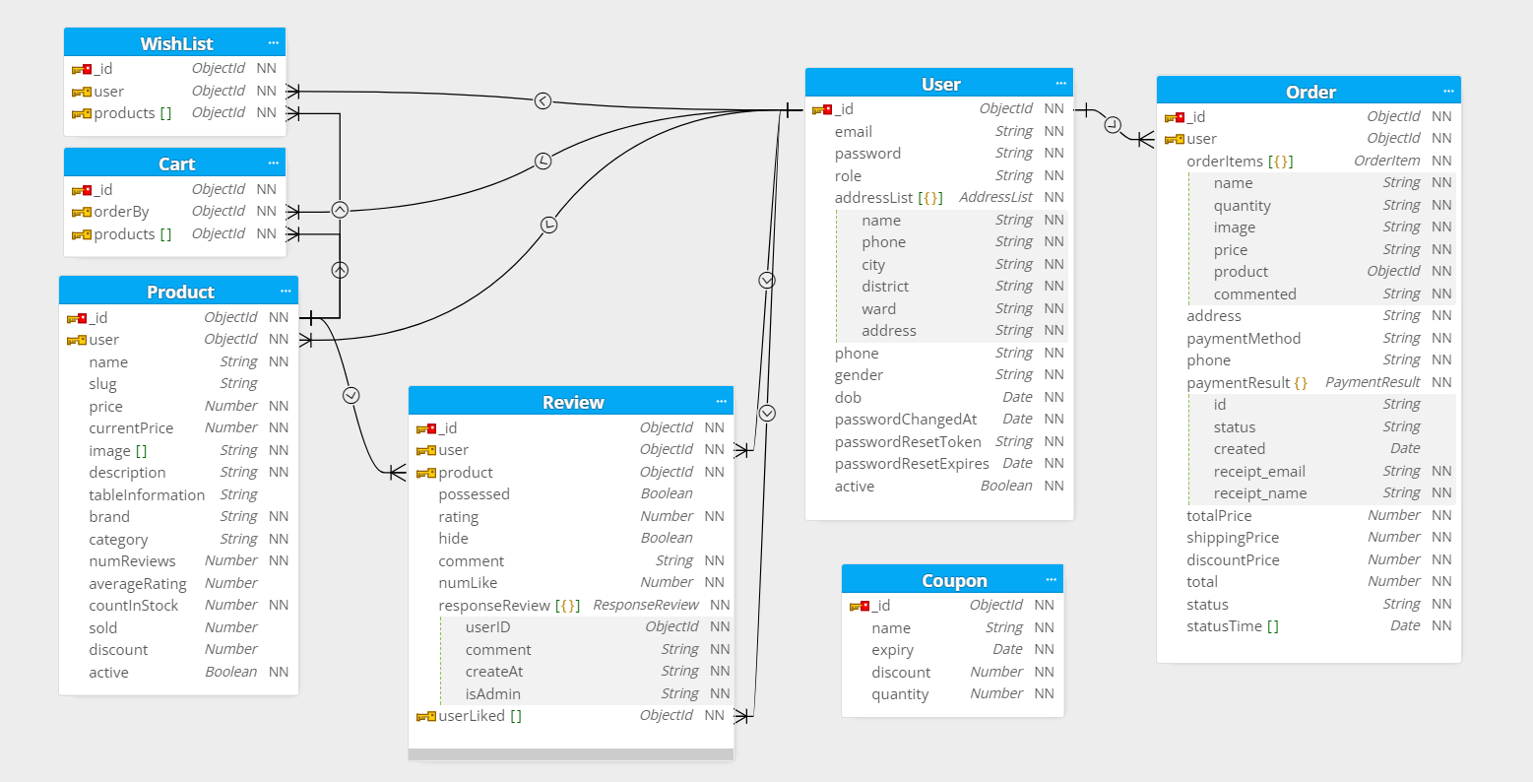

**Figure: Database Design**

**4.5.1 Product**

|  |  |  |  |  |  |
| --- | --- | --- | --- | --- | --- |
| **ID** | **Attribute** | **Type** | **Key** | **Meaning** | **Note** |
| 1 | productID | objectId | Primary Key | ID of product |  |
| 2 | userID | objectId | Foreign Key | ID of customer |  |
| 3 | Name | string |  | Product name |  |
| 4 | Slug | string |  | add “-” to the product name |  |
| 5 | Price | numeric |  | Product price |  |
| 6 | Image | array |  | Image of products |  |
| 7 | Description | string |  | Product description |  |
| 8 | tableInformation | string |  | Product specification |  |
| 9 | brand | string |  | Product brand |  |
| 10 | Category | string |  | Product category |  |
| 11 | numReviews | numeric |  | Number of reviews |  |
| 12 | averageRating | numeric |  | Average of rating |  |
| 13 | countInStock | numeric |  | Number of products in stock |  |
| 14 | Sold | numeric |  | Number of products sold |  |
| 15 | discount | numeric |  | Product discount |  |
| 16 | currentPrice | numeric |  | Current price |  |
| 17 | active | boolean |  | Check product deleted or not |  |
| 18 | CreateAt | date |  | Product creation time |  |
| 19 | updateAt | date |  | Product update time |  |

**4.5.2 Review**

|  |  |  |  |  |  |
| --- | --- | --- | --- | --- | --- |
| **ID** | **Attribute** | **Type** | **Key** | **Meaning** | **Note** |
| 1 | reviewID | objectID | Primary Key | ID of review |  |
| 2 | userID | objectID | Foreign Key | ID of user |  |
| 3 | productID | objectID | Foreign Key | ID of product |  |
| 4 | Rating | numeric |  | Product rating |  |
| 5 | Comment | string |  | Product comment |  |
| 6 | numLike | numeric |  | Number of likes |  |
| 7 | createAt | date |  | Review creation time |  |
| 8 | updateAt | date |  | Review update time |  |
| 9 | userLiked | array |  | User liked |  |
| 10 | Respond review | document |  | Include user, comment, createAt,  isAdmin |  |
| 11 | Possessed | boolean |  | Check whether customers receive product or not |  |

**4.5.3 User**

|  |  |  |  |  |  |
| --- | --- | --- | --- | --- | --- |
| **ID** | **Attribute** | **Type** | **Key** | **Meaning** | **Note** |
| 1 | userID | objectID | Primary Key | ID of user |  |
| 2 | Email | string |  | Email |  |
| 3 | fullName | string |  | Name of user |  |
| 4 | Password | string |  | Password |  |
| 5 | Role | string |  | Role of user |  |
| 6 | Phone | string |  | Phone number |  |
| 7 | Gentle | string |  | Gentle of user |  |
| 8 | dateOfBirth | date |  | Date of birth |  |
| 9 | passwordChangeAt | date |  | Password change time |  |
| 10 | PasswordResetToken | string |  | Password reset token time |  |
| 11 | passwordResetExpires | date |  | Password reset expires time |  |
| 12 | createAt | date |  | User creation time |  |
| 13 | updateAt | date |  | User update time |  |
| 14 | addressList | array |  | Address list |  |
| 15 | active | boolean |  | Check product deleted or not |  |

**4.5.4 Wish List**

|  |  |  |  |  |  |
| --- | --- | --- | --- | --- | --- |
| **ID** | **Attribute** | **Type** | **Key** | **Meaning** | **Note** |
| 1 | favoriteID | objectID | Primary Key | ID of favorite |  |
| 2 | userID | objectID | Foreign Key | ID of user |  |
| 3 | products | array |  | List of product |  |

### **4.5.5 Coupon**

|  |  |  |  |  |  |
| --- | --- | --- | --- | --- | --- |
| **ID** | **Attribute** | **Type** | **Key** | **Meaning** | **Note** |
| 1 | couponID | objectID | Primary Key | ID of coupon |  |
| 2 | name | string |  | Name of coupon |  |
| 3 | expiry | date |  | Expiry time |  |
| 4 | discountPrice | numeric |  | Discount |  |
| 5 | quantity | numeric |  | Number of coupons |  |

**4.5.6 Cart**

|  |  |  |  |  |  |
| --- | --- | --- | --- | --- | --- |
| **ID** | **Attribute** | **Type** | **Key** | **Meaning** | **Note** |
| 1 | cartID | objectId | Primary Key | ID of cart |  |
| 2 | products | array |  | List product |  |
| 3 | orderBy | objectId | Foreign Key | ID of customer |  |

**4.5.7 Order**

|  |  |  |  |  |  |
| --- | --- | --- | --- | --- | --- |
| **ID** | **Attribute** | **Type** | **Key** | **Meaning** | **Note** |
| 1 | orderID | objectID | Primary Key | ID of order |  |
| 2 | userID | objectID | Foreign Key | ID of user |  |
| 3 | address | string |  | Address of customer |  |
| 4 | totalPrice | numeric |  | Total price |  |
| 5 | paymentMethod | string |  | Payment Method |  |
| 6 | paymentAt | date |  | Payment time |  |
| 7 | status | string |  | Status of order |  |
| 8 | orderItems | array |  | List product in order |  |
| 9 | createAt | date |  | Order creation time |  |
| 10 | updateAt | date |  | Order update time |  |
| 11 | discountPrice | numeric |  | Discount |  |
| 12 | Shipping Fee | numeric |  | Shipping fee |  |
| 13 | total | numeric |  | Total price |  |
| 14 | paymentResult | document |  | Include paymentID, status, created, receipt_email, receipt_name |  |
| 15 | statusTime | arrayDate |  | Contain an array of update order status times |  |

# **CHAPTER 5: UI DESIGN**

## **5.1 Overview UI**

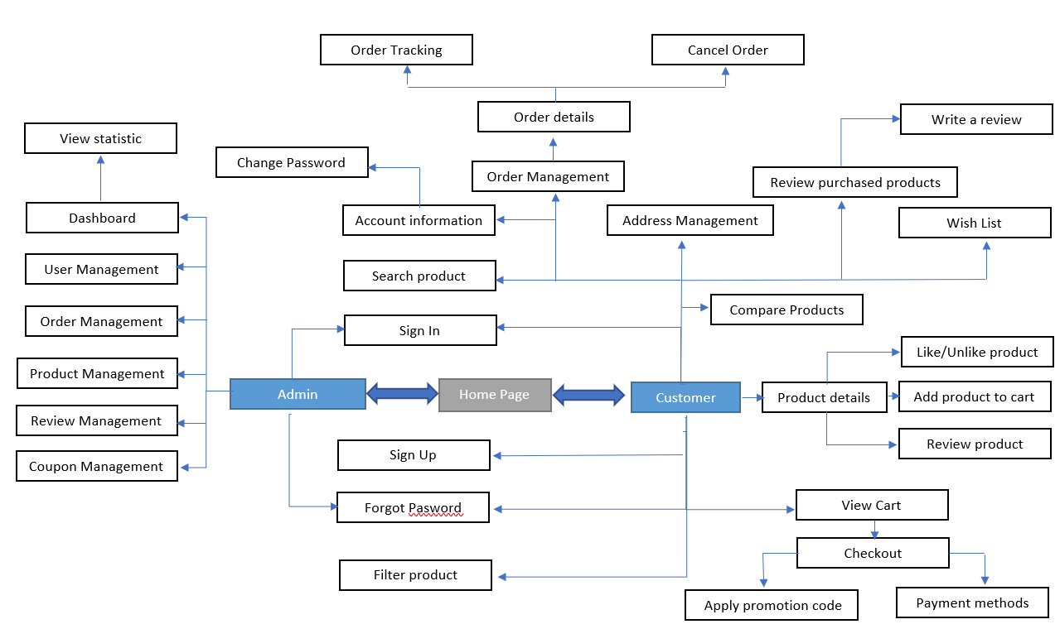

## **5.2 Detailed description of screens**

### **5.2.1 Home Page Screen**

+ **Meaning**: Customer can view all categories product, discount product, best-selling, top rating, new available

+ **Detail about screen**:

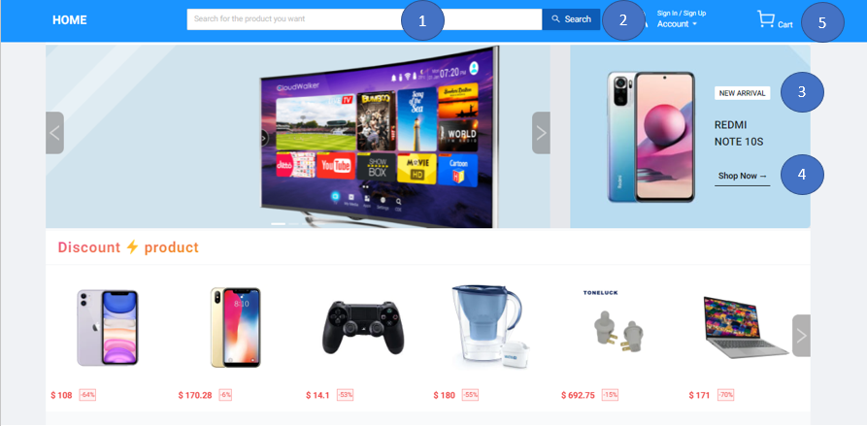

**Entities in screen:**

|  |  |  |
| --- | --- | --- |
| **Order** | **Type** | **Meaning** |
| 1 | Input | Allow customer search products |
| 2 | Button (Search) | Click to search |
| 3 | Button (New arrivals) | Click to roll down to the new arrivals path |
| 4 | Button (Shop now) | Click to change the page to all products with a filter |
| 5 | Button (Cart) | Click to view your cart |

**Event Handling Diagram:**

Search products by name

Navigate to all products with filter page

Roll down to new arrivals path

Click on Shop Now Button

Click on New Arrivals Button

Click on Search Button

Navigate to cart page

Click on Cart Button

### **5.2.2 Login Modal**

+ **Meaning**: Customer can log in to the website

+ **Detail about screen**:

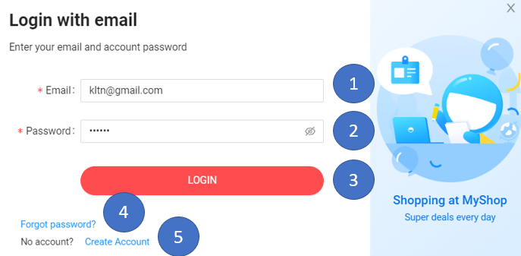

**Entities in screen:**

|  |  |  |
| --- | --- | --- |
| **Order** | **Type** | **Meaning** |
| 1 | Input | Allow input email |
| 2 | Input | Allow input password |
| 3 | Button (Login) | Allow customer login |
| 4 | Button (Forgot Password) | If customer forgot password |
| 5 | Button (Create Account) | If customers don’t have an account |

**Event Handling Diagram:**

Change modal state to create account

Change modal state to forgot password

Click on Create Account Button

Click on Forgot Password Button

Click on Login Button

Login in to website

### **5.2.3 Register Modal**

+ **Meaning**: Customer can sign up for an account

+ **Detail about screen**:

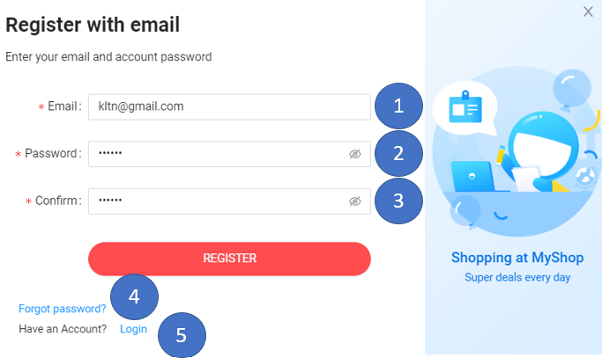

**Entities in screen:**

|  |  |  |
| --- | --- | --- |
| **Order** | **Type** | **Meaning** |
| 1 | Input | Allow input email |
| 2 | Input | Allow input password |
| 3 | Input | Confirm password |
| 4 | Button (Register) | Click to Register |
| 5 | Button (Forgot Password) | If customer forgot password |
| 6 | Button (Login) | Change modal state to log in |

**Event Handling Diagram:**

Register account

Change model state to Login

Change model state to forgot password

Click on Login Button

Click on Forgot Password Button

Click on Register Button

### **5.2.4 Forgot Password Modal**

+ **Meaning**: If customers forget their password, they can enter their email to retrieve their password

+ **Detail about screen**:

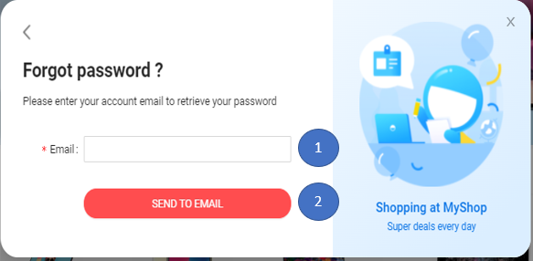

**Entities in screen:**

|  |  |  |
| --- | --- | --- |
| **Order** | **Type** | **Meaning** |
| 1 | Input | Allow input email |
| 2 | Button (Send to Email) | Send link to reset the password via email |

**Event Handling Diagram:**

Send link to reset password via email

Click on Send To Email Button

### **5.2.5 Edit Profile Screen**

+ **Meaning**: Customer can their information

+ **Detail about screen**:

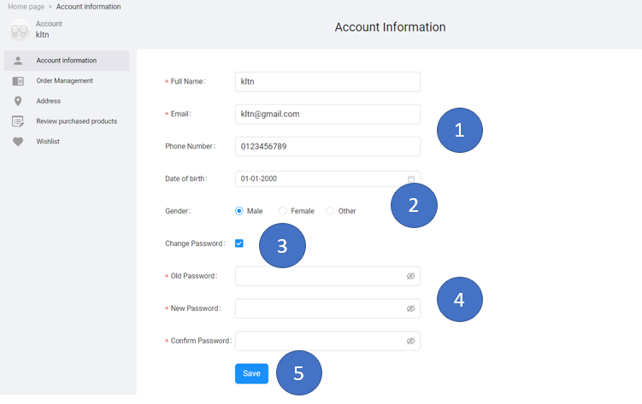

**Entities in screen:**

|  |  |  |
| --- | --- | --- |
| **Order** | **Type** | **Meaning** |
| 1 | Input | Allow input information of the customer |
| 2 | Radio | Allow customers to select gender |
| 3 | Checkbox | If the customer wants to change the password |
| 4 | Input | Allow input to change password |
| 5 | Button (Save) | Click to Save |

**Event Handling Diagram:**

select gender

Click to update customer information

Display change password part

Click on Save Button

Click on Checkbox

Click on Radio

### **5.2.6 Address Screen**

+ **Meaning**: Customer can add multiple addresses and update/delete address

+ **Detail about screen**:

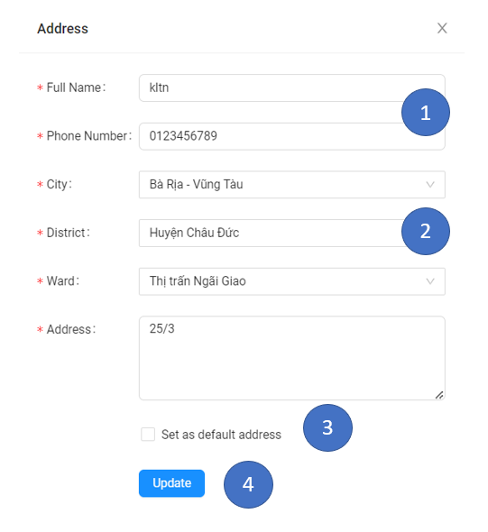

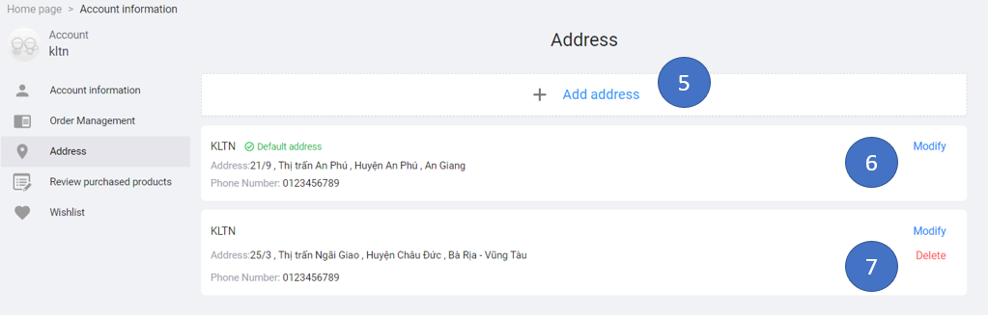

**Entities in screen:**

|  |  |  |
| --- | --- | --- |
| **Order** | **Type** | **Meaning** |
| 1 | Input | Allow input customer information |
| 2 | Select | Select city, ward, district |
| 3 | Checkbox | Click to set the default |
| 4 | Button (Save) | Click to save information |
| 5 | Button (Add) | Click to add an address |
| 6 | Button (Modify) | Click to modify an address |
| 7 | Button (Delete) | Click to delete the address |

**Event Handling Diagram:**

Click on add button

Show modal to add address

Click on select

Show city, ward, district

To set default address

Click to save customer address

Click on save button

Click on checkbox

Click on modify button

Click to update customer address

Click on delete button

Click to delete customer address

### **5.2.7 Like/Dislike Product and Wish List Screen**

+ **Meaning**: Customer can add or remove product to their wish list

+ **Detail about screen**:

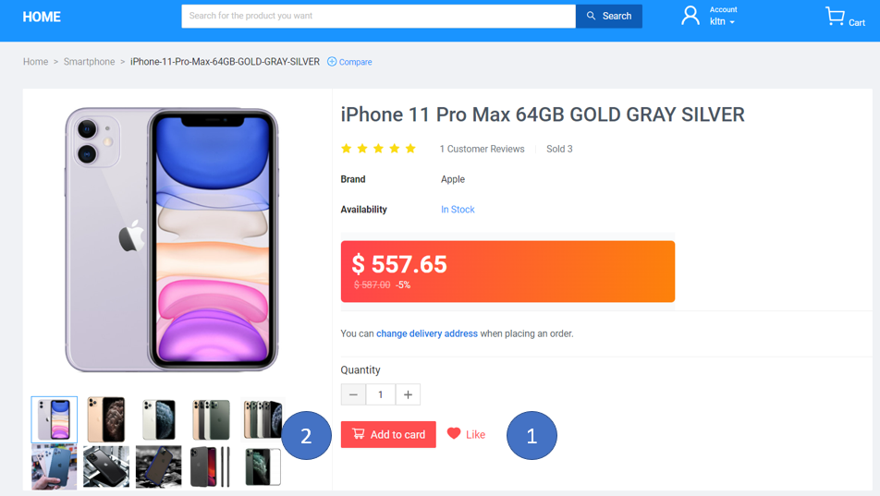

After adding to the wish list, we move to the wish list page

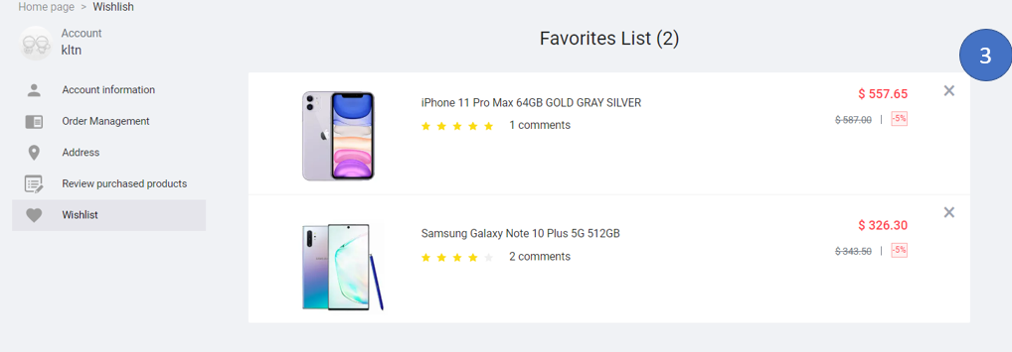

**Entities in screen:**

|  |  |  |
| --- | --- | --- |
| **Order** | **Type** | **Meaning** |
| 1 | Button (Heart Icon) | Allow customers to add or remove products to their wish list |
| 2 | Button (Add to cart) | Allow customer add to cart |
| 3 | Button (X Icon) | Allow customers to remove products from wish list |

**Event Handling Diagram:**

Click on Add to cart

Add products to cart

add or remove products to their wish list

remove products from wish list

Click on x icon

Click on heart icon

### **5.2.8 Cart Screen**

+ **Meaning**: Customer can log in to the program

+ **Detail about screen**:

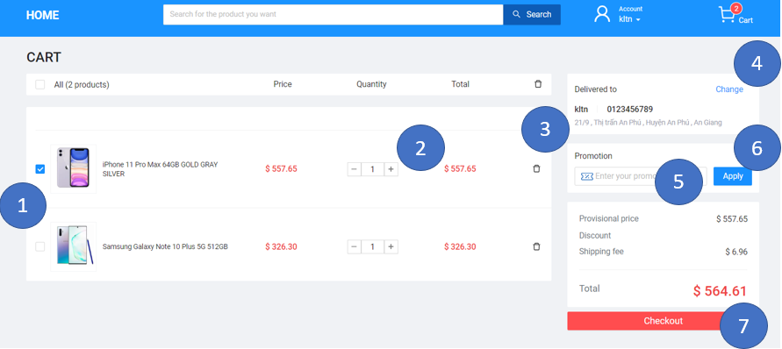

**Entities in screen:**

|  |  |  |
| --- | --- | --- |
| **Order** | **Type** | **Meaning** |
| 1 | Checkbox | Toggle select products |
| 2 | Button (-/+ icon) | Increase or Decrease quantity of product |
| 3 | Button(Trash icon) | Delete products from the cart |
| 4 | Button (Change) | Change address |
| 5 | Input | Allow customer input coupon |
| 6 | Button (Apply) | Click to apply coupon |
| 7 | Button (Checkout) | Checkout products selected |

**Event Handling Diagram:**

Click on button (trash icon)

Delete products from cart

Click on button (-/+ icon)

Increase or Decrease quantity of product

Select or deselect products

Navigate to customer address

Click on change button

Click on checkbox

Checkout products selected

Click on checkout button

Click on apply button

Check and apply coupon

### **5.2.9 Checkout Screen**

+ **Meaning**: Customer can choose a payment method to checkout

+ **Detail about screen**:

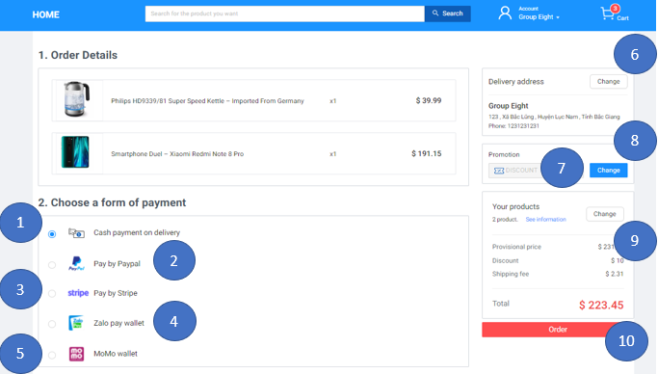

**Entities in screen:**

|  |  |  |
| --- | --- | --- |
| **Order** | **Type** | **Meaning** |
| 1 | Radio (Cash) | Cash payment on delivery |
| 2 | Radio (PayPal) | Pay by PayPal |
| 3 | Radio (Stripe) | Pay by Stripe card |
| 4 | Radio (ZaloPay) | Pay by ZaloPay (Scan QR code) |
| 5 | Radio (Momo) | Pay by Momo (Scan QR code) |
| 6 | Button (Change) | Change address |
| 7 | Input | Allow customer input coupon |
| 8 | Button (Apply) | Click to apply coupon |
| 9 | Button (Change) | Return cart page |
| 10 | Button (Order) | Order |

**Event Handling Diagram:**

Click on radio (payment methods)

Choose payment method

Return cart page

Check and apply coupon

Click on button change (product)

Click on apply button

Navigate to customer address

Click on change button

Create order base on payment method

Click on order button

### **5.2.10 Review Product Screen**

+ **Meaning**: Customer can review products after they bought

+ **Detail about screen**:

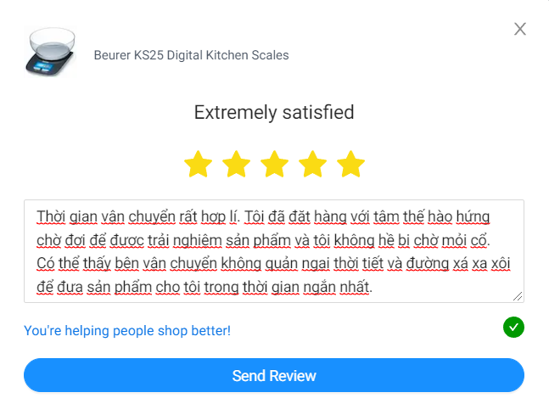

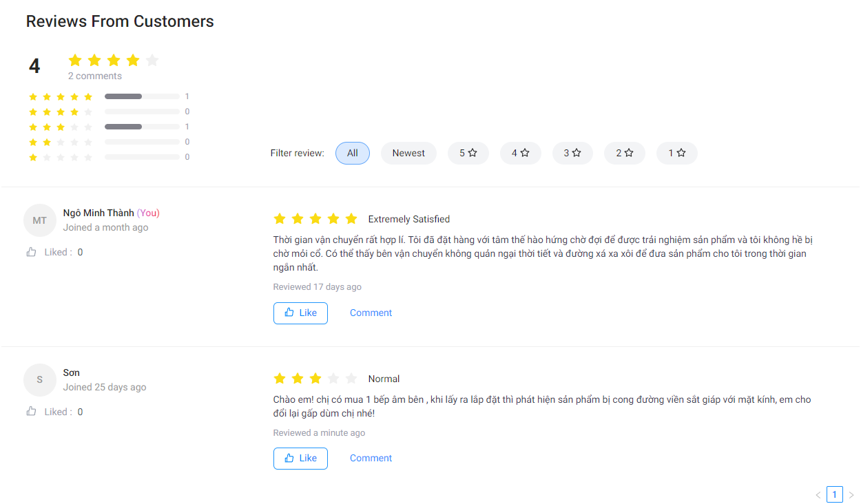

**Entities in screen:**

|  |  |  |
| --- | --- | --- |
| **Order** | **Type** | **Meaning** |
| 1 | Icon (Start rating) | Allow customer rating |
| 2 | Text area | Allow input password |
| 3 | Button (Like) | Allow customer like comment |
| 4 | Button (Filter) | Allow customer filter review |
| 5 | Button (Comment) | Allow customer comment |
| 7 | Button | Change review page |

**Event Handling Diagram:**

Click on like button

Like comments

Star rating product

Filter comment by star rating and newest

Click on filter button

Click on star icon

Add more comment

Click on comment button

### **5.2.11 Recommended Items Screen**

+ **Meaning**: Customer can view some product that same category

+ **Detail about screen**:

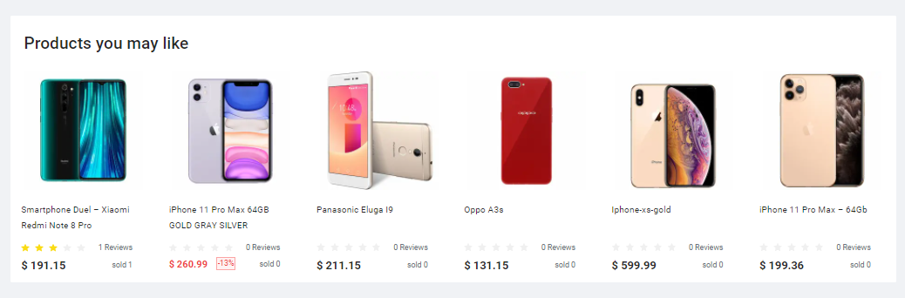

**Entities in screen:**

|  |  |  |
| --- | --- | --- |
| **Order** | **Type** | **Meaning** |
| 1 | div tag | Allow view products detail |

**Event Handling Diagram:**

Click on product

Navigate to products detail page

### **5.2.12 Order Management for Customer Screen**

+ **Meaning**: Customer can view their orders

+ **Detail about screen**:

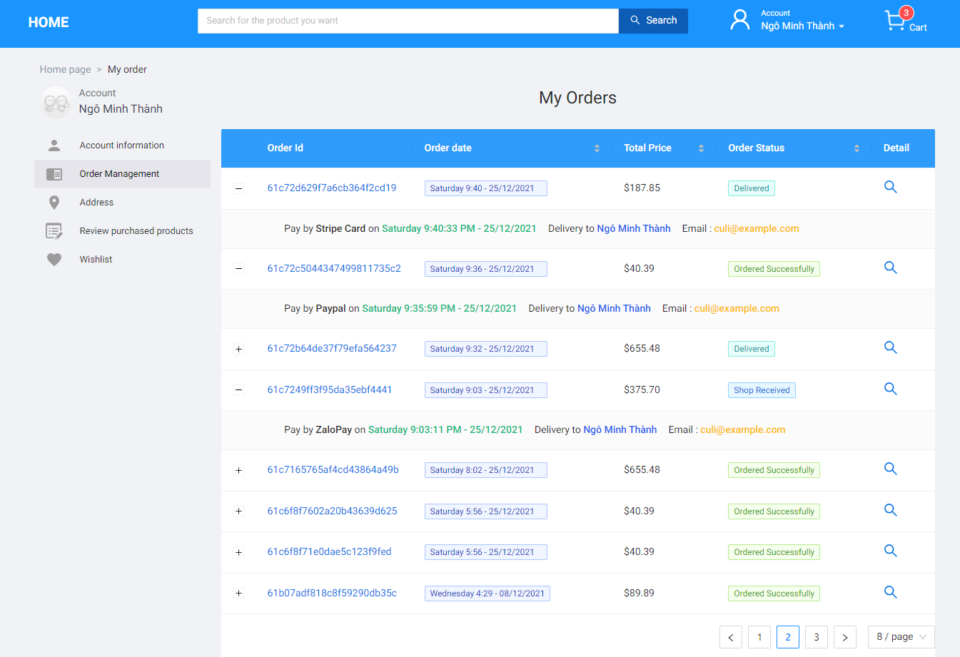

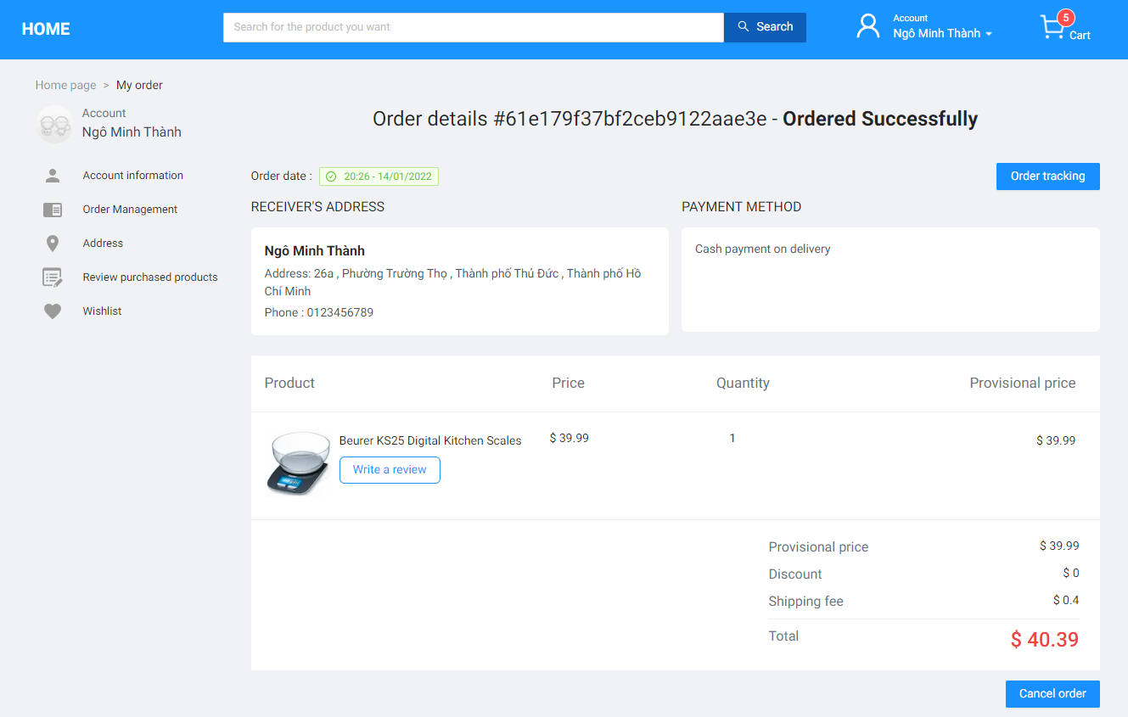

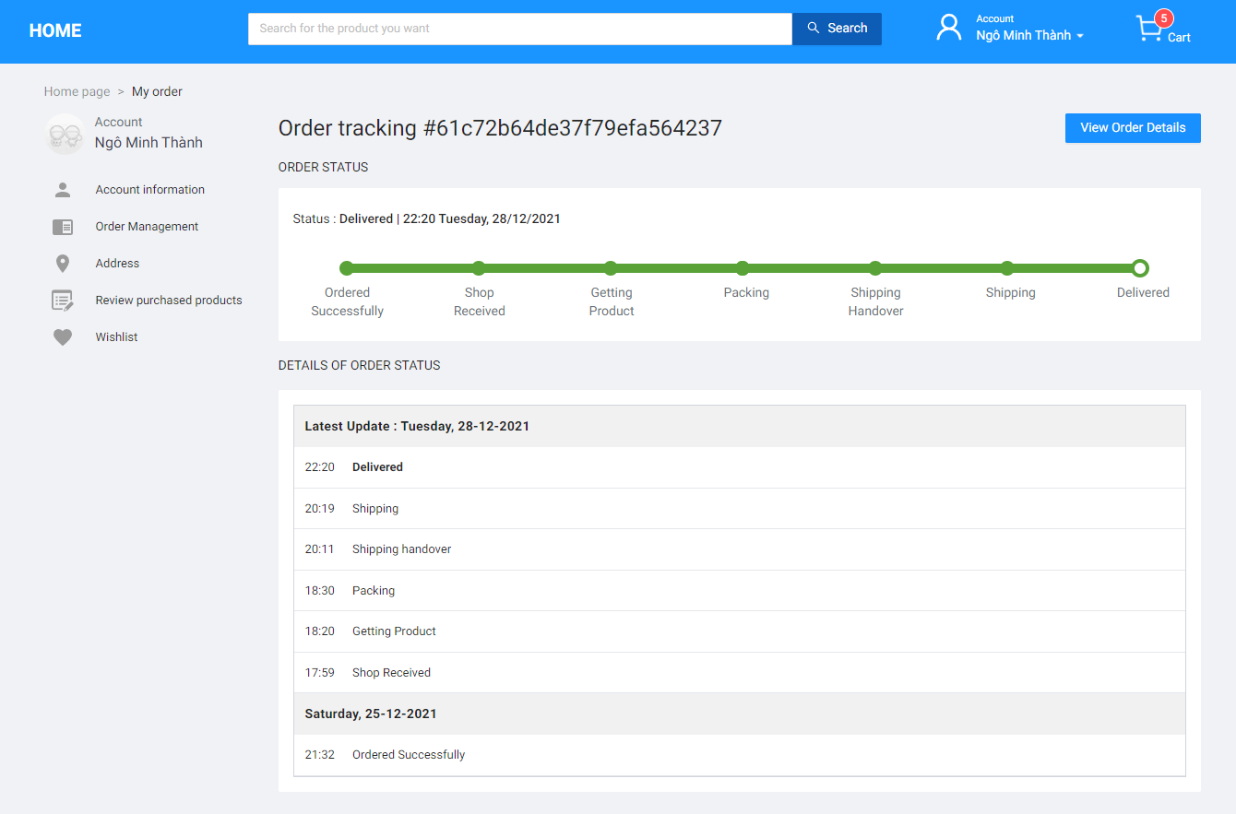

**Entities in screen:**

|  |  |  |
| --- | --- | --- |
| **Order** | **Type** | **Meaning** |
| 1 | Button (-/+ icon) | Show part detail order |
| 2 | Button (detail icon) | Show detail order |
| 3 | Button (pagination) | View list order follow pages |
| 4 | Button (Order tracking) | Navigate to the status order page |
| 5 | Button (Write a review) | Navigate to review modal |
| 6 | Button (Cancel order) | Cancel order (if the status of the order is not packed yet) |
| 7 | Button (Order Detail) | Navigate to order detail page |

**Event Handling Diagram:**

Click on button (-/+ icon)

Show part detail order

Click on button (detail icon)

Click on button(pagination)

View list order follow pages

Show detail order

Navigate to status order page

Click on order tracking button

Navigate to review modal

Click on write a review button

Click on view order detail button

Navigate to order detail page

Click on cancel order button

Cancel order

### **5.2.13 Review Purchased Product Screen**

+ **Meaning**: Customer can view unreviewed products in the last 7 days

+ **Detail about screen**:

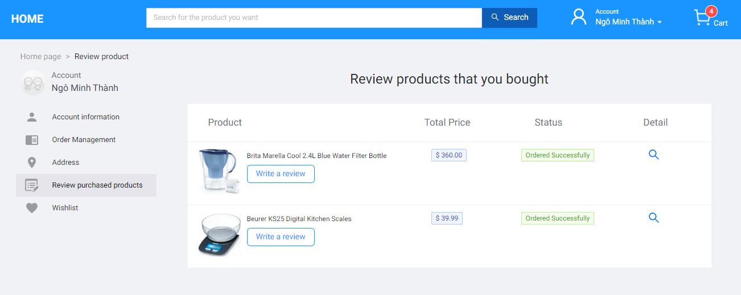

**Entities in screen:**

|  |  |  |
| --- | --- | --- |
| **Order** | **Type** | **Meaning** |
| 1 | Button (Write a review) | Allow customer rating and comment product |
| 2 | Button (detail icon) | Navigate to order detail that contains products bought |

**Event Handling Diagram:**

Click on write a review button

Show modal to review

Navigate to order detail that contain product bought

Click on (detail icon) button

### **5.2.14 View, Search product Screen**

+ **Meaning**: Customer can view or filter product

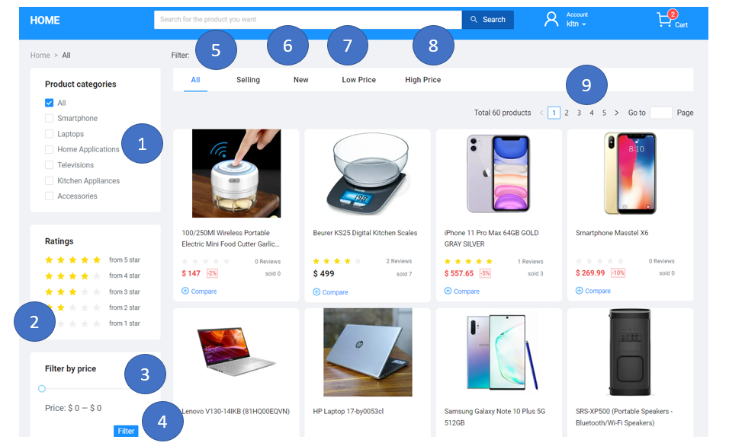

**Entities in screen:**

|  |  |  |
| --- | --- | --- |
| **Order** | **Type** | **Meaning** |
| 1 | CheckBox | Filter product by category |
| 2 | Button | Filter product by star |
| 3 | Slider | Choose by price range |
| 4 | Button | Filter product by price range |
| 5 | Tab | Filter products by selling |
| 6 | Tab | Filter products by newest |
| 7 | Tab | Filter products by low to high price |
| 8 | Tab | Filter products by high to low price |
| 9 | Button | Change product page |

**Event Handling Diagram:**

Show product by star

Click on Button (star)

Click on Check box category

Show product by category

Press and hold the right mouse button and adjust the price range

Show price range

### **5.2.15 Dashboard Screen**

Click on button (pagination)

Show product by price range

Click on selling , New, Low Price ,High Price Tab

Show product by selling, newest, low to high price, high to low price

Show product by price range

Click on Filter button

+ **Meaning**: Manager can view statistics of total reviews, total customers, total orders, total products, total revenue and can view latest orders, the latest review

+ **Detail about screen**:

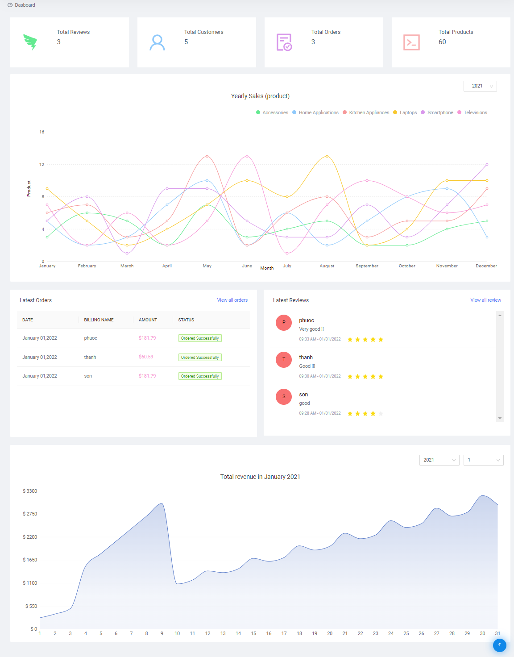

**Entities in screen:**

|  |  |  |
| --- | --- | --- |
| **Order** | **Type** | **Meaning** |
| 1 | Button (View all order) | Navigate to the order management page |
| 2 | Button (View all review) | Navigate to review management page |
| 3 | Select (year) | Select year want to view statistic |
| 4 | Select (month) | Select month want to view statistic |

**Event Handling Diagram:**

Navigate to order management page

Click on view all order button

Click on view all review button

Navigate to review management page

Select year want to view statistic

Click on select (year)

Click on select (month)

Select month want to view statistic

### **5.2.16 User Management Screen**

+ **Meaning**: Admin can manage all users

+ **Detail about screen**:

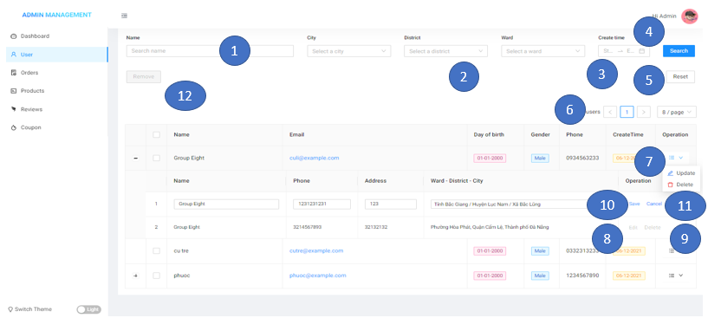

**Entities in screen:**

|  |  |  |
| --- | --- | --- |
| **Order** | **Type** | **Meaning** |
| 1 | Input | Allow input username |
| 2 | Select | Allow admin select city, ward, district |
| 3 | Datetime Range | Allow admin choose range of time created account |
| 4 | Button (Search) | Click to search account |
| 5 | Button (Reset) | Click to reset all field |
| 6 | Button (Pagination) | Click to change view list users pages |
| 7 | Dropdown  (Update/Delete Button) | Click the Update button to update customer information and click the delete button to disable customer account |
| 8 | Button (Edit) | Click to edit customer address |
| 9 | Button (Delete) | Click to delete customer address |
| 10 | Button (Save) | Click to save customer address |
| 11 | Button (Cancel) | Click to cancel edit customer address |
| 12 | Button (Remove) | Click to disable selected users |

**Event Handling Diagram:**

Click on select

Show city, ward, district

Click on datetime range

Click on search button

Click to search username

Show date

Click to reset all field

Click on reset button

Click on button (pagination)

Click to view list users by pages

Click to disable selected users

Click on remove button

Click on edit button

Click to edit customer address

Click on delete button

Click to delete customer address

Hover operation icon

Show update button and delete button

Click on save button

Click to save customer address

Click to cancel edit customer address

Click on cancel button

### **5.2.17 Order Management for Admin Screen**

+ **Meaning**: Admin can manage all orders

+ **Detail about screen**:

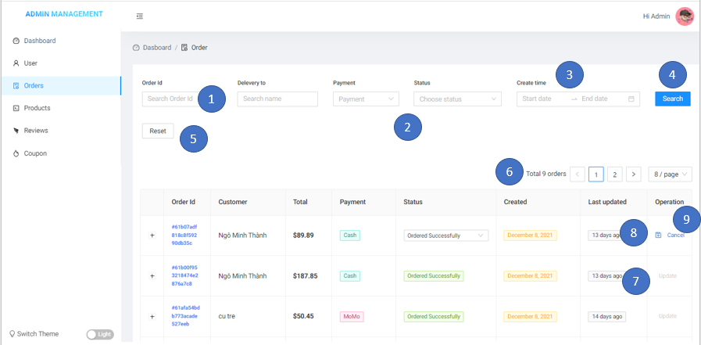

**Entities in screen:**

|  |  |  |
| --- | --- | --- |
| **Order** | **Type** | **Meaning** |
| 1 | Input | Allow input orderId, receiver |
| 2 | Select | Allow admin select payment methods, order status |
| 3 | Datetime Range | Allow admin choose range of time created order |
| 4 | Button (Search) | Click to search order |
| 5 | Button (Reset) | Click to reset all field |
| 6 | Button (Pagination) | Click to change view list orders pages |
| 7 | Button (Update) | Click to update the order status |
| 8 | Button (Save Icon) | Click to save order status |
| 9 | Button (Cancel) | Click to cancel update order status |

**Event Handling Diagram:**

Click on select

Show payment methods, order status

Click on datetime range

Click on search button

Click to search orderId, receiver

Show date

Click to reset all field

Click on reset button

Click on button (pagination)

Click to view list orders by pages

Click to update order status

Click on update button

Click on save button

Click to save order status

Click on cancel button

Click to cancel update order status

### **5.2.18 Product Management Screen**

+ **Meaning**: Admin can manage all products

+ **Detail about screen**:

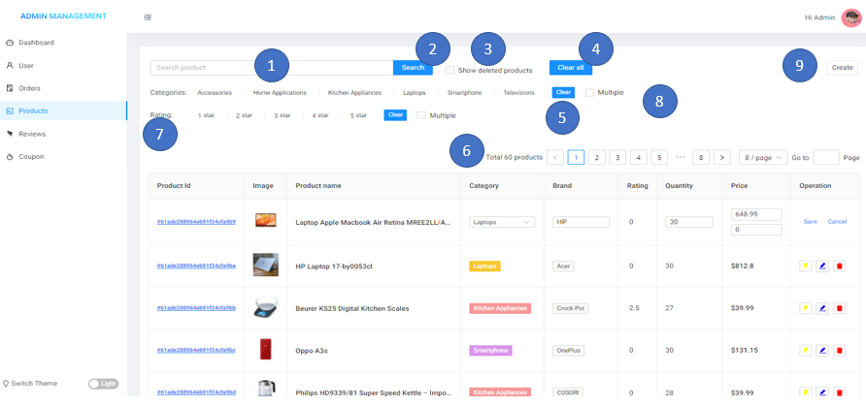



**Entities in screen:**

|  |  |  |
| --- | --- | --- |
| **Order** | **Type** | **Meaning** |
| 1 | Input (search) | Allow input product name |
| 2 | Button (Search) | Click to search product |
| 3 | Checkbox | Click to show deleted product |
| 4 | Button (Clear all) | Click to clear all field |
| 5 | Button (clear) | Click to clear filter |
| 6 | Button (Pagination) | Click to change view list products pages |
| 7 | Button (Filter) | Click to filter by categories product |
| 8 | Checkbox (Multiple) | Click to choose multiple filters |
| 9 | Button (Create) | Click to create products |
| 10 | Button (Flash icon) | Click to edit part product information |
| 11 | Button (edit icon) | Click to edit product information |
| 12 | Button (trash icon) | Click to disable product |

**Event Handling Diagram:**

Click on search button

Click to search product

Click on CheckBox(Show deleted products)

Click on clear all button

Click to clear all field

Click to show deleted products

Click to clear filter

Click on clear button

Click on button (pagination)

Click to view list products by pages

Click to choose multiple filter

Click on checkbox (multiple)

Click on create button

Navigate to create product page

### **5.2.19 Create Product Screen**

Navigate to edit product page

Click on Button (edit icon)

Click to edit part product information

Click on button (Flash icon)

Click to disable product

Click on Button (trash icon)

+ **Meaning**: Admin can create products

+ **Detail about screen**:

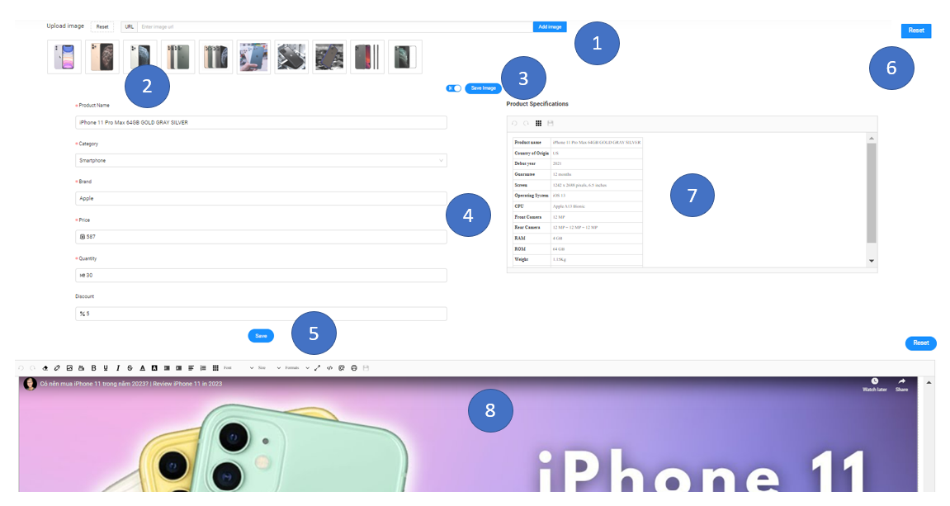



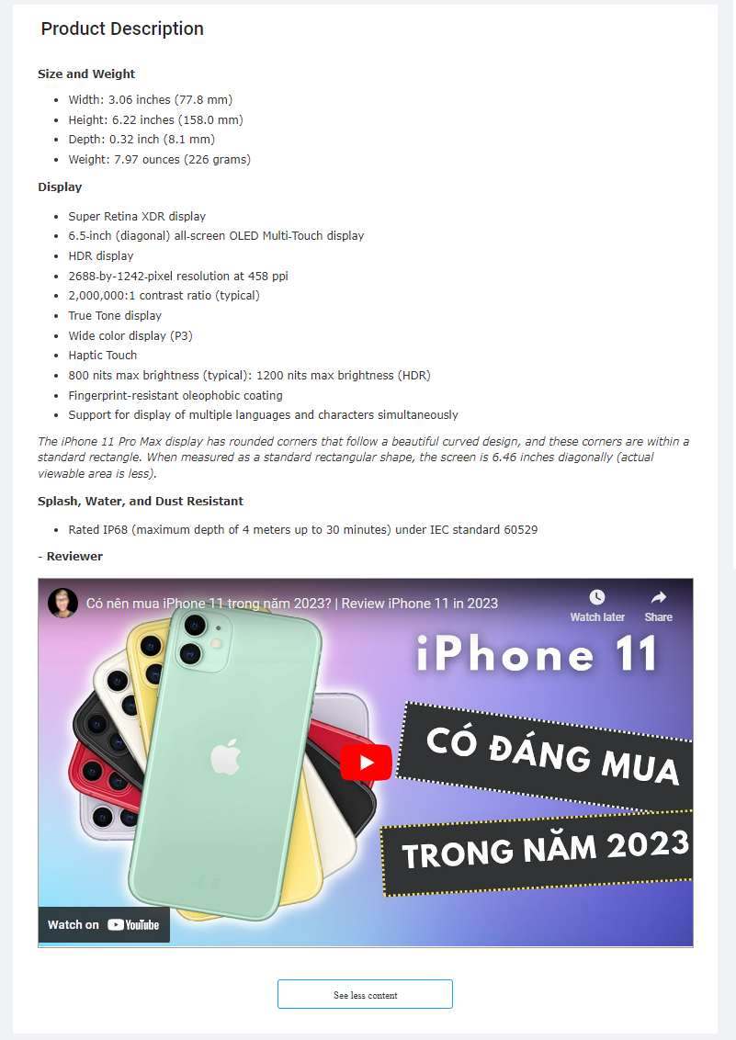

**Entities in screen:**

|  |  |  |
| --- | --- | --- |
| **Order** | **Type** | **Meaning** |
| 1 | Button (add image) | Click to add URL images |
| 2 | Button (+ upload) | Click to upload images |
| 3 | Switch (scissor) | Click to enable/disable crop image before upload |
| 4 | Input (product information) | Allow input product information |
| 5 | Checkbox (upload images to the could) | Click to enable/disable upload images to the cloud |
| 6 | Button (reset) | Click to reset field |
| 7 | Editor | Product Specification |
| 8 | Editor | Add the description of products |
| 9 | Button (Create Product) | Click to update images of the product |

**Event Handling Diagram:**

Click on checkbox (upload images to the could)

Click on Button (add image)

Click on Switch (scissor)

Click to upload images

Click on Button (+ upload)

Click to enable/disable crop image before upload

Click to add image

Click on reset button

Click to enable/disable upload images to cloud

Click to reset field

Click on create product button

Click to create product

### **5.2.20 Review Management Screen**

+ **Meaning**: Admin can management all reviews

+ **Detail about screen**:

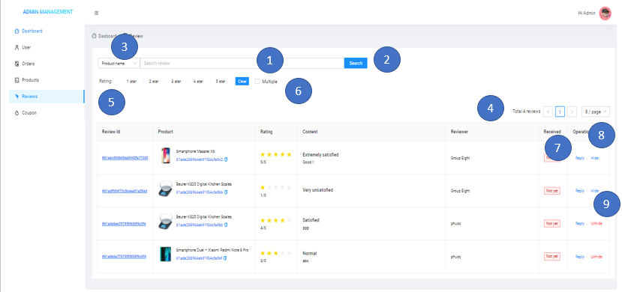

**Entities in screen:**

|  |  |  |
| --- | --- | --- |
| **Order** | **Type** | **Meaning** |
| 1 | Input (search) | Allow input product name, review name, product id |
| 2 | Button (Search) | Click to search product |
| 3 | Select | Click to select product name, review name, product id |
| 4 | Button (Pagination) | Click to change view list products pages |
| 5 | Button (Filter) | Click to filter by categories product and rating |
| 6 | Checkbox (Multiple) | Click to choose multiple filters |
| 7 | Button (Reply) | Click to show modal to reply review |
| 8 | Button (Hide) | Click to hide comment |
| 9 | Button (Unhide) | Click to unhide comment |

**Event Handling Diagram:**

Click on search button

Click to search product, review

Click to view list products by pages

Click on button (pagination)

Click to filter rating of products

Click on button (filter)

Click to select product name, review name, product id

Click on select

Click on checkbox (multiple)

Click to choose multiple filter

Click to show modal to reply review

Click on reply button

Click to hide comment

Click on hide button

### **5.2.21 Coupon Management Screen**

Click on unhide button

Click to unhide comment

+ **Meaning**: Customer or Manager can log in to the program

+ **Detail about screen**:

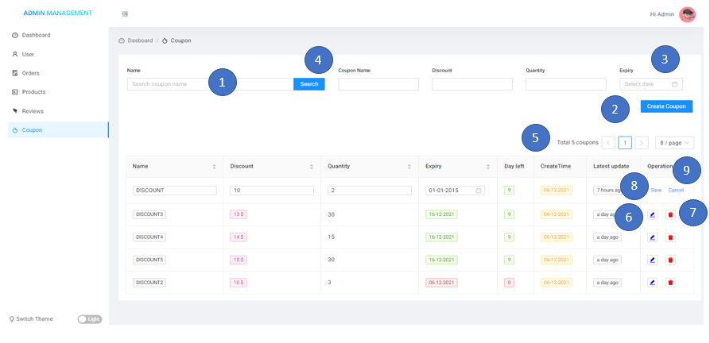

**Entities in screen:**

|  |  |  |
| --- | --- | --- |
| **Order** | **Type** | **Meaning** |
| 1 | Input | Allow input coupon name, discount, quantity |
| 2 | Button (Create Coupon) | Click to create a coupon |
| 3 | Datetime Range | Allow admin choose range of time created the coupon |
| 4 | Button (Search) | Click to search coupon |
| 5 | Button (Pagination) | Click to change view list coupon pages |
| 6 | Button (Edit icon) | Click to show modal edit coupon information |
| 7 | Button (trash icon) | Click to delete coupon |
| 8 | Button (Save) | Click to save coupon information |
| 9 | Button (Cancel) | Click to cancel edit coupon information |

**Event Handling Diagram:**

Click on create coupon button

Click to create coupon

Click on button (pagination)

Click to view list coupon by pages

Click on datetime range

Click on search button

Click to search coupon

choose range of time created coupon

Click on button (edit icon)

Click to show modal edit coupon information

Click on button (trash icon)

Click to delete coupon

Click on save button

Click to save coupon information

Click to cancel edit coupon information

Click on cancel button

### **5.2.22 Chat Facebook Plugin**

+ **Meaning**: Customer can chat with admin for product information or other thing

+ **Detail about screen**:

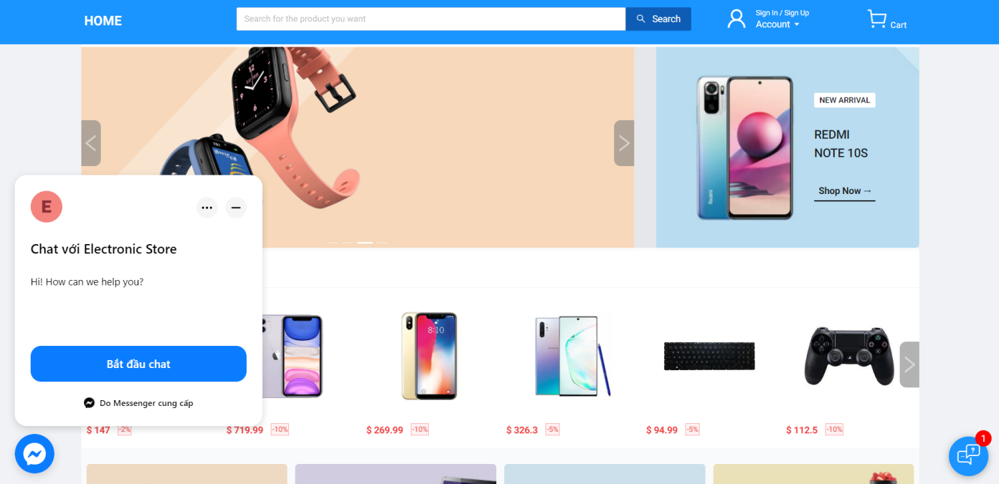

### **5.2.23 ChatBot**

+ **Meaning**: Customers can receive messages automatically from the ChatBot which we build using the ChatGPT package that uses the official OpenAI completion API with a leaked model that ChatGPT uses under the hood.

+ **Detail about screen**:

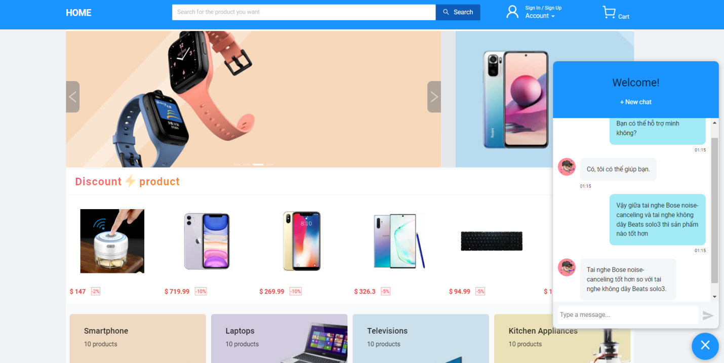

### **5.2.24 Send an email to confirm the checkout**

**+ Meaning:** Customers can view their order history by email

**+ Detail about screen:**

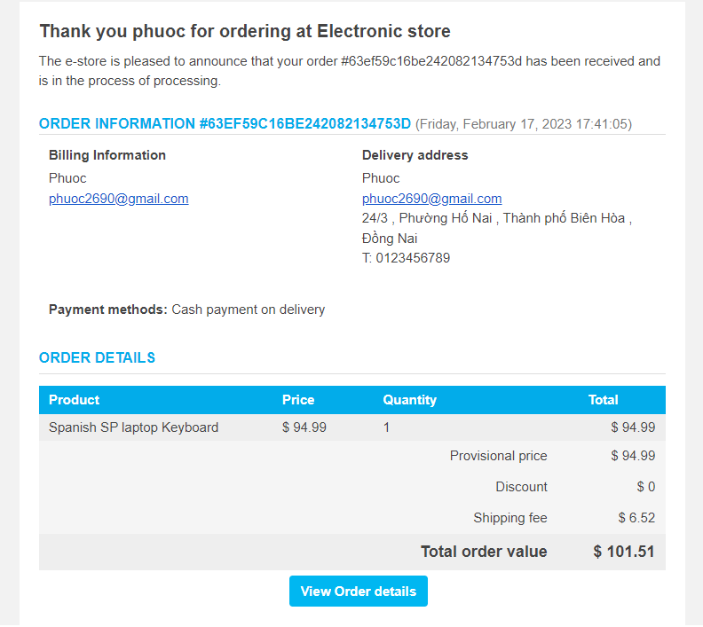

### **5.2.25 Compare Products**

**+ Meaning:** Customers can compare products

**+ Detail about screen:**

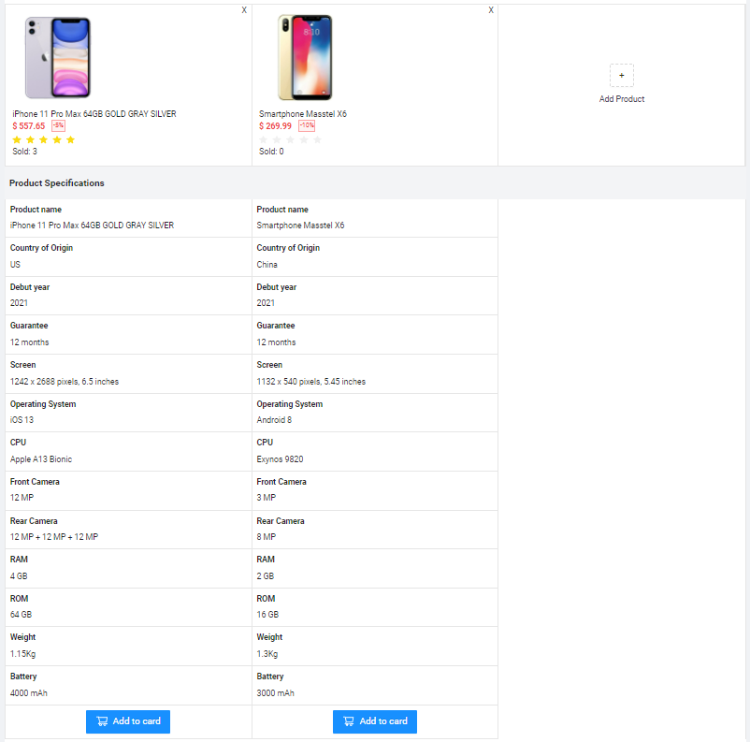

# **CHAPTER 6: SOFTWARE TESTING**

|  |  |  |  |  |  |  |
| --- | --- | --- | --- | --- | --- | --- |
| **ID** | **Description** | **Test Steps** | **Test Data** | **Expected Result** | **Actual Result** | **Status** |
| TC_01 | Log in with a valid account | - Enter email and password  - Click Login | Email: culi@example.com  Password: 123456 | Login successfully | As Expected | Pass |
| TC_02 | Log in with an account that doesn't exist | - Enter email and password  - Click Login | Email: abc@abc.com  Password: 123456 | Login fails and shows message invalid email or password | As Expected | Pass |
| TC_03 | Log in with the wrong email or password | - Enter email and password  - Click Login | Email: abc@example.com  Password: 123 | Login fail  Show message Invalid email or password | As Expected | Pass |
| TC_04 | Register with valid information | - Enter email, password and confirm  - Click Register | Email: abc@example.com  Password: 123456  Confirm: 123456 | Register successfully | As Expected | Pass |
| TC_05 | Register with an existing email account | - Enter email, password and confirm  - Click Register | Email: culi@example.com  Password: 123456  Confirm: 123456 | Register fail and show message user already exists | As Expected | Pass |
| TC_06 | Register with a password that doesn't match | - Enter email, password and confirm  - Click Register | Email: culi@example.com  Password: 123456  Confirm: 123 | Register fail and show message passwords do not match | As Expected | Pass |
| TC_07 | Forgot password with valid email | - Enter email  - Click Send to email | Email: culi@example.com | Send successfully | As Expected | Pass |
| TC_08 | Forgot password with email does not exist | - Enter email  - Click Send to email | Email: abc@example.com | Send fail  and show message email is not valid | As Expected | Pass |
| TC_09 | Search product | - Enter the name of the product  - Click search | Search: laptop | Show list products had laptop name | As Expected | Pass |
| TC_10 | Filter products by product category | - Click Shop Now  - Select product category | Select Laptops | Show list laptop products | As Expected | Pass |
| TC_11 | Filter products with product reviews | - Click Shop Now  - Select ratings | Select 3 start | Show list products had 3 stars or more | As Expected | Pass |
| TC_12 | Filter products with product price | - Click Shop Now  - Choose range price | Select range price | Show list products with range price | As Expected | Pass |
| TC_13 | Filter products with bestsellers | - Click Shop Now  - Click the selling tab |  | Show list products bestsellers | As Expected | Pass |
| TC_14 | Filter products with the latest products | - Click Shop Now  - Click the new tab |  | Show list of latest products | As Expected | Pass |
| TC_15 | Filter products with the lowest price | - Click Shop Now  - Click the low price tab |  | Show list of products with the lowest price | As Expected | Pass |
| TC_16 | Filter products with the highest price | - Click Shop Now  - Click the high price tab |  | Show list of products with the highest price | As Expected | Pass |
| TC_17 | Product details with zoom image of the product | - Click to product  - Hover to the picture |  | Zoom product image | As Expected | Pass |
| TC_18 | Product details with a variable quantity of product | - Click to product  - Click icon +/- to change the quantity of product |  | Change quantity of product | As Expected | Pass |
| TC_19 | Product details with add product to cart | - Click to product  - Click Add to cart |  | Add product to cart | As Expected | Pass |
| TC_20 | Product details with like product | - Click to product  - Click icon heart to like product |  | Change the color of the heart icon and add the product to the wish list | As Expected | Pass |
| TC_21 | Product details with unlike product | - Click to product  - Click icon heart to like product  - Click icon heart again to unlike product |  | Change the color of the heart icon and remove a product from the wish list | As Expected | Pass |
| TC_22 | Product details with rating review filter | - Click to product  - Click rating to filter review | Select 3 star | Show list review with rating 3 star | As Expected | Pass |
| TC_23 | Product details with like comment | - Click to product  - Click Like |  | Show liked | As Expected | Pass |
| TC_24 | Product details with a reply comment | - Click to product  - Click comment |  | Can reply to other people's comments | As Expected | Pass |
| TC_25 | Cart with product quantity change | - Click cart  - Click icon +/- to change the quantity of product |  | Change quantity of product in the cart | As Expected | Pass |
| TC_26 | Cart with remove product from the cart | - Click cart  - Click icon trash to delete product in the cart | Select product want to remove | Remove the product from the cart | As Expected | Pass |
| TC_27 | Cart with valid promo code applied | - Click cart  - Enter promo code  - Click Apply | Promotion code: DISCOUNT | 10% discount | As Expected | Pass |
| TC_28 | Cart with invalid promo code applied | - Click cart  - Enter promo code  - Click Apply | Promotion code:  ABC | Show message invalid promo code | As Expected | Pass |
| TC_29 | Checkout with cash | - Click cart  - Select product  - Click checkout  - Select cash payment |  | Order successfully | As Expected | Pass |
| TC_30 | Checkout with PayPal | - Click cart  - Select product  - Click checkout  - Select PayPal payment | Login PayPal account | Order successfully | As Expected | Pass |
| TC_31 | Checkout with stripe card | - Click cart  - Select product  - Click checkout  - Select stripe card payment | Enter card number | Order successfully | As Expected | Pass |
| TC_32 | Checkout with ZaloPay | - Click cart  - Select product  - Click checkout  - Select ZaloPay payment | Scan QR code | Order successfully | As Expected | Pass |
| TC_33 | Checkout with Momo | - Click cart  - Select product  - Click checkout  - Select Momo payment | Scan QR code | Order successfully | As Expected | Pass |
| TC_34 | Add address | - Click address  - Click add | Full name: abc  Phone number: 0123456789  City: TP.HCM  District: TP.Thủ Đức  Wards: Phường Linh Trung  Address: 213 abc | Add address successfully | As Expected | Pass |
| TC_35 | Modify address | - Click address  - Click modify | Full name: abc  Phone number: 0123456789  City: TP.HCM  District: TP.Thủ Đức  Wards: Phường Linh Trung  Address: 213 abc | Modify address successfully | As Expected | Pass |
| TC_36 | Delete address | - Click address  - Click delete |  | Delete address successfully | As Expected | Pass |
| TC_37 | Order detail | - Click order management  - Click icon detail |  | Show order details | As Expected | Pass |
| TC_38 | Cancel order | - Click order management  - Click icon detail  - Click cancel the order |  | Cancel order successfully | As Expected | Pass |
| TC_39 | Latest order | - Login with admin  - Click Dashboard |  | Show the latest order | As Expected | Pass |
| TC_40 | Latest review | - Login with admin  - Click Dashboard |  | Show latest  review | As Expected | Pass |
| TC_41 | Update user | - Login with admin  - Click User  - Click update | Full name: abc  Email: abc@gmail.com  Phone number: 0123456789  Date of birth: 1/1/2000  Gender: Male | Update user successfully | As Expected | Pass |
| TC_42 | Delete user | - Login with admin  - Click User  - Click delete |  | Disable user successfully | As Expected | Pass |
| TC_43 | Update order status | - Login with admin  - Click Order  - Click update  - Click Save | Select status | Update order status successfully | As Expected | Pass |
| TC_44 | Create product | - Login with admin  - Click Product  - Click create | Product name: TV  Category: Televisions  Brand: LG  Price: 300$  Quantity: 100  Discount: 10%  Description: abc | Create product successfully | As Expected | Pass |
| TC_45 | Edit product | - Login with admin  - Click Product  - Click edit | Product name: TV  Category: Televisions  Brand: LG  Price: 300$  Quantity: 100  Discount: 10%  Description: abc | Edit product successfully | As Expected | Pass |
| TC_46 | Delete product | - Login with admin  - Click Product  - Click delete |  | Delete product successfully | As Expected | Pass |
| TC_47 | Hide comment | - Login with admin  - Click Review  - Click hide |  | Hide comment  successfully | As Expected | Pass |
| TC_48 | Create coupon | - Login with admin  - Click Coupon  - Click create | Coupon name:  DISCOUNT5  Discount: 10$  Quantity: 10  Expiry: 1/1/2022 | Create coupon successfully | As Expected | Pass |
| TC_49 | Edit coupon | - Login with admin  - Click Coupon  - Click edit | Coupon name:  DISCOUNT5  Discount: 10$  Quantity: 10  Expiry: 1/1/2022 | Edit coupon successfully | As Expected | Pass |
| TC_50 | Delete coupon | - Login with admin  - Click Coupon  - Click delete |  | Delete coupon successfully | As Expected | Pass |

# **CHAPTER 7: SUMMARY**

## **7.1 The summary result that we got:**

**About knowledge and soft skills:**

* Work in a group.
* Studied knowledge and a process to develop software
* Get acquainted and have access to new technologies like Next. js, and MongoDB
* Methods to design and implement functions, a graphic user interface
* Learn more about the various types of diagrams used in software development, such as use case diagrams, sequence diagrams, and class diagrams.
* Way to design a database and build APIs in software development.

**About Project:**

The program that is developed by our group makes sure that it is qualified to help users access online shopping.

* Allow users to access online shopping.
* A wide range of products from which users can choose
* Users can rate and comment on products.
* There are detailed product images and videos to help users grasp the product in the clearest way.
* Users can pay using a variety of methods.
* Users can add their favorite products.
* There are discount products and discount codes to help users save more money.
* Users can view their purchase history as well as the status of their orders.
* Suggest some similar products to help users shop more conveniently.
* Allows management to manage users, invoices, products, reviews, and discount codes.
* There are sales statistics of all kinds to make management easier to manage.

## **7.2 Advantages:**

* The program is simple to operate.
* A user-friendly and professional interface.
* Offer numerous functions that can assist users in resolving issues with online shopping.
* Quick web page loading
* Online customer support
* Various forms of payment
* After each payment, send the user the payment details.
* Assist managers in easily managing data.
* Various electronic products

## **7.3 Disadvantages:**

* There is no function to update multiple order statuses at the same time.
* Only one manager has the admin account.
* Only one email login method is available.
* The mobile interface is not great.
* It is difficult for customers to know if there is a discount code because customers can use the same discount code many times.

## **7.4 Advanced functions of the website:**

* A shipping fee calculator API app is available.
* After commenting, users can respond.
* Has integrated Facebook chat for easy user interaction.
* The user can see the order time status.
* There are various payment sizes available, such as Momo and ZaloPay.
* Based on the preferences of others, recommend products that users may be interested in.
* On the product detail page, use NextJS's featured features (Incremental Static Regeneration, On-Demand Revalidation).
* Because we have saved user carts in the database, we can use the API to sync with list carts if we have a mobile version.
* There is a chatbot through which customers can request information.

## **7.5 Things to update in the future:**

In the future, we will try to update more functions related to website management to make them more effective, such as:

* More administrators to manage
* Provide users with discount code notifications.
* Only use one discount code at a time.
* Integrate multiple login methods, such as Google and Facebook.
* Email verification feature that is valid
* Phone's email verification feature
* Enhanced responsiveness
* Using React Native to build a mobile version
* Create an automated system that can check user comments before publishing.

# **REFERENCES**

Inspiration based on design and layout on many websites especially from tiki website

**REFERENCED WEBSITE:**

[1]. <https://www.youtube.com/>

[2]. <http://stackoverflow.com/>

[3]. <https://tiki.vn/>

[4]. <https://shopee.vn/>

[5]. <https://www.lazada.vn/>

[6]. <https://www.sendo.vn/>

[7]. https://docs.zalopay.vn/v1/docs/gateway/overview.html

[8]. https://developers.momo.vn/v3/vi/docs/payment/onboarding/overall

[9]. https://developer.paypal.com/tools/sandbox/

[10] https://viblo.asia/p/xay-dung-collaborative-filtering-rs-recommender-system-co-ban-phan-3-Az45bMqolxY

[11] https://www.dienmayxanh.com/

[12] https://www.thegioididong.com/

# **ROLE TABLE**

|  |  |  |
| --- | --- | --- |
| **Content** | **Outcome** | **Member** |
| * Choosing and researching the technology applied in the project. * Giving the ideas and conclusions for the project (what kind of website?). * Research the basic knowledge related to the website. | * Get a certain understanding of Next.js * Determine the type of project to build | All member |
| * Describe the functions and roles to be performed * Define roles for each member of the team. | Identify the functions that need to be done in the project, complete the roles of the members | All member |
| * Database design. * Create mock JSON data | * Finished designing the database model * Done creating fake JSON data | All member  Phước, Sơn |
| * Build API * Connect the Front-End to the Back-End | * Complete CRUD   + User  + Product  + Order  + Wish List  + Review  + Coupon   * Connect Successful | Thành,  Sơn,  Phước  Thành |
| * UI design for modal Sign In, Sign Up, Forgot Password * Verify email to reset password | * Complete UI and function for modal Sign In, Sign Up, Forgot Password * Send email to reset password | Sơn, Phước  Thành |
| * Custom component Carousel * Custom component Search * UI design for Header | * Complete function Carousel * Complete function search product * Complete UI for Header | Sơn  Thành  Phước |
| * UI design for the product categories section * Product card component * UI design for the product section (Best-selling products, new arrivals, top rating) | * Complete UI for the product categories section * Complete Product card component * Complete UI for the product section (Best-selling products, new arrivals, top rating) | Thành  Sơn  Phước |
| * UI design Filter products page * Recommended Product * Compare Products * UI design Product Details * UI Product Review | * Complete UI for Filter products page * Recommended Product function * Complete function compares products * Complete UI for Product Details * Complete UI for Product Review | Thành  Sơn  Phước |
| * Design Cart Item Components * Design order fee section * Design adds coupon section * Design address section | * Complete Cart Item Components * Complete UI for order fee section * Complete UI for add coupon section * Complete UI for address section | Thành  Phước  Sơn |
| * Add Payment Methods (Stripe, PayPal, ZaloPay, Momo) * Send mail when successfully checkout | * Complete add payment methods * Complete send mail function | Thành |
| * Design account information page * Design order management page * Design address page * Design review purchased product page * Design wish list page | * Complete account information page * Complete order management page * Complete address page * Complete review purchased product page * Complete wish list page | Sơn  Phước |
| * Design dashboard page * Design user management page * Design order management page * Design review management page * Design product management page * Design coupon management page | * Complete dashboard page * Complete user management page * Complete order management page * Complete review management page * Complete product management page * Complete coupon management page | Thành  Sơn  Phước |
| * ChatBot * Chat Facebook with Shop * Improve website performance | Complete functions | Thành |
| * Responsive * Testing * Write report * Slide | Complete | All members |